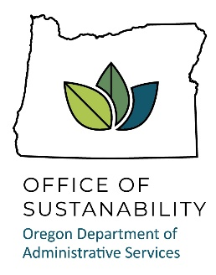

**Proposed 2024 Schedule: Oregon Sustainability Board**

|  |  |  |
| --- | --- | --- |
| Date | Proposed Location | Tentative Agenda Items |
| March 22 | Salem | * Intro of new Board members, icebreaker, comments from Governor’s office. * Legislative updates – last day for short session 3/10. * DAS sustainability program intro. * EV program briefing session. * Agencies presenting sustainability plan updates: ODOT, DSL, ODOE. |
| June 14 | Eugene | * DAS sustainability program updates. * Agencies presenting sustainability plan updates. * Agencies presenting sustainability plan updates: DLCD, DCBS, Business Oregon. |
| September 12/13 (Thursday/Friday) | Enterprise | * Guest presenters, eastern Oregon. * Field trip. * Board work plan updates. * Agencies presenting sustainability plan updates: DAS, ODA, OHCS. |
| December 13 | Salem | * Work plan updates. * Community presentations. * Agencies presenting sustainability plan updates: DOC, OWEB, OWRD. |