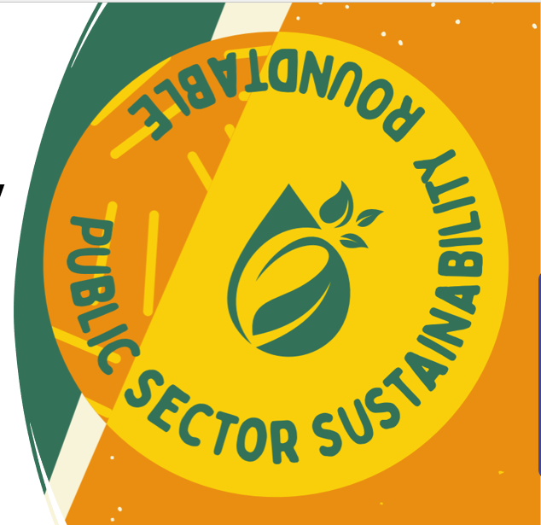
2025 Annual Report
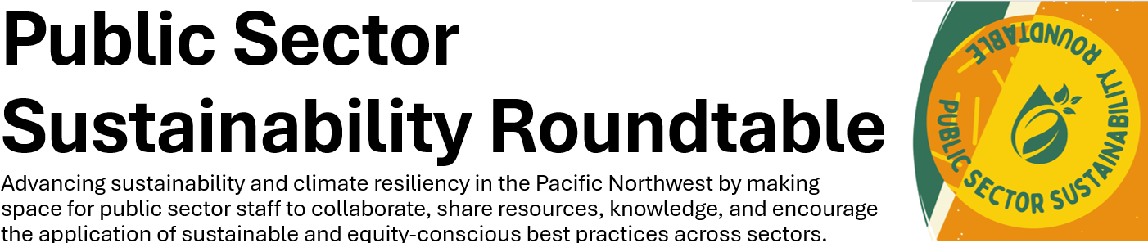
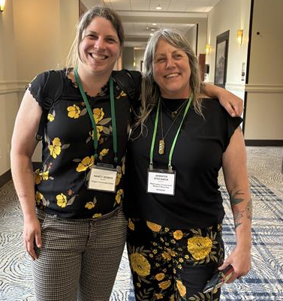
Introduction:__________________________________________________________________________________
On behalf of the Strategic Planning Team, we thank you for being part of the Public Service Sustainability Roundtable. This volunteer run group is the fruit of hard work by all of you as members, workgroup leaders and the strategic planning team members. We are happy to report that our membership continues to grow and that we look forward to finding new ways to engage with participants and members to grow our ranks, help people advance into leadership roles within the organization and help continue to chart the path for this group. We look forward to helping continue to advance sustainability and equity with you all in 2026.
– The PSSR Strategic Planning Team
PSSR 2025 Co-Chairs Nancy Reimer (L) and Jennifer Stefanick (R). They aren’t always in matching outfits, but when they are, we had to snag a photo.

Membership:___________________________________________________________________________________
Membership is now currently at 160 members across 50+ agencies, 2 states, with representatives from city, county, regional, state and federal levels along with special districts and public learning institutions. PSSR is committed to being a space where any public service staff that are interested in sustainability are welcome to join us, participate and learn together with us all. Whether you are experienced in sustainability or interested and want to learn more and apply it to your work area, we would love to have you!
Get involved! We are always interested in sharing the fun, learning, professional development, collaboration and more with others. It doesn’t happen by magic, but it does with a bit of fun teamwork (not a ton of time). You don’t need to be an expert to contribute, just bring the interest! We could use a hand in the following areas:
- Strategic Planning – help guide PSSR, plan events, help members feel welcome and get to know everyone.
- Climate Action Workgroup – learn and share about best practices in advancing climate action in your community.
- Sustainable Procurement Workgroup – help your agency spend equitably and sustainably and gain support in doing so.
- Member Engagement and Development Workgroup – (on pause, seeking chair) help bring more people into PSSR, help host fun networking and educational events and spread resources that aide in everyone’s professional development.
Plug in! Contact PSSR Co-chair Jennifer Stefanick (jennifer_stefanick@washingtoncountyor.gov) and she can get you connected!

Diversity, Equity, Inclusion and Belonging: _______________________________________________________

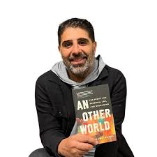
PSSR values the deep interconnection of Sustainability work and Diversity, Equity, Inclusion and Belonging. In 2022 and 2023, the group embarked on a process to further center DEIB into the groups Mission, Vision, Values and Norms through a collaborative process with members and leadership. The new PSSR Charter is now live and reflects those changes. This year, the Strategic Planning Team has been continuing to find ways to further operationalize DEIB in our work. This year, the group evaluated local DEIB lenses and has begun using them to plan events and make decisions. We had the opportunity to host Hanif Fazal for an excellent Roundtable discussion about operationalizing DEIB and sustainability in the current political landscape. We also attended the NW EcoFilm fest, which focused on environmental justice films. Many of PSSR’s leadership attended this year’s Northwest Public Employees Diversity Conference. We welcome ways to further enhance DEIB within PSSR. Please reach out to any folks in PSSR leadership with your ideas and suggestions: pssroundtable@gmail.com
Hanif Fazal with his book An Other World and the billboard from the Hollywood Theare during the Portland EcoFilm Festival.
Roundtables: _________________________________________________________________________________
- Winter Roundtable: PSSR Strategic Workgroup – January 14, 2025
- PSSR members shared successes from their programs from previous year and future projects looking ahead to 2025 that they are excited about. Cochairs shared the PSSR year in review that included three roundtable events and a brief list of topics that members shared in the PSSR Basecamp HQ message board. The Climate Action Workgroup and Sustainable Purchasing Workgroup shared highlights from the year and offered ways to get more involved with these workgroups. Cochairs asked the attendees what they wanted to see in 2025 for more engagement. Jennifer Stefanick from Washington County was nominated and elected as the new PSSR Co-Chair to work alongside Nancy Reimer, PSSR’s other Co-Chair.
  - 19 attendees

- Summer Roundtable: Hanif Fazal – July 23, 2025
  - Hanif Fazal is the Co-Founder and Managing Partner of the Center for Equity and Inclusion (CEI), author, An Other World
  - Hanif guided the conversation on centering racial equity and making meaningful and sustainable changes within an organization’s identity, policies and procedures. Attendees joined breakout rooms to further discuss and collaborate using prompts offered by Hanif.
  - 60 registered attendees

- Fall Roundtable: Active Transportation – November 3, 2025
  - Guest presenters included Bike Buddy program, TriMet, Upstream Access and Westside Transportation Alliance.
  - Presentations focused on matching community members with experienced bike riders to build bike commuting skills and provided help with exploring different modes of transportation and incentive-based programs. Presenters shed light on the gaps in access to transportation for disabled communities and the need to build transportation systems that are equitable and responsive.
  - 25 attendees

Workgroups: ____________________________________________________________________________________
Climate Action
In 2025, the PSSR Climate Action Workgroup (CAW) continued under the leadership of Dana Visse and Amanda Watson. Robin Straughan stepped down from her co-chair role in February, after several years of helping to shape and lead the workgroup. The CAW holds hourlong bi-monthly virtual meetings where we learn from each other and local experts advancing climate action initiatives across our region. The workgroup currently includes 39 members, and we average 12 attendees at meetings. Six workgroup meetings were held during 2025, including:
· February: Preview of climate and environmental bills in the 2025 Oregon Legislature’s short session, presented by Jacqui Traeger, Senior Campaign Manager with Oregon Environmental Council (OEC)
· April: City of Gresham Climate Action Engagement and Outreach, presentation by Denise Lopez and Gregg Hayward, City of Gresham
· June: Multnomah County’s Climate Justice Plan, presentation by John Wasiutynski, Director of Multnomah County Office of Sustainability
· August: Review of 2025 Oregon Legislative session outcomes for climate and environmental bills, presented by Jacqui Traeger, Senior Campaign Manager with OEC
· October: Breaking Barriers Collaborative’s Fleet Electrification Accelerator Program, presented by Adam Nashban with Climate Solutions
· December: Roundtable discussion on Generative AI – integrating climate and equity considerations into organizational policies and practices
Meetings: Fourth Monday of every other month, 10-11 am Find more on Basecamp. Interested in getting involved? Contact Dana Visse: dana.visse@oregonmetro.gov

Sustainable Procurement
The Public Sector Sustainability Roundtable (PSSR) Sustainable Procurement Workgroup continued to convene monthly, offering mutual support for participants' projects throughout the year. Our established methodology emphasizes the principles of diversity, equity, and inclusion, ensuring that marginalized voices and projects requiring assistance are brought forward in a manner that is impactful to all attendees.
We are all working towards supporting the City of Portland as they explore how to update their Low Carbon Concrete Program. We extend this opportunity to support Low Carbon Concrete by attending our workgroup meetings or contacting the City of Portland Sustainable Procurement Program Manager, Cary Watters, for more information on how to support and align with the City’s efforts. Join the bi-monthly meetings by contacting:
We are open to anyone attending our meetings. We are consistently seeking fresh perspectives and new topics to explore within the realm of sustainable procurement, and we warmly welcome any questions or suggestions that our members may have.
Procurement, at its core, is a vital activity that extends far beyond simple purchasing. It fundamentally involves actively collaborating with all interested internal and external parties—from suppliers and end-users to community members and environmental advocates. This comprehensive engagement is essential for achieving outcomes that not only secure necessary goods and services but also generate positive and lasting impacts across our entire value chain, fostering social equity, environmental stewardship, and economic resilience.
Our meetings are inclusive forums, and attendance is open to anyone interested in contributing to or learning about sustainable procurement practices, regardless of their specific role or department. We encourage participation from across the organization and the wider community to ensure a diverse and impactful dialogue.
Meetings: Last Thursday of each month 1 to 2 pm
Find out more on Basecamp. Interested in getting involved? Shawn Postera and Carry Waters help coordinate. Contact Shawn Postera shawn.postera@multco.us
Strategic Planning
This group is made of workgroup co-chairs, PSSR’s co-chairs, and members at large. This year we continued to work on expanding membership, helped put on 3 roundtables, a happy hour, eco film fest gathering and continued working on implementing DEIB practices into PSSR. We also had some fun get-togethers and enjoyed collaborating each month.
We could always use an extra hand or set of ideas, please don’t hesitate to join us to help set the direction for PSSR. Help plan Roundtables and events, advance DEIB in the group, help us reach new audiences, and keep this rad boat afloat! There’s plenty of roles for everyone, with time commitments that can usually work into most schedules. Help grow and support sustainability and equity across the Public Sector!
Meetings: Second Thursday of each month, 3:15-4:15 pm
Find out more on Basecamp. Interested in getting involved? Contact Gregg Hayward Gregg.Hayward@GreshamOregon.gov

Basecamp ______________________________________________________________________________________________
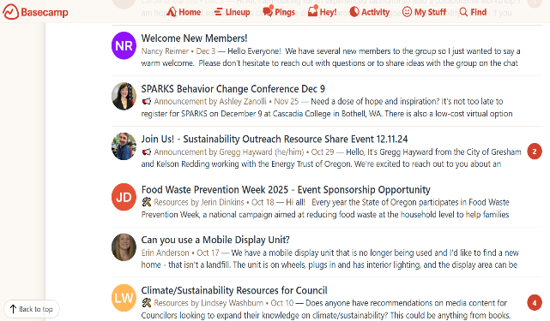
PSSR’s Basecamp platform continues to be a helpful place for members to post questions, ideas, opportunities and more, pinging the collective reach of our 150+ members. This year 45 different topics were discussed on Basecamp. This is a great feature for promoting dialogue, sharing resources and helping further our work in a convenient way. The more conversations here the better!
PSSR's Basecamp Message Board
Inclusive language reminder: Ya’ll are doing great, but just a friendly reminder as part of our DEIB work, that Basecamp is an extension of our PSSR space. Please keep utilizing the Norms in our PSSR Charter when interacting in this space.

Help Bring more Folx to PSSR! __________________________________________________________________________

Our community can become more and more helpful with more minds and perspectives all working together. Again, you don’t have to be a sustainability expert to be part of PSSR, just be:
- A public service employee
- Have interest in furthering sustainability and equity.
- A desire to learn more, share and collaborate.
Share our PSSR Flyer with anyone that meets the criteria above and is interested!
See you soon, thank you for all you do. Take care of yourself and keep taking care of others! – The PSSR Team

