MOCK PURA BELPRÉ AWARD:
Remember: “Each of these must be an original work that portrays, affirms and celebrates the Latino cultural experience.”
Argueta, Jorge (au) & Duncan Tonatiuh (ill) Salsa: Un poema para cocinar /A Cooking Poem.
Toronto: Groundwood Books, 2015.
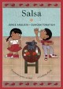
Engle, Margarita (au) & Rafael Lopez (ill) Drum Dream Girl: How One girl’s Courage Changed Music.
Boston: Houghton Mifflin Harcourt Books, 2015.

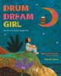
Engle, Margarita (au) & Edel Rodriguez (ill) Enchanted Air: Two Cultures, Two Wings: A Memoir.
New York: Simon & Schuster Inc., 2015.
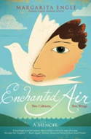

Garza, Xavier (au, ill) The Great and Mighty Nikko! El Paso, TX: Cinco Punto Press, 2015.
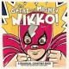

Luna, James (au) & Muraida, Thelma (ill) The Place Where You Live / El lugar donde vives.
Houston, TX: Arte Público Press, 2015.
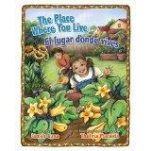

Manzano, Sonia (au) Becoming Maria : love and chaos in the South Bronx. A Memoir.
New York: Scholastic Inc., 2015.
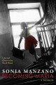

Manzano, Sonia (au) & Marjorie Priceman (ill) Miracle on 133rd Street.
New York: Simon & Schuster Inc., 2015.
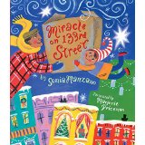
Medina, Meg (au) & Angela Dominguez (ill) Mango, Abuela y yo.
Somerville, MA: Candlewick Press, 2015.
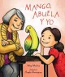
Mora, Pat (au) & Robert Casilla (ill) The Remembering Day / El día de los muertos.
Houston, TX: Arte Público Press, 2015.
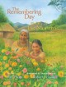

Rivera-Ashford, Roni Capin (au) & Antonio Castro (ill) My Tata’s Remedies / Los Remedios de mi Tata.
El Paso, TX: Cinco Punto Press, 2015.
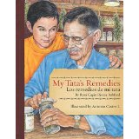
Tonatiuh, Duncan (au & ill) Funny bones : Posada and his Day of the Dead Calaveras.
New York: Abrams Books, 2015.
