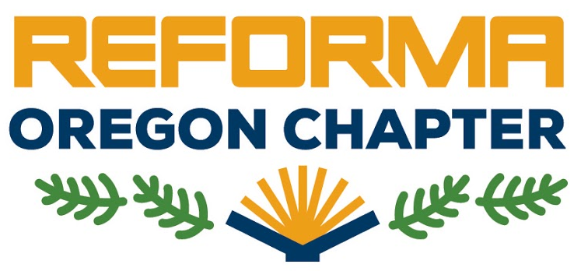

**Chapter Meeting & 2018 Mock Pura Belpré Award**

Saturday, December 8, 2018, 10 am – 4:30 pm

Estacada Public Library, 825 NW Wade St, Estacada, OR 97023

**REFORMA OR Meeting 10 am – 12:30 pm**

10:00 – 10:15 Welcome & Introductions

10:15 – 10:30 Leadership Team & Treasurer’s Reports

10:30 – 11:10 Committee Updates (Fundraising, Communication, OLA Scholarship, Libros for Oregon)

11:10 – 11:25 OLA/WLA Conference proposal update

11:25 – 11:40 Group photo / Stretch break

11:40 – 11:50 FIL Highlights

11:50 – 12:00 Presentation at Asamblea Anual, Reforma Puerto Rico

12:00 – 12:25 Member Updates

12:25 – 12:30 Next Meeting Location & Date

**Lunch 12:30 – 2 pm**

**Mock Pura Belpré Award 2 – 4:30 pm**

2:00 – 2:05 Welcome & Introductions

2:05 – 2:15 Pura Belpré award History & Purpose

2:15 – 3:00 Guadalupe Garcia McCall, 2012 Pura Belpré Author Winner (Under the Mesquite)

3:00 – 3:10 Mock Criteria

3:10 – 4:00 Book discussion and selection of best author and illustrator in small groups

4:00 – 4:20 Final vote

4:20 – 4:30 Wrap-up and evaluation

**ADJOURN**