Apple Store
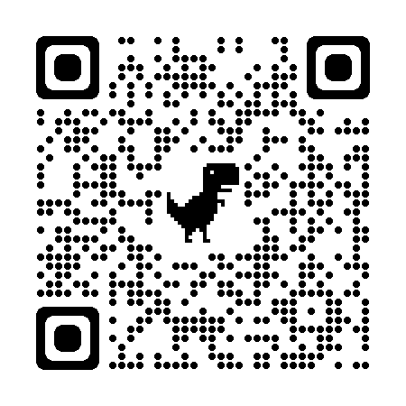
- Search for ‘MemberClicks Conference App’ or scan the QR code
  - You should see ‘MemberClicks Conference App’ in the results
- Click on ‘GET’
- Download the app to your phone
- Open the app
- You’ll be prompted to search for an app or enter a code
  - Search: OLA 2023
  - Code: ola23
- You should now have access to the event
- Click the profile icon located at the top right of the app home page to log in
  - Follow the prompts on the screen to obtain an access code
    - Make sure to use the email you registered with
  - Enter the access code sent to your email
- You should now have access to the event

Google Play Store
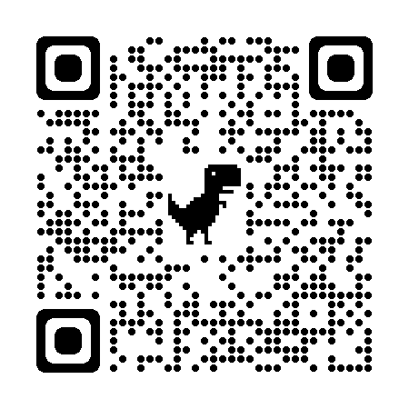
- Search for ‘MemberClicks Conference App’ or scan the QR code
  - You should see ‘MemberClicks Conference App’ in the results
- Click on ‘Install’
- Download the app to your phone
- Click on ‘open’
- You’ll be prompted to search for an app or enter a code
  - Search: OLA 2023
  - Code: ola23
- Click the profile icon located at the top right of the app home page to log in
  - Follow the prompts on the screen to obtain an access code
    - Make sure to use the email you registered with
  - Enter the access code sent to your email
- You should now have access to the event
Note: Android version is 5.1 or later is required to run the app
Website Users
- If you plan to access event content to through the event website instead of the mobile app, you can do so by clicking on the following URL link: https://l49jc7yw31097qozwbo.app.mobileup.io/
- Note: The website does not include the full functionality of the app. We recommend using the app in order to take advantage of the full features and functionality available within.

