PNLA Virtual Conference 2025: Reach Further
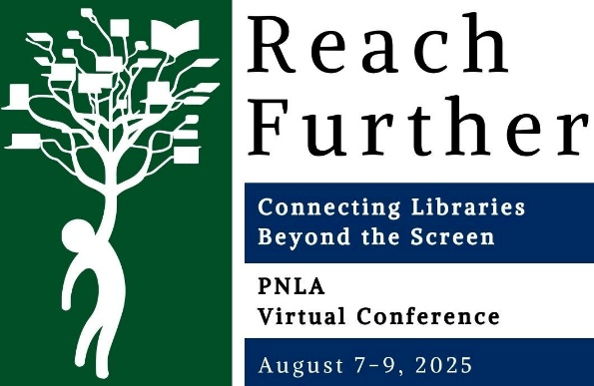
2025 PNLA Virtual Conference August 7-9, 2025
Registration—Please read the Code of Conduct and Refund Policy at end of registration form.
Name:
Address:
Institution:
Email address:

Mail checks to: Debbi Kramer, 5176 N Valle Dorado, Kingman, AZ 86409
A paid receipt will be sent to the above email address once payment is received.

_____ PNLA Member - Entire - Early Bird – $100.00
(invoices not paid by July 5 will be charged Regular rate, $150)
_____ PNLA Member - Entire - Regular – $150.00
_____ PNLA Member - One Day - Early Bird – $60.00
(invoices not paid by July 5 will be charged Regular rate, $100)
_____ PNLA Member - One Day - Regular – $100.00
_____ Non-Member - Entire - Early Bird – $175.00
(invoices not paid by July 5 will be charged Regular rate, $225)
_____ Non-Member - Entire - Regular – $225.00
_____ Non-Member - One Day - Early Bird – $75.00
(invoices not paid by July 5 will be charged Regular rate, $175)
_____ Non-Member - One Day - Regular – $175.00
_____ Student, Trustee, Retiree - Entire – $75.00

Recorded Sessions
Disclaimer: Please be advised that we will be recording sessions during the conference.

Code of Conduct
By registering, you indicate your agreement.
PNLA is committed to providing a harassment-free conference experience for everyone, regardless of gender, gender identity and expression, age, sexual orientation, disability, physical appearance, body size, race, ethnicity, national origin, or religion. Harassment of conference participants in any form will not be tolerated.
Prohibited behaviors include, but are not limited to:
- Harassment or intimidation based on race, religion, language, gender, sexual orientation, gender identity, gender expression, disability, appearance, political affiliation or beliefs, or other group status.
- Sexual harassment or intimidation, including unwelcome sexual attention, stalking (physical or virtual), or unsolicited physical contact.
- Yelling at or threatening conference presenters. This applies to in-person or virtual interactions.
Participants asked to stop hostile or harassing behaviors are expected to comply immediately. Conference participants violating these rules may be expelled from the conference without a refund at the discretion of the conference organizers.
If you are being harassed, observe someone else being harassed, or have concerns, please notify an event organizer immediately. Please send emails to our chair Debbi Kramer debkramerpnla@gmail.com We will be happy to assist with immediate intervention or contacting law enforcement if necessary. We value your attendance and well-being!

Refund Policy
1. The Conference Planning Committee may approve requests for refunds due to cancellation up until 14 days prior to the first day of the conference (July 23, 2025, for the 2024 PNLA Virtual Conference). Such requests must be in writing and directed to the Conference Planning Committee via debkramerpnla@gmail.com. A $25.00 handling fee will be deducted from the refund amount. Credit Card refunded amount will be after transaction fees are deducted and will be by check only.
2. Requests for refunds due to cancellation or change of plans will not be approved if made after the date stated in Section I above, except that the Conference Planning Committee has the discretion to approve requests for refunds due to cancellations caused by medical emergencies or death in the immediate family. Such requests must be in writing and directed to the Conference Planning Committee. A $25.00 handling fee will be deducted from the refund amount.
3. Without exception, requests for refunds made more than 30 days after the last day of the conference will not be approved.
4. Appeal may be made to the Co-Chairs of the Conference Planning Committee for review or refund decisions made by the Conference Planning Committee. The decision of the Co-Chairs will be final.
5. For PNLA refunds, contact Debbi Kramer, debkramerpnla@gmail.com.

