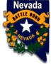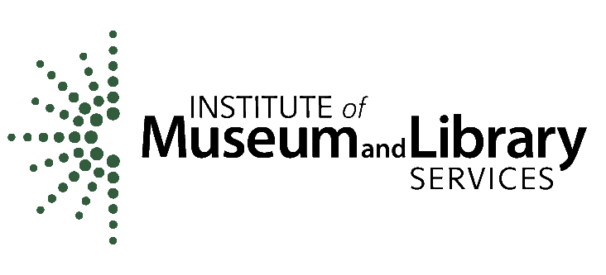NEVADA STATE LIBRARY, ARCHIVES and PUBLIC RECORDS

Nevada Department of Administration

100 North Stewart Street

Carson City, NV 89701

**Federal 2020 LSTA GRANT-IN-AID AWARD**

**Sub-Grantee**: Click here to enter text.

**Address:** Click here to enter text.

**DUNS Number:** Click here to enter text.

**Project Title:** Click here to enter text.

**Grant Number:** 2020-xx **P/P# or CFDA #:** 45310-20

**Sub-Award Project dates:** July 1, 2020 – August 31, 2021

**General**

1. Grant funded activities shall provide services and equipment as outlined in the approved grant application. Grant funds must be used to meet NSLAPR Five Year Plan and federal LSTA goals. The approved grant application submitted by the sub-grantee becomes part of this agreement.
2. The sub-grantee may not obligate or encumber grant funds prior the effective date of this agreement. Funds may not be obligated or encumbered after August 31, 2021.
3. All unexpended grant funds must be returned to the Nevada State Library, Archives and Public Records

**Grant Amounts and Reimbursement Procedures**

1. Total Amount of Federal funds obligated for this project: **$** xxx
2. The sub-grantee must request payments as reimbursement of actual funds expended for the normal grant cycle. Advance payments may be requested under special circumstances and must be authorized by the LSTA Coordinator and NSLAPR Administrator prior to a payment request.
3. The sub-grantee may not obligate or encumber grant funds before the effective date of this agreement or after August 31, 2021.
4. Funds for the grant project are authorized according to the final application budget; required match is at least 10%.

**Request for Fiscal and/or Programmatic Changes**

The sub-grantee may request a budget and/or program amendments for fiscal or programmatic changes as outlined below. Sub-grantee must submit a request for the budget or program change in writing to NSLAPR. All requests for changes must be received on or before June 30, 2021. Requests received after that date will be considered on a case by case basis. The revision must be submitted before obligating or expending grant funds.

1. Fiscal Changes must have a Budget Revision for any of the following conditions:
   1. Transfers of grant funds among budget categories that exceed ten (10) percent of a budget category:
   2. A transfer of funds into a budget category that currently equals zero ($0);
   3. A change in the items listed in the approved budget categories if an item’s cost or features are substantially different from the approved grant application specifications.
2. Programmatic changes to the approved grant application must be submitted for a change in scope or objectives of the approved program, even if there is no associated budget revision. A change in scope is a substantive difference in the approach or method used to reach program objectives.

**Reporting Requirements**

The sub-grantee is responsible for submitting periodic reports that reflect the sub-grantee’s level of performance for the approved grant application.

Reports will be due on the following

Reporting period Report Due date

1st quarter, July 1, 2020 – Sept 30, 2020 Oct 31, 2020

2nd quarter, Oct 1, 2020 – Dec 31, 2020 Jan 31, 2021

3rd quarter, Jan 1, 2021– Mar 31, 2021 Apr 30, 2021

Final Report November 1, 2021

**Assurances and Conditions**

1. The sub-grantee will complete and sign all required certifications and assurances.
2. The sub-grantee agrees to maintain all financial and programmatic records, supporting documents and other records relating to this grant award for three (3) years after the last State Program Report for the Nevada LSTA State Plan 2018 - 2022, to be submitted on December 31, 2023. The sub-grantee will maintain their records through December 31, 2026.
3. The sub-grantee accepts that any duly authorized representative of NSLAPR, the Nevada Division of Audits, the Legislative Counsel Bureau and the Institute of Museum and Library Services shall have access to any books, documents, papers and all records of information determined to be necessary to conduct an audit for funds expended under the terms and conditions of this sub-grant.
4. This sub-grant may be terminated by written notice and mutual agreement of both parties.
5. Termination for Non-Appropriation: The continuation of this sub-grant is subject to and contingent upon sufficient funds being appropriated, budgeted, and otherwise made available by federal sources.  Reservation of funds based upon budget reductions is included herein.  The granting authority may reduce or terminate this sub-grant, and the sub-grantee waives any and all claim(s) for damages, effective immediately upon receipt of written notice (or any date specified therein) if for any reason the granting agency's funding from federal sources is not appropriated or is withdrawn, limited, or impaired.

|  |  |
| --- | --- |
| Name of Federal awarding agency: Institute of Museum and Library Services | |
| Name of recipient: Nevada State Library, Archives and Public Records, Nevada Department of Administration | |
| Recipient Unique Entity Identifier: 946481140 | |
| CFDA Name:  LSTA Grants to States | CFDA Number: 45.310 |
| Federal Award ID Number (FAIN):  LS-246180-OLS-20 | Federal Award Date: February 04, 2020 |
| Total Amount of Federal Award: $ $1,847,802 | Research & Development: No |
| Period of Performance Start Date: Oct. 1, 2019  Period of Performance End Date: Sept. 30, 2021 | Indirect Cost Rate: 0.0 |

**Contact Information**

Question or concerns about an LSTA project should be directed to:

Sulin Jones/LSTA Coordinator

Nevada State Library, Archives and Public Records

(775) 684-3340 / Fax (775) 684-3311

E-mail: sulinjones@admin.nv.gov or nslaprlsta@admin.nv.gov

**Required Signatures:**

|  |  |  |
| --- | --- | --- |
|  |  |  |
| State Library, Archives & Public Records Administrator | JoVon Sotak | Date |
|  |  |  |
| Sub-grantee Authorized Official |  | Date |
|  |  |  |
| Printed Name and Title |  |  |