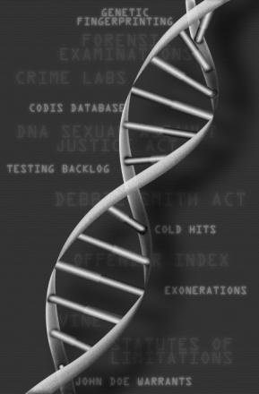
“The CSI Effect”-

Maximizing the Potential of Forensic DNA

Register today for this FREE training

December 4, 2013 * Seattle, Washington

The National Center is pleased to announce a free training opportunity. We are offering a one-day training on forensic DNA called “The CSI Effect” - Maximizing the Potential of Forensic DNA on December 4, 2013, in Seattle Washington.
Hear from the nation’s leading experts in forensic DNA, including a cold case detective, a retired New York City Homicide investigator, two survivors/advocates, and scientific and public policy experts. We will discuss the CODIS database; arrestee DNA testing; best practices for working cold cases; using DNA in missing persons and trafficking cases; crime scene evidence collection and Touch DNA; and innovations in the criminal justice use of DNA such as familial searching and rapid DNA testing.
More information and register at victimsofcrime.org/dna
Contact: Ilse Knecht, iknecht@ncvc.org
Phone: 646.620.5270
Location: Doubletree by Hilton Seattle Airport
18740 International Blvd.
Seattle, WA
206-246-8600
Thank you to our funder, Life Technologies Inc., for supporting our work
on victims and forensic DNA!

Follow us on Twitter: @DNA_Answers

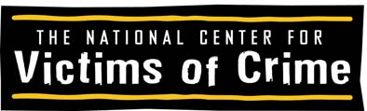

“The CSI Effect”: Maximizing the Potential of Forensic DNA
December 4, 2013 * Seattle, Washington
Agenda

Time | Activity | Speakers
7:30 | Registration
8:30 | Welcome | Ilse Knecht, Deputy Director, Public Policy, National Center for Victims of Crime
8:45 | Katie’s Law: Preventing Crimes and Saving Lives with Arrestee DNA Databases | Jayann Sepich, Survivor and Advocate, DNASaves.org
9:15 | Charissa’s Story ─Washington State Preventable Crime | Charissa, Rape Survivor
9:30 | Washington State Arrestee DNA Initiative | Guest Speaker
9:45 | CODIS Overview, Policy Update, and Funding News | Lisa Hurst, Consultant, Gordon Thomas Honeywell Governmental Affairs
10:30 | Break
10:45 | A Detective’s Perspective: Innovations in Law Enforcement Use of DNA | Joe Blozis, Retired Detective, New York City Police Department.
12:30 | Lunch and ParaDNA demonstration
1:30 | A Prosecutor’s Perspective: Making the Most of DNA Evidence | Mitchell Morrissey, District Attorney, Denver, Colorado
2:30 | The Green River Killer | Sergeant Katie Larson  Internal Investigations Unit/King County Sheriff's Office
3:30 | Break
3:45 | The Big Picture: Maximizing the Potential of DNA Technology | Chris Asplen, Asplen and Associates, LLC
4:45 | Wrap-up and adjourn

