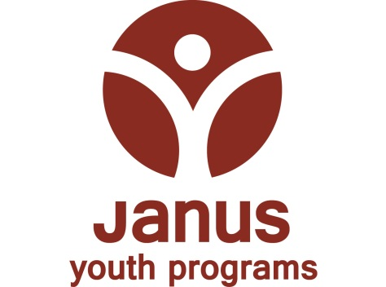

POSITION ANNOUNCEMENT – PLEASE POST

Residential Counselor – Athena House -
30+ hours per week, schedule not yet determined but could include days/swings and week-end hours

January 16, 2015

Position Summary:
The Residential Counselor oversees the day-to-day operation of Athena House, a shelter serving youth identified as commercially sexually exploited children between the ages of 14 and 21 in a coed facility. The position provides individualized youth care, planning, supervision of daily routine, individual and group counseling, crisis intervention, and close intensive supervision of clients. The Residential Counselor will work closely with community service providers such as Life Works Northwest, the Sexual Assault Resource Center and the Department of Human Services to provide wrap around services to youth. This program operates 24-hours per day, 365 days per year.

Education and Experience Requirements:
A typical background for the person who can fulfill the duties of this position is as follows:

- Experience in a mental health/case management setting working with adolescents and previous experience/knowledge of the issues impacting youth who have been sexually exploited. Preference for those who have personal or professional experience with exploitation.
- Prior experience working with adolescents in a residential treatment setting preferred.
- Advanced education, training, and experience are preferred to effectively conduct the responsibilities of the position.

We consider education, training, experience and demonstrated skills, and preference may be extended to current employees of Janus Youth Programs, Inc.

Required Knowledge, Skills and Abilities:
- Must value working in a multicultural/diverse environment.
- Ability to work effectively in the following areas: Cultural diversity: team-dependent models; crisis management; systemic theory; strength based theoretical orientation; adolescent development; and family reunification. Ability to work effectively may be demonstrated through academic experience, job experience, references, and interview answers.
- Extensive exercise of independent and team coordinated discretion and judgment.
- Ability to work effectively as a team member and within a team-dependent environment.
- Openness to feedback and supervision.
- Ability to climb at least two flights of stairs.
- Ability to walk at least one mile in order to accompany youth on outings.
- Ability to accurately read, record, and interpret information.
- Ability to communicate effectively, both orally and in writing.
- Ability to provide visual and auditory supervision of clients.
- Ability to stay calm, alert, and emotionally available in an environment serving adolescents.
- Ability to perform and/or supervise routine household task (cleaning, cooking, emptying trash)
- Ability to exercise tact, discretion & judgment in working with a variety of people.
- Ability to maintain appropriate professional boundaries in working with others and in handling confidential information.
- Ability to stay awake and alert throughout assigned shift.
- Ability to regularly attend scheduled shifts and meetings, be punctual for all shifts and meetings, and be in a condition suitable for assuming the responsibilities of the position.
- Manual/physical dexterity allowing for performance of routine office and household tasks, such as phone use, computer use, faxing, copying, filing, bending, lifting, etc.

Other Requirements:
- Drives agency van and/or personal vehicle to transport clients is required. If driving a personal vehicle for work purposes must have and maintain valid driver’s license for state of residency, personal auto liability coverage ($100,000/$300,000 levels strongly recommended), and have a driving record meeting corporate driving requirements. All employees driving for work purposes, regardless of whether driving a personal or agency vehicle, must complete the agency’s driving approval process before driving.
- Blood borne Pathogens training is required on first day of employment.
- Provides emergency first-aid, as needed, and maintains a current standard first-aid/CPR certification. (note: must have before being alone with a youth or temporarily the only staff in charge of one or more youth)
- Must pass criminal history check.
- Obtain valid “Food Handler’s” card within 5 days of hire.

Salary/Benefits: Beginning salary is $10.25/hour; excellent benefits program including medical, dental, life & long-term disability insurance; EAP; 401(k) and paid time off. Benefit programs have varied eligibility waiting periods. Voluntary optional coverages are also available.

Application Process: Submit resume and cover letter to Andrea Siede, c/o Harry’s Mother, 738 NE Davis St., Portland, OR 97232 or e-mail to her at asiede@janusyouth.org. Position is open until filled.

WE VALUE DIVERSITY – EOE

Janus Youth Programs, Inc., 707 NE Couch Street, Portland, OR 97232
www.janusyouth.org

