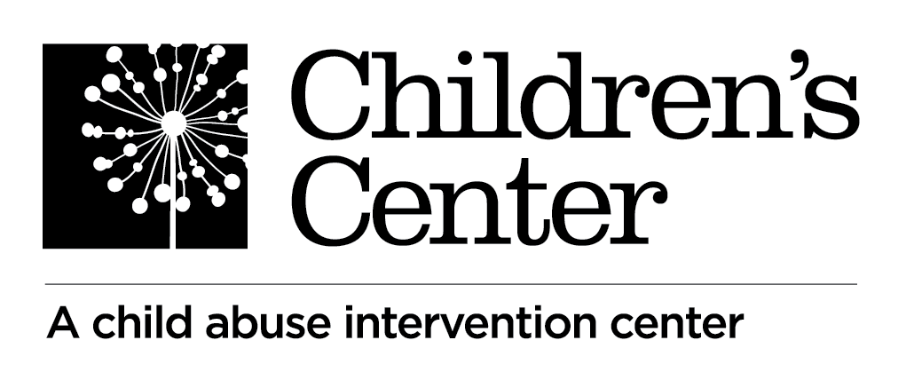

**Intake Specialist**

**OVERVIEW**

Children’s Center is a nonprofit child abuse intervention center that takes pride in uniting the community as champions for children and families in Clackamas County. We are seeking qualified candidates for the position of full-time **Intake Specialist**.

**JOB SUMMARY**

The Intake Specialist is responsible for triaging and processing referrals for assessments of children suspected of abuse or neglect. This position also participates in a multidisciplinary team approach to the evaluation of suspected child abuse by working in partnership with medical examiners, interviewers and local investigative agencies.

**Status:** Full-time, Exempt

**Reports to:** Family Support & Intake Supervisor

**Location:** Oregon City

**ESSENTIAL DUTIES AND RESPONSIBILITIES**

**Intake**

* Triage assessment referrals to determine appropriate action according to Children’s Center policies and protocols.
* Respond to requests for information and referral from community members, parents and other professionals.
* Complete all required documentation and reports.
* Gather appropriate documentation and information from parents/caregivers, law enforcement agencies, DHS and other parties needed to triage and schedule assessments.
* Schedule assessments and follow-up with all relevant professionals and parents regarding appointment times.
* Maintain Center statistics regarding services provided and intake demographics.
* Build and maintain positive and collaborative relationships with community partners.

**General**

* Keep informed of the latest child abuse issues.
* Receive continuing education related to child abuse issues, including specific training as requested.
* Participate in team meetings and case consultations.
* Testify in court, as necessary.
* Maintain punctual, regular and predictable attendance.
* Work collaboratively in a team environment with a spirit of cooperation. Develop and maintain positive working relationships at all levels of the organization that supports our customer-centered, caring and collaborative culture.
* Respectfully take direction from supervisor.
* Maintain confidentiality.
* Perform other job duties as assigned.

**REQUIREMENTS**

* Master’s degree in social work, counseling, psychology, sociology, child development or related field and minimum one year of applicable clinical experience; or equivalent combination of education and relevant experience required.
* Knowledge of child sexual abuse dynamics.
* Experience and skill in crisis management and information & referral services.
* Demonstrated proficiency in working with Microsoft Office suite applications including Word, Excel, and Outlook. Willing to learn other data management systems.
* Active listening skills.
* Excellent communication skills in English - reading, verbal, and written.
* Bi-lingual English/Spanish speaking skills preferred.
* Proven problem-solving and decision-making capabilities.
* Attention to detail.
* Discretion in handling confidential matters, tactful and diplomatic interpersonal skills.
* Customer service focus.

**PHYSICAL DEMANDS**

While performing the essential functions of the job, the employee is regularly required to use a phone, to sit, talk and hear, to see and use a computer, to use hands to feel and handle documentation and utilize standard office equipment. The employee is occasionally required to walk within the work area.

**Additional Information**

This position spends approximately 50 % of work time on the phone.

**COMPENSATION**

Children’s Center offers a competitive pay and benefits package including 95% paid medical, dental and vision insurance for employee; flexible spending account; retirement plan; EAP program, paid holidays and a generous paid time off policy.

**HOW TO APPLY**

Send your resume with cover letter to [HR@childrenscenter.cc](mailto:HR@childrenscenter.cc) by April 27th for immediate consideration. Include “Intake Specialist” in the subject line of your email.