**Starting June 12, OVC TTAC will deliver the National Victim Assistance Academy Effective Management Series, Succession Planning online, and we invite you to attend!** If you are interested, [please complete the **application**](https://ovcttac.wufoo.com/forms/effective-management-series-succession-planning/)**.**

The purpose of the training is to provide you with the knowledge and skills to identify and develop new leaders who can replace current leaders when they leave or retire.

The following are the training objectives:

* Define succession planning.
* Describe the different types of planning processes.
* Identify the key roles and responsibilities of stakeholders.
* Identify strategies to help guide your organization through transition and change.
* Generate a succession plan template for your organization.

**Training Schedule**

The training uses a blended-learning approach with a combination of self-paced online training and facilitated webinars. This training will occur over 3 weeks and include two webinars, each about 75 minutes long. In addition to participating in the webinars, you will be asked each week to complete assignments, read articles, or watch videos that complement the webinar topics.

**Introductory Week:** June 12 – 16. (There is no webinar. Participants are asked to engage in forums, watch a video, and complete and submit a worksheet.)

**Week 1: The Purpose of Succession Planning**. June 19 – 23. The facilitated webinar will take place on June 22 at 11:00 am (PT).

**Week 2: Preparing for Change**. June 26 – 30. The facilitated webinar will take place on June 29 at 11:00 am (PT).

If you are unable to attend the live webinar, you can listen to the webinar recording for that week.

**Training Instructor**

**Barbara Paradiso**

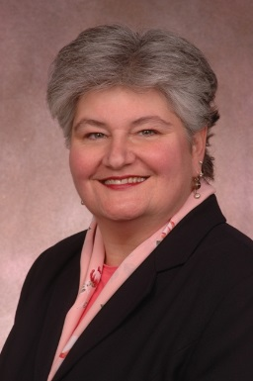Barbara Paradiso has worked on behalf of victims of domestic and sexual violence for more than 30 years as an advocate, administrator, and activist. She is the founder and director of the Center on Domestic Violence (Center) at the School of Public Affairs, University of Colorado Denver (CU Denver). Ms. Paradiso is responsible for the development and maintenance of a groundbreaking center for original research, service, and graduate level educational programming, the first of its kind in the nation, training individuals in interpersonal violence program management and public policy.