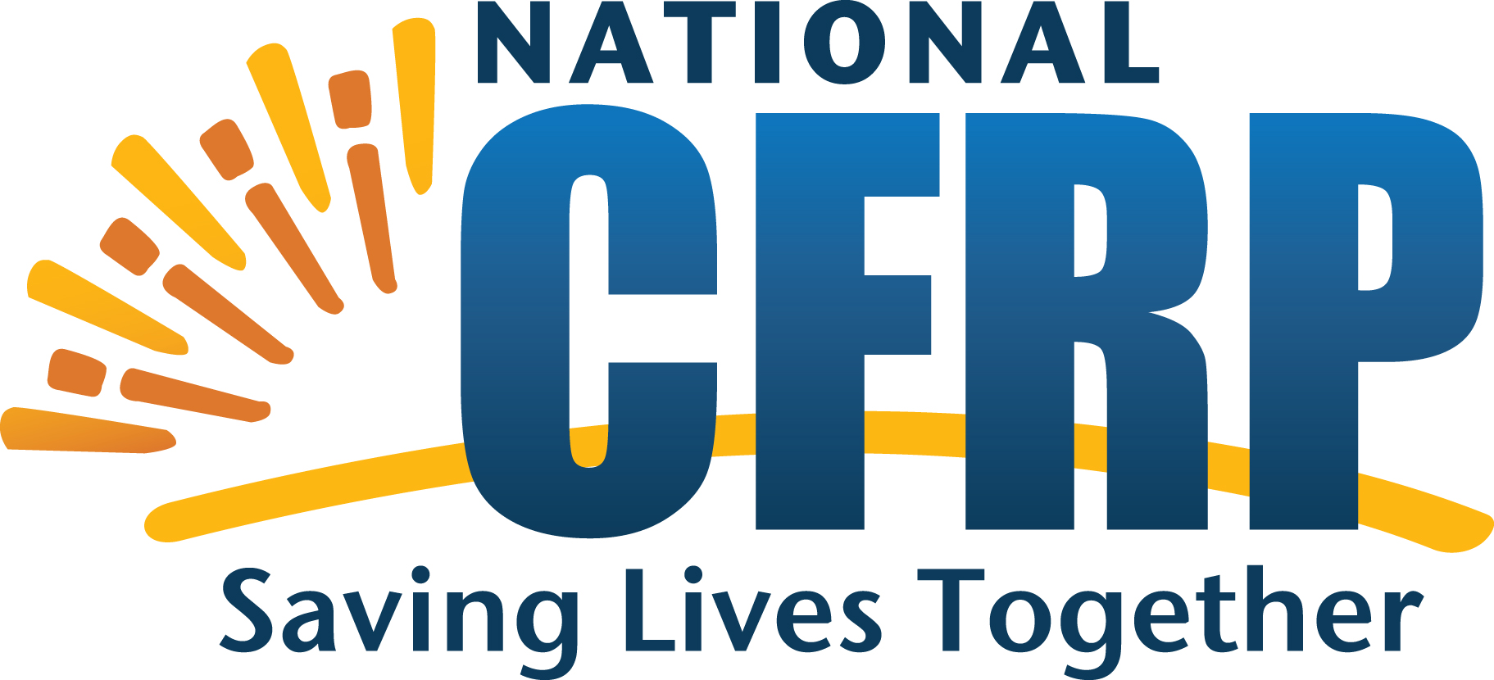
Register Now!
The National Center for Fatality Review and Prevention announces an upcoming Webinar on:
Improving our understanding of infants with substance exposure and Neonatal Abstinence Syndrome (NAS)

WHEN: October 31, 2017
2:00 p.m. – 3:00 p.m. ET

Webinar will be recorded and posted with the slides on the NCFRP website: www.ncfrp.org

Opening Remarks: Bethany Miller,* M.Ed., MSW, Health Resources and Services Administration
Director of Injury and Violence Prevention Programs, Division of Child, Adolescent and Family Health at U.S. HRSA, MCHB

Guest Speaker: Nancy K Young,* PhD, MSW, Executive Director, Children and Family Futures,
Nancy Young is the Executive Director of Children and Family Futures (CFF), a California-based research, evaluation and technical assistance institute whose mission is to improve safety, permanency, well-being and recovery outcomes for children, parents and families affected by trauma, substance use and mental disorders.
*More complete bios for Dr. Young and Ms. Miller are below.
Why attend: Have you wondered what the difference is between an infant born substance exposed and an infant born with neonatal abstinence syndrome (NAS)? Join Dr. Nancy K. Young for an interactive webinar that will cover the picture of opioid use disorders; substance use during pregnancy; the difference between NAS and substance exposure; best practices for collaboration and plans of safe care; and suggestions for what fatality review teams can do to address the needs of families affected by substance use disorders.
Who should attend: CDR and FIMR coordinators and team members, facilitators, abstractors, interviewers

To register: https://attendee.gotowebinar.com/register/3685145547865455362

SAVE THE DATE for our next webinar:

Effective intervention to support mothers and babies impacted by substance use
November 2017
Date and registration details to follow.

SPEAKERS

Dr. Nancy K. Young
Nancy Young is the Executive Director of Children and Family Futures (CFF), a California-based research and policy institute whose mission is to improve safety, permanency, well-being and recovery outcomes for children, parents and families affected by trauma, substance use and mental disorders. CFF operates a number of evaluation and technical assistance programs. Since 2002, she has served as the Director of the federally-funded National Center on Substance Abuse and Child Welfare and the Director of the Administration on Children and Families technical assistance program for the Regional Partnership Grants since 2007. In 2010, she began serving as the Director of the Office of Juvenile Justice and Delinquency Prevention’s technical assistance program for Family Drug Courts and the Statewide System Reform Program in 2014. She led the effort to create the foundation-funded Prevention and Family Recovery Program to implement evidence-based parenting and children’s intervention in family drug courts in 2013. In addition, Dr. Young has been involved in numerous projects related to public policy analysis, strategic planning and program evaluation through her work with these programs and serving as a consultant to various states, counties, tribes, communities and foundations on behalf of the children, parents and families affected by substance use and mental disorders involved in the child welfare and judicial systems. Dr. Young is a graduate of California State University Fullerton and received her M.S.W. and her Ph.D. from the University of Southern California, School of Social Work.

Bethany Miller, M.Ed., MSW
Bethany Miller is the Director of Injury and Violence Prevention Programs within the Division of Child, Adolescent and Family Health. Bethany comes to HRSA with nearly nine years of federal service at the Administration of Children and Families (ACF) and the Substance Abuse and Mental Health Services Administration. She has served as Project Officer over numerous discretionary grants, technical assistance contracts, and evaluation contracts in both the child welfare and children’s mental health arenas. Prior to federal service, Bethany spent the first eight years of her career as a clinical social worker in the greater Los Angeles metropolitan area. She received her Master of Social Welfare from the University of California, Los Angeles, and also has a Master of Education in Guidance and Counseling and a Bachelor of Science in Psychology, both from Virginia Commonwealth University.

