Please join us on November 1st to hear about Crime Victims’ Compensation (CVC) updates. We encourage anyone from a Child Advocacy Center (CAC) to attend. Please submit any questions you would like answered when you register.
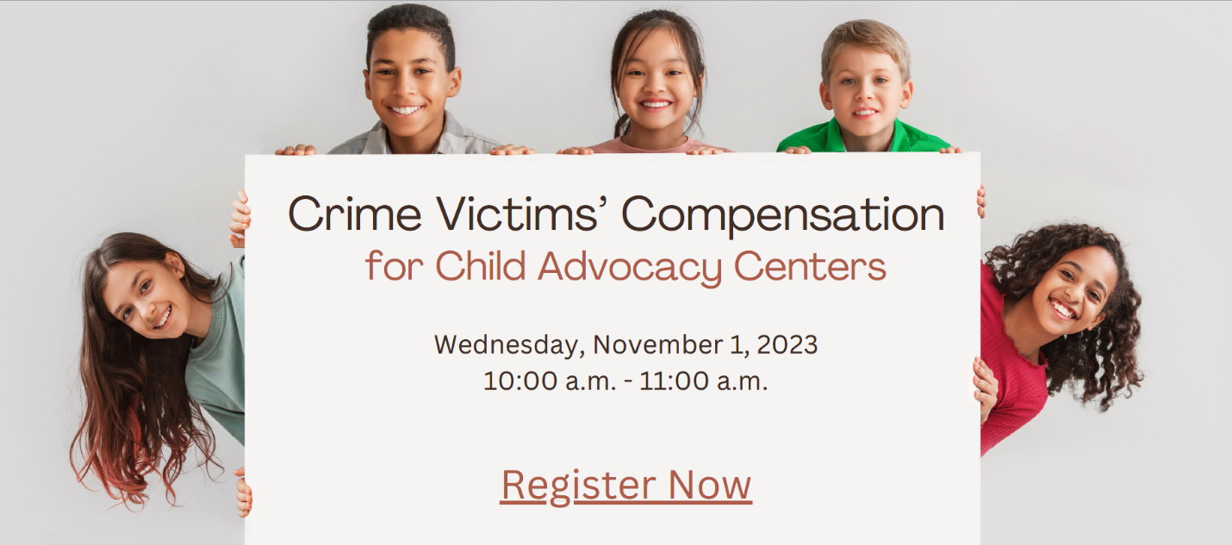
Registration Link
Please visit CVC’s website for additional information.
Link for Children’s Advocacy Centers and CVC’s webpage

