

News
April 2020
COVID-19

Healthcare Products and Services
The COVID-19 pandemic has stressed the MMCAP Infuse personal protective equipment (PPE) supply chain. PPE shortages are likely to continue for the next few weeks or possibly longer.

Our medical supply distributors are prioritizing their limited supply of PPE to front line hospital providers. If product does become available, a percentage will be allocated to existing customers based on the members’ historical purchases. New members or existing members who do not have a history of PPE purchases are unlikely to receive fulfillment of their PPE requests until the supply chain stabilizes.

MMCAP Infuse has been successful in adding the COVID-19 test kits to our existing contracts including:

- Concordance Healthcare
- Henry Schein Medical

Please review the MMCAP Infuse website which summarizes each of the COVID-19 test kit offerings. The ven- dor will need to confirm that the requesting facility is qualified under CLIA to conduct highly complex lab tests.

MMCAP Infuse is in daily contact with our distributor partners and routinely requests inventory status of PPE. Eventually the supply chain will stabilize, however, as hot spot infectious area of the country emerge, PPE sup- plies will be diverted by the federal government to those areas.

If you have questions and concerns, please contact the Healthcare Products and Services team.

Pharmaceutical Products
MMCAP Infuse continues to receive COVID-19 notifications from its contracted pharmaceutical manufacturers. These notifications range from supply reassurances to force majeure notifications. When specific products have been named, MMCAP Infuse has worked to add alternate manufacturers’ products to contract. As of late, manufacturers are notifying MMCAP Infuse of supply delays or shortages in products coming from India due to that country’s 21-day air and sea ban that began on March 25. MMCAP Infuse will continue to add alter- nate products to our contract during this time, but shortages could occur. Please note that these shortages will
eventually affect all pharmaceutical wholesalers and distributors unless India’s travel ban is lifted, as the Trump administration has requested. If you are having difficulty finding a product, please email MMCAP Infuse at MMCAP_Infuse.Contracts@state.mn.us.

Be Vigilant of Scams
Times of crisis can bring out the best in people. Unfortunately, it can also bring out the worst. As healthcare providers across the country scramble to secure PPE, the climate has become a breeding ground for scammers to try and profit by selling fraudulent or non-existent product.

In early April, 3M and Prestige Ameritech – two of the world’s biggest manufacturers of

1

Continued on Page 3

N95 masks – issued warnings regarding fraudulent products. CNN provided a full account of the claims, which extend further into the supply chain.’
From Page 1

These attempts aren’t, however, limited to PPE. The Federal Trade Commission website has listed advice on how to deal with everything from offers to sell COVID-19 vaccinations to soliciting donations to fielding calls and texts regarding federal stimulus money.

2
Continued on Page 4

Assistance with COVID-19 Response

Senior Account Executives
MMCAP Infuse Senior Account Executive (SAE) duties have been adjusted to align with the national
direction in response to the COVID-19 pandemic.

SAE responsibilities have shifted away from account management and in-person quarterly business reviews. SAEs are now spending most of their time assisting State Contacts with sourcing PPE, med- ical equipment, and supplies to meet member and patient needs during the COVID-19 pandemic. As our State Contacts explore alternative products and avenues of procurement, the SAEs are a valu- able resource and have demonstrated quick turnaround on inquiries with the MMCAP Infuse distrib- utors and contract managers. Additionally, they are implementing webinar training on our contracted products and services and are providing instructions on account set-up and purchasing from MMCAP Infuse contracts.

If you have requests or questions, please contact your Senior Account Executive as listed below.

Northwestern Region Kim Hankins kim.hankins@state.mn.us
Washington Oregon Idaho Montana Wyoming

As requested and/or remote coverage:
Alaska Hawaii

Vaccines

Vaccine Information, Pricing and Agreements
From Page 3

Vaccine Distribution (routine vaccine and influenza vaccine)
Vendor | Contract Number | Start Date | Expiration | Vendor Contact Information
FFF Enterprises, Inc. | MMS1900142 | 1/1/2020 | 12/31/2021 | Phone: 800.843.7477  Web: myfluvaccine.com
McKesson Medical-Surgical | MMS1900151 | 3/10/2020 | 12/31/2021 | Phone: 800.328.8111 (option 1) Web: mms.mckesson.com/portal/ index.mck

Influenza Vaccine Direct from Manufacturers
Vendor | Contract Number | Start Date | Expiration | Vendor Contact Information
GlaxoSmithKline | MMS17016 | 01/01/2018 | 12/31/2022 | Web orders only:  gskdirect.com
Sanofi Pasteur | MMS17019 | 01/03/2018 | 12/31/2020 | Phone: 800.822.2463  Web: vaccineshoppe.com
Seqirus USA Inc. | MMS16001 | 06/20/2016 | 05/30/2021 | Phone: 855.358.8966  Web: flu.seqirus.com

Contact the vendors directly to place your influenza vaccine prebooking orders.

To view the products and pricing, go to the MMCAP Infuse website and follow the link at the top of the page to the MMCAP Infuse legacy website. Log in and click on “Programs.” Under “What’s inside” click on “Influenza Prebooking & Pricing Information.”

The completed agreements are also posted on the MMCAP Infuse legacy website and can be accessed by clicking on the “Contracts” tab. Reminder: be sure to communicate to the vendors when placing your orders that you are an MMCAP Infuse member and want to be attached to MMCAP Infuse contract pricing.
Pharmaceutical Program

MMCAP Infuse Waste Contract Updates
MMCAP Infuse has a contract in place with Green Frontier Environmental Service, LLC – contract # MMS2000160 with an effective date of April 1, 2020.

This contract offers mail back disposal for Regulated Medical Waste and Sharps disposal across the conti- nental U.S. in a variety of container sizes. Each order will be personalized for the member location to ensure state-specific disposal regulations are met. Additional contract and account set-up information can be found on the “Contracts” page of the MMCAP Infuse legacy website.

As a reminder, the contract with Clean Harbors (contract # MMS14036) ended on March 31, 2020, for hazardous pharmaceutical waste disposal. Any member wishing to continue using this vendor will need to do so through a different relationship. MMCAP Infuse does offer pharmaceutical waste

3

disposal options with National Pharmaceutical Returns (contract # MMS1900131), although hazardous medi- cation disposal is limited to states that have adopted EPA Subpart P regulations.

Pharmacy Program Contracting Updates
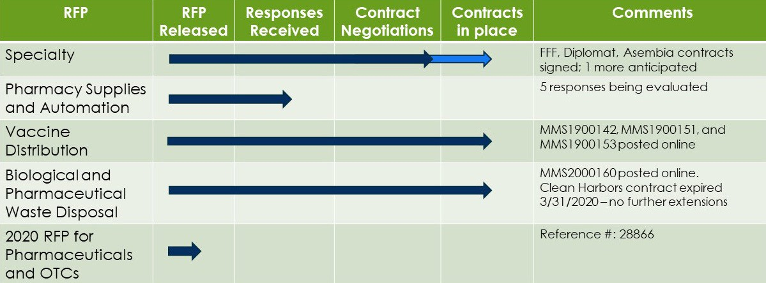
Pharmacy Distribution Services

Product Allocations
COVID-19 is disrupting the pharmaceutical supply chain, causing many products to be placed on allocation at the wholesalers’ distribution centers.

This means that your facility’s Average Monthly Usage (AMU) will be used to determine how much of the supply is available to your facility at the time you order. Unfilled quantities can be placed on backorder, to the extent of the allocation allowed.

Another avenue to see if your allocation can be changed is to reach out to your assigned wholesaler represen- tative, or to the wholesalers’ respective customer services lines. Each of the wholesalers are working diligently to provide as much product as they can in this time of need.

The MMCAP Infuse website has a list that can be downloaded to find your state’s specific wholesaler represen- tative.

To access this list:
- Click on Products and Solutions
- then Programs
- then Pharmacy
- and then Pharmaceutical Wholesaler
- Scroll down through to the Pharmaceutical Wholesaler Program Documents, to Wholesaler Account Management Contacts and click on the document entitled MMCAP Infuse Wholesaler Distribution Services Contacts March 2020

4

Continued on Page 7

From Page 5

Customer Service information:
Wholesaler – Customer Service | Phone | Email
Cardinal Health | 866.641.1199 | GMB-P_SPL_V_GOV@cardinalhealth.com

Cost of Goods (Service Fee Discounts) To be Updated for an effective date of
May 1, 2020
It is anticipated that updated Cost of Goods (COGs) files for each of the wholesalers will be posted the MMCAP Infuse legacy website prior to May 1, 2020. The updated COGs will go into effect on May 1, 2020, utilizing the service fee discount matrices found in Attachment C of each of the wholesaler contracts. The next COGs review will be in July (April, May and June sales) and will go into effect on August 1, 2020.
The updated COG information can be found on the MMCAP Infuse legacy website. To access:
- Follow the link in the upper right-hand corner of the MMCAP Infuse website
- Enter your username and password to log-in
- Click on “Member News,” then “MMCAP News,” then select “Pharmaceutical Wholesaler Cost of Goods” and click on the Wholesaler COG by Facility document that applies to your state

Look for the file showing an effective date 5-1-2020. For members’ convenience, both the current file and the prior quarter file are kept on the website. If you have any questions about the COG updates, feel free to reach out to Debra López-Burandt, Pharmacy Distribution Services Coordinator at 651.201.3053 or
debra.lopez-burandt@state.mn.us.

Pharmacy Distribution Services Staff
Last month we announced that the PDS staff has gained a new resource – Jason Hexom, CPhT, Pharmacy Distribution Services Assistant Coordinator. Jason has had a unique onboarding, amidst COVID-19 social dis- tancing requirements, Jason’s contact information is jason.hexom@state.mn.us or 651.201.3127.

Pharmaceutical Distribution Contracts
The old pharmaceutical distribution services contracts have been removed from the MMCAP Infuse legacy website. If a member needs access to the old contract series MMS15XXX, please let Kim Hankins 503 999-5013 or kim.hankins@state.mn.us

The new contracts are:
Wholesaler | Contract
Cardinal Health | MMS1900113

Wholesaler Generics Programs
Cardinal Health: the contracts that will be considered to be “on-contract” are:

- MMCAP (MMCAP Infuse Contract Products)
- GOVSRC; ACA; LTCBAC; LTCINJ (Wholesaler generic program products – 4 different product portfolios)

5

Continued on Page 8

Access-M will no longer be available for it was the designation for the “back-up” product items that were avail- able under prior contract.
From Page 6

Morris & Dickson: the contracts that will be considered to be “on-contract” are:
- G (MMCAP Infuse Contract Products)
- M (Wholesaler generic program products)

AmerisourceBergen: the contracts that will be considered to be “on-contract” are:
- MMST (MMCAP Infuse Contract Products)
- PRxO (Wholesaler generic program products)
For questions, contact Debra López-Burandt at 651.201.3053 or debra.lopez-burandt@state.mn.us.
DSCSA Information Corner
Link to FDA’s DSCSA web page

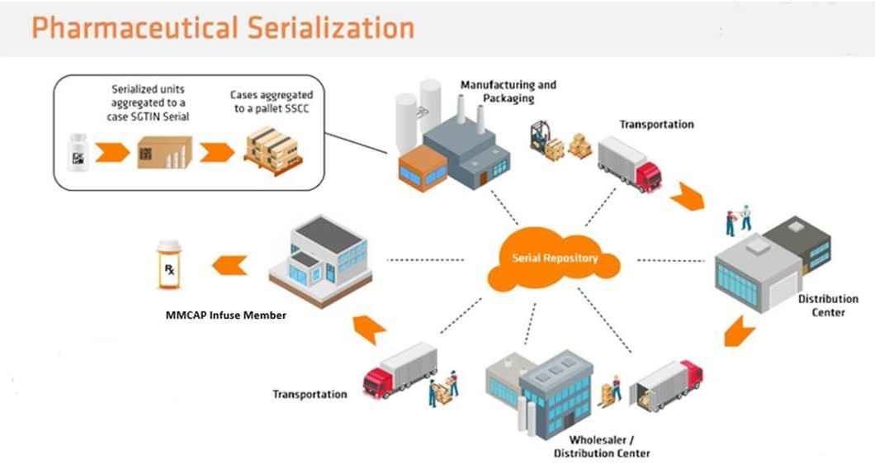
The pharmaceuticals currently being delivered to MMCAP Infuse members should arrive in package labeling containing a 2-D bar code. This 2-D barcode indicates the product is serialized at the unit level. While there is still some grandfathered product in the supply chain, primarily products placed into com- merce before November 27, 2018, exempted from serialization enforcement, serialized product should represent a greater share of what is being delivered by the wholesalers.

Last June, the FDA issued enforcement guidance on verifying returns, meaning that prior to a returned prod- uct being placed in the distribution center, returning the product back into the supply chain, the return must be verified to the originating source. While the industry was piloting some very promising solutions to verifying the returns, the industry prevailed in their case to the FDA that this effort was not ready to effectively move forward. While more efforts have been invested in serialized data repositories, time is ticking and unless some further enforcement discretion is granted, the industry will be expected to move forward with verifying returns in a bit over seven months.

The next DSCSA timeline requirement of November 27, 2020, is a focus on dispensers. As of that date, dis- pensers can only purchase product that is serialized, unless the product has grandfathered status. The only way to distinguish grandfathered product is to review the 3T Data, which will identify when the product went into commerce. If the 3T Data shows the product was placed into inventory before November 27, 2018, then the product is acceptable without a 2-D barcode. Facilities will need to update their Standard Operating Procedures (SOPs) to reflect the process to be used to validate grandfathered status of a product
received after November 27, 2020, if the product does not have a 2-D barcode. This will be auditable by the FDA through your facilities’ invoices, so it is recommended that changes to

6

7

your SOPs are made to ensure this does not become an audit finding.
From Page 7

To support MMCAP Infuse members regarding the storage of 3T Data and the accessing of 3T Data to respond to an FDA inquiry in the required 48 hour request time, MMCAP Infuse has two service subscription vendors with web-based solutions to allow members to consolidate all their 3T Data into one repository. In addition, should an MMCAP Infuse member transition from one wholesaler to another, this solution will allow for the storage of past 3T Data, and current 3T Data, providing a repository that can become the “one location” source to search and access the 3T Data in the event of an FDA inquiry.

DSCSA Solution Provider | Contract #
rfXcel | MMS18021
RxTransparent | MMS18022

If you have questions about these two service contract offerings, please feel free to contact Debra Lopez-Bu- randt at debra.lopez-burandt@state.mn.us or 651.201.3053.

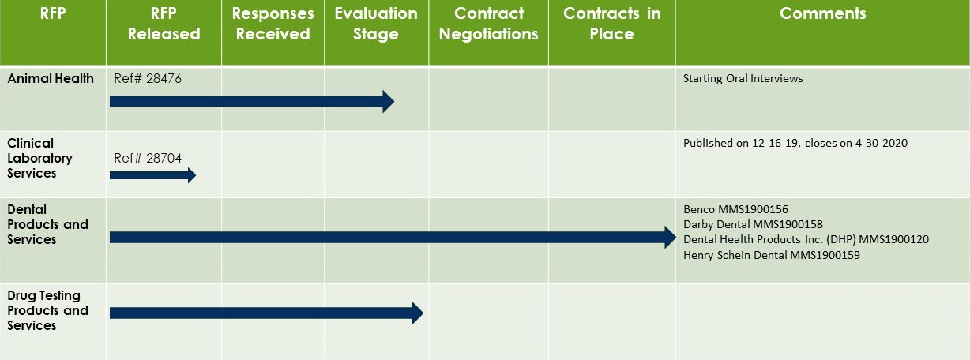
Healthcare Products and Services

