The following Abbott Nutrition products are low in inventory, as the manufacturer has prioritized the manufacturing of products in high demand. This largely applies to purchases directly from Abbott Nutrition. Members purchasing through a wholesaler/ distributor should work with them, as inventory levels may differ.

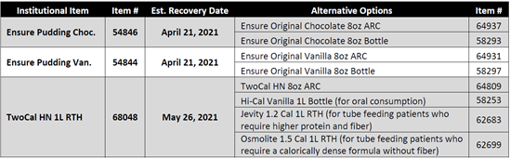

The use of tube feeding products must be determined by the healthcare professional. When patients need to change to a new formula, they should work with their healthcare professional to determine the best alternative product and transition plan.

Prior to being able to access MMCAP Infuse contract pricing on nutritionals with Abbott Nutrition, Members must complete a Letter of Participation for the corresponding contract they would like to access pricing for. Forms are available on the MMCAP Infuse website.

