**EE Plan Management**

**MyOEBB**

**EE Plan Management**

**Guide**

This MyOEBB feature makes it easy for entity administrators to manage yearly benefit plans. You’ll use this page to quickly renew existing plans and rate structures, or make the changes necessary to ensure smooth transition to new plans for the upcoming plan year.

# Navigating to EE Plan Management

After logging into MyOEBB, you’ll find the OEBB EE Plan Management page under the Plan Management section of the left-side navigation menu:

.

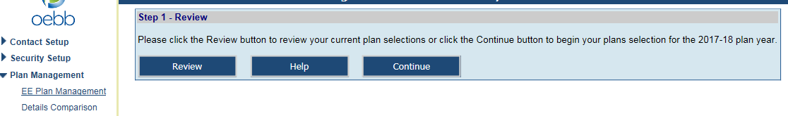

# Step 1: Review Plans

The first step is to click the Review_button button in Step 1.

You’ll see a list of all your current plan selections, organized by Member Type and Employment Type.

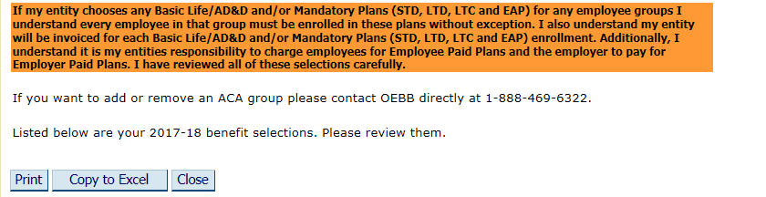

After reviewing the plans, click **Close**. This will take you back to Step 1. Click the **Continue** button.

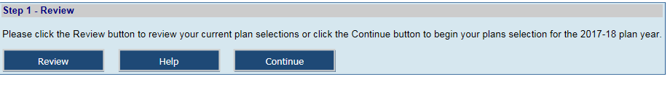

**Step 2: Employee Assistance Program (EAP) Selection**

You can choose one of three options for your entity. Select **“Yes”** and click on

**Continue.** If you do not choose to offer EAP, select **“No”.**



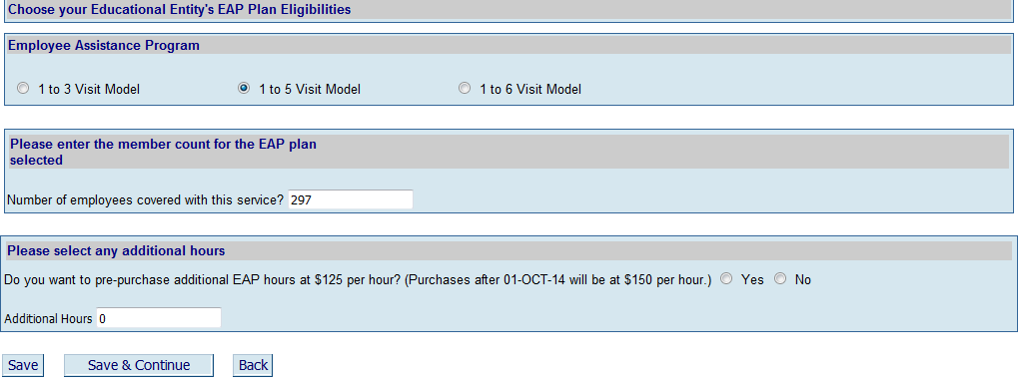

Check which option and then enter the amount of employees your entity will be covering with this service. You can choose to cover your entire MyOEBB benefit eligible employees only, or you can cover all your non-benefits eligible employees in addition to your benefit eligible employees. You can also choose to pre-purchase additional EAP hours for training sessions at your entity.

When you have finished click **Save & Continue.**

**Step 3: Plan Eligibilities for Active Full-Time Employees**

Start by making new plan eligibility selections for active full-time employees. All current OEBB rules and restrictions will be applied to your selections.

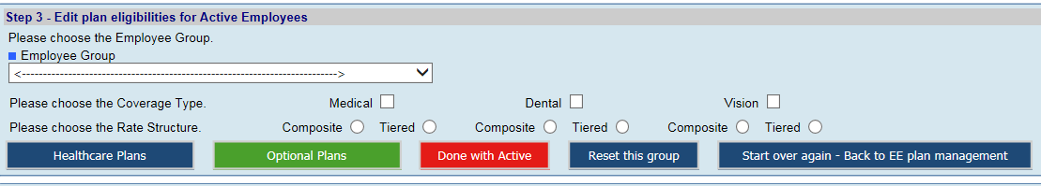

Select a Member Type/Employment Type combination for which to make changes. Click any Coverage Types you wish to change. Select any rate structure that will change for this combination. Then click the **Healthcare Plans** button.

(Note: selecting a change to composite rate structure from a tiered rate structure or vice versa will cause an additional screen to appear, making sure you are aware of the change you’re making, and that taking this action results in the termination of older plans for the upcoming plan year).

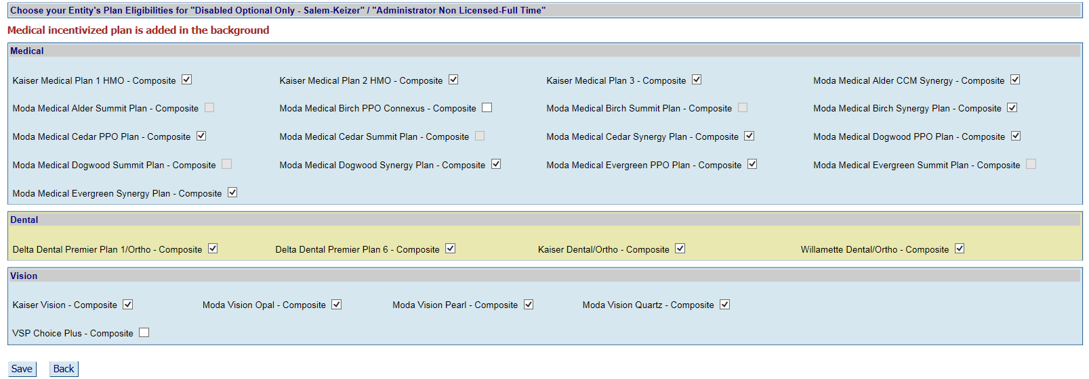

*Your current plans will have a check in the box.* Check boxes for any plans you choose to add or uncheck the box to remove. When you have finished, click **Save** at the bottom of the screen. You’ll see **Record Saved Successfully!** at the top left of the screen. Click Back_Button to return to the EE Plan Management page.

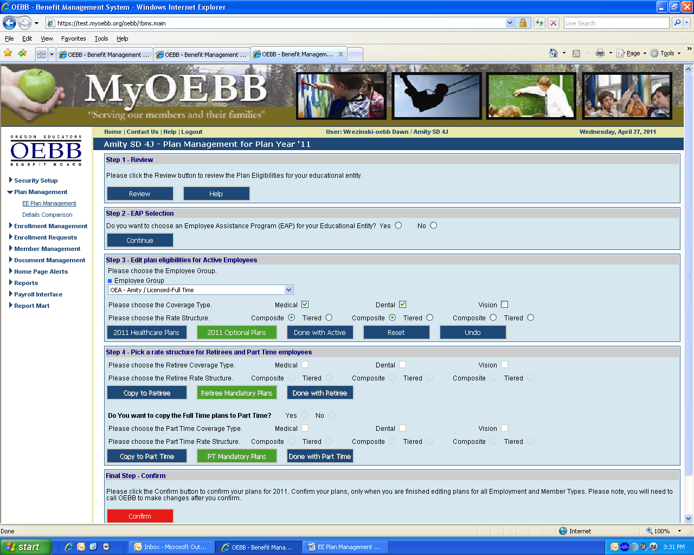

After each selection, you can click the **Review Plans/and or Confirm** button to see what changes you’ve saved thus far. Newly selected plans will appear in **blue type.** Plans that are no longer offered will appear in **red type** on the Review page.

Click on and make your selections. When you are finished with all plans for this full-time Employment Type/Member Type, click the  button and move back to Step 4 before selecting the next Employment Type/Member Type combination.

If you get confused or make mistakes when selecting plans, you can always click the  button and to clear the screen and start again.

If you saved changes and moved ahead to other steps, you can click the  button to revert back to previous years selections. As long as you have not confirmed changes in the Final Step, you can always start over.

# Step 4: Retirees, and Part-Time Employees

Making changes to plans and rate structures for retirees and part-time employees is similar to those for full-time, however with a one button click, you can copy the plans from the full-time selections and apply them to respective retiree and part-time plans.

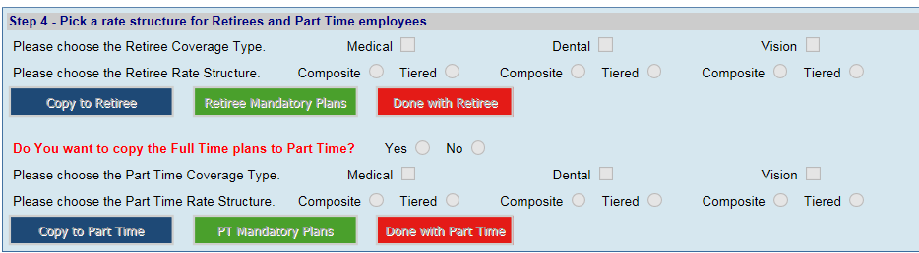

Retirees and part-time employees must have the same plans as the full-time active employees, but you do have the option to choose different *rate structures* for retirees and part-time employees. Select the same Coverage Type and same/different Rate Structure boxes as with the full-time selections. Then click. You will receive a dialog box as shown below confirming your request to copy plans and a confirmation that you plans were copied successfully.

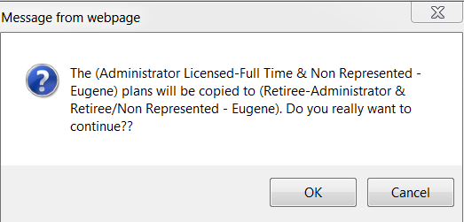

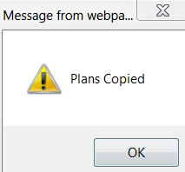

Click the button. Then repeat the same process for part-time employees.

Remember you must deliberately select **Optional Plans** for part-time employees, since these may or may not differ from the ones for full-time employees.

If your part-time benefit rate structures differ from the full-time selections, you can select a different rate structure for each, possibly add Optional Plans, and then click the  button.

If you do not have Part Time plans then select the **“No”** button to move to the next employment group in Step 3.

# Final Step: Confirming Your Plan Year Selections

Once you’ve made and saved all changes for all plans, it’s time to finalize your selections. Remember to use the **Review** button frequently throughout the process to examine the changes to your benefit program as a whole. You can use the  button in the full-time member section to revert to last year’s plans at any time, even if you’ve successfully “saved” one or more sets of changes in the interim.

**However: once you confirm all selections in the Final Step, you’re considered locked in for the plan year. You’ll have to call OEBB Administration for a reset of your selections.**

Click  at the bottom of the EE Plan Management page. Then, on the Review page that displays, click again. This will finalize your plans for the coming year.

# Questions?

If you have any additional questions or concerns, don’t hesitate to contact us by phone or email at 1-888-469-6322 or OEBB.benefits@state.or.us.