How to Run a List of your Agency’s Active Users

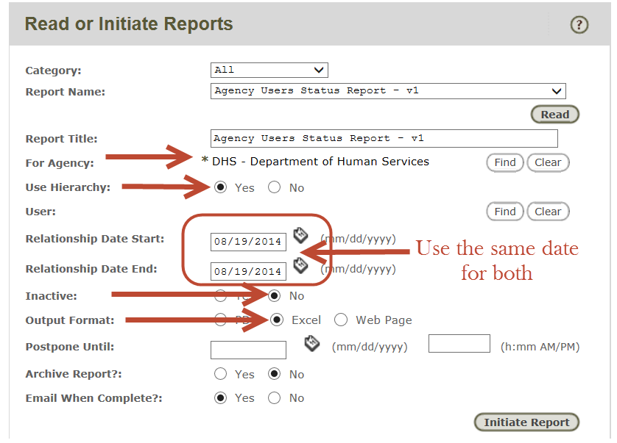

Instructions:
- Go to “Read/Initiate Reports” in the menu bar and select the “Agency Users Status Report – v1” report.
- Set the “For Agency” as the top level of your agency’s hierarchy.
- Set the “Use Hierarchy” button to Yes.
- Enter the same date in the “Relationship Date Start” and “Relationship Date End” fields. This will give you a ‘snapshot in time’ of your active users.
- Set the “Inactive” button to No so that the report will not include inactivated users.
- Set the “Output Format” to Excel.
- Click on Initiate Report!

