This is the Terms and Conditions page that suppliers must agree to when creating a supplier registration:
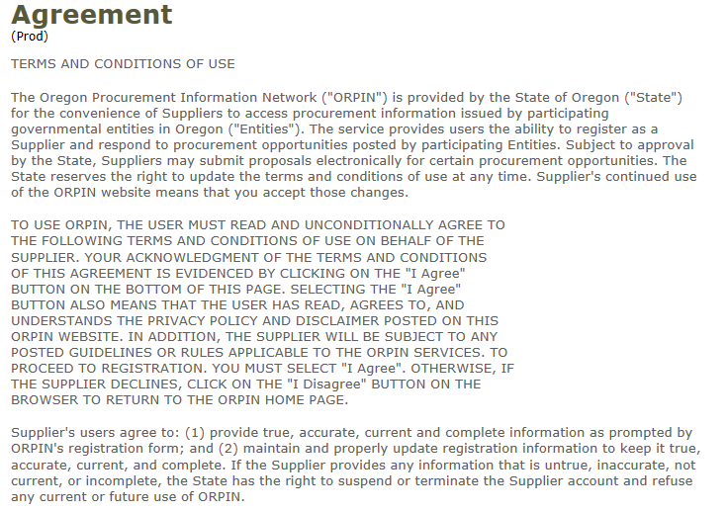
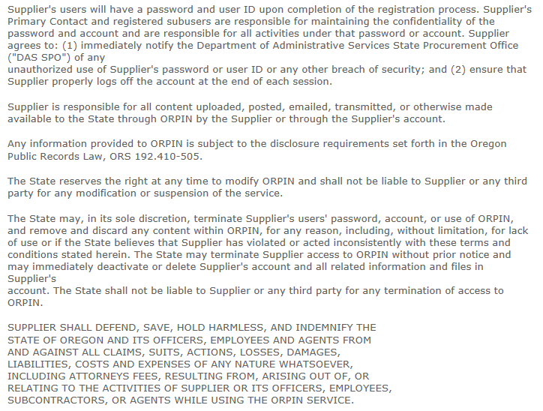
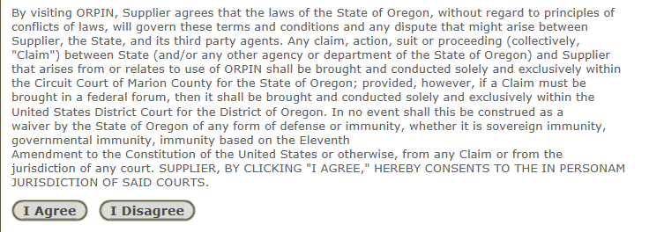

This is the Offeror Acknowledgement that suppliers must agree to when creating an Electronic Bid (eBid)
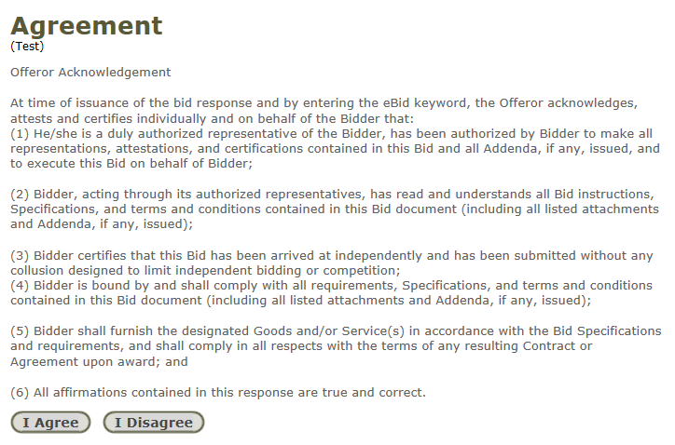

This is the Disclaimer language that is always available at the bottom of every page in ORPIN:

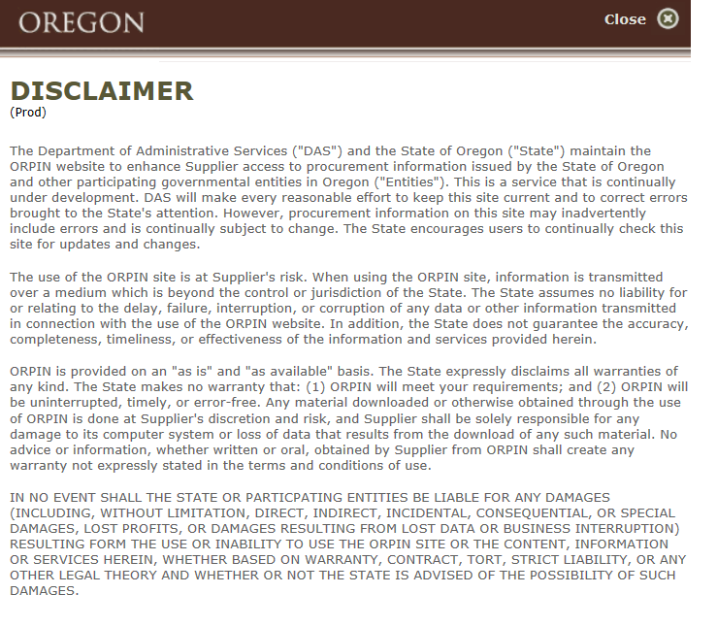

This is the Privacy Policy that is always available at the bottom of every page in ORPIN:
