Delegate Authority Tool:
If you have a user in your agency who will be unavailable to do work in the ORPIN system for a period of time, you can use the Delegate Authority tool to assign their tasks to someone else.

In my example below, I am designating my ORPIN work to Vicki Simonsen for the week of July 13th through July 17th. During that time, staff members won’t know that anything is different – they will continue selecting my name when assigning workflow steps. However the ORPIN system will actually assign it to Vicki in the background instead of me.

If a person assigning a workflow step to me in ORPIN checks the box to notify me via email of this workflow step, the system will send an email to me and an email to Vicki.

Also, if the user who will be filling in has a lower privilege level in ORPIN than the user they are filling in for, they will be temporarily given the ability to do the higher level workflow steps. This will only apply to tasks they receive via this Delegate tool.

Here is how to set it up. (Note: This option can only be turned on by an OAC or a System Administrator.)

- Pull up the account for the person who is going to be out of the office.
- On the Person Maintenance screen, click the Add/Edit button next to Delegated Authority.

- Click the “Find” button next to ‘Delegate’ to locate the person who will be taking over the work in this user’s absence.

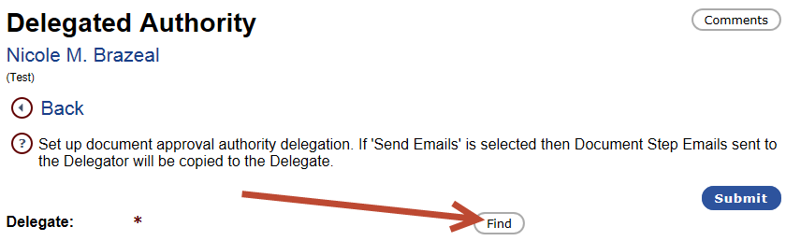

- Enter the Effective and Expiration dates that the delegation of duties should occur between. Also be sure that the Send Emails box is checked.

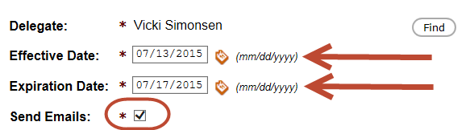

- Hit the Submit button at the top of the page to save.

