Proposed Change:
Update the Browse Award Results page for both internal users and suppliers to make it easier to understand the function of the tool and how to use it.

Details:
Currently there is a menu bar option called Browse Opportunity Notices and Results, and then underneath it are two selections: Browse Award Results and Browse Opportunity Notices.



The ORPIN upgrade we received in June beefed up the capabilities of the Browse Award Results tool so that there is no longer a need for both options. We propose removing the Browse Opportunity Notices page and changing the remaining label from ‘Browse Award Results’ to ‘View Opportunity Results’. Doing this means only one option will show for users in their menu bar.

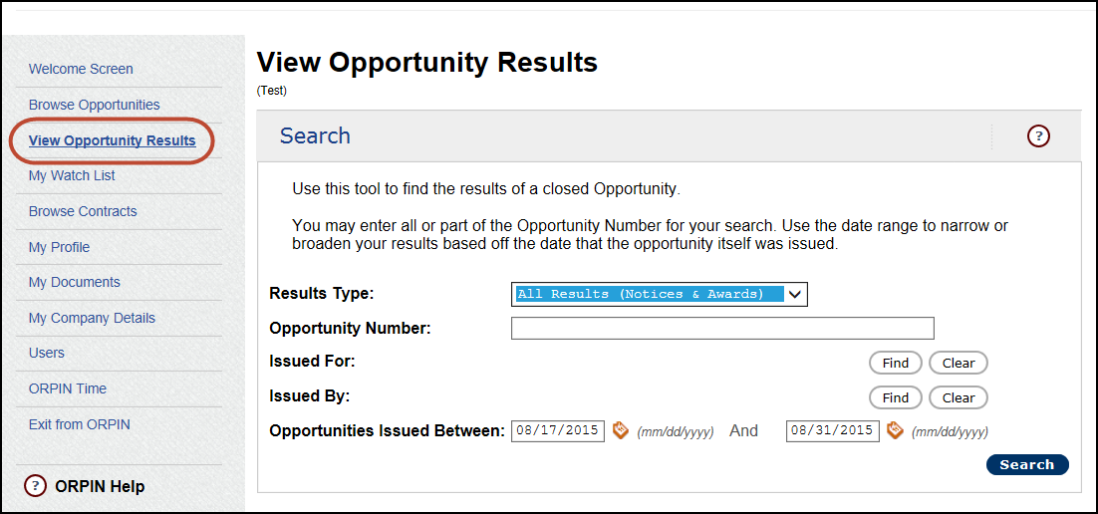

In addition, we would like to update the View Opportunity Results page itself as follows (see below).

Current View:

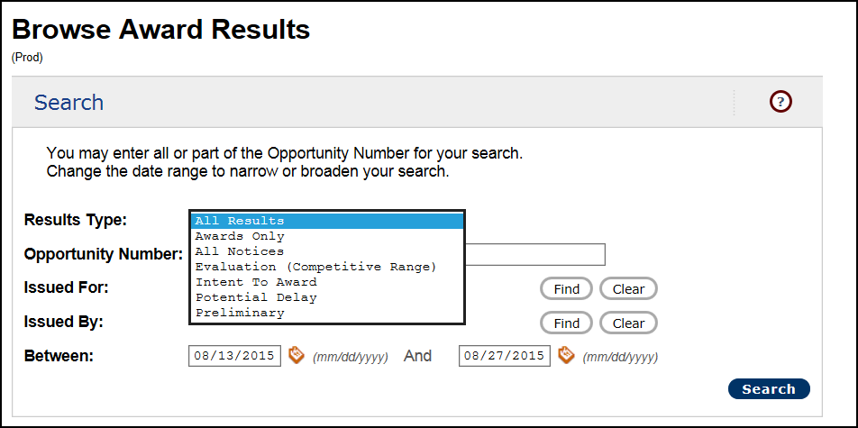

Proposed Updates.
- Change the title at the top (and in the menu bar)
- Update the text describing the tool
- Indent certain choices in the dropdown so that it is more apparent which options are the categories and which are individual folders
- Add text to the Between label at the bottom

