The Emergency Commodities Report provides a list of Suppliers with the selected Commodity in their profile.
- Click Reporting/Inquiry -> Read or Initiate Reports
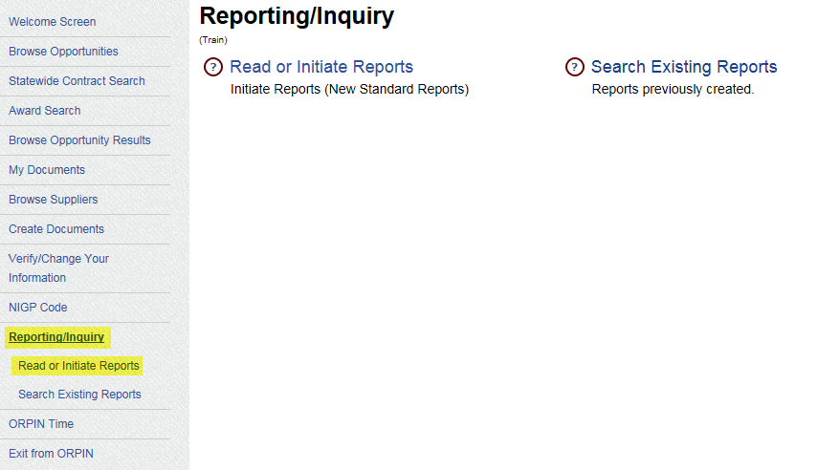
- Select the Report Name: Emergency Commodities Report
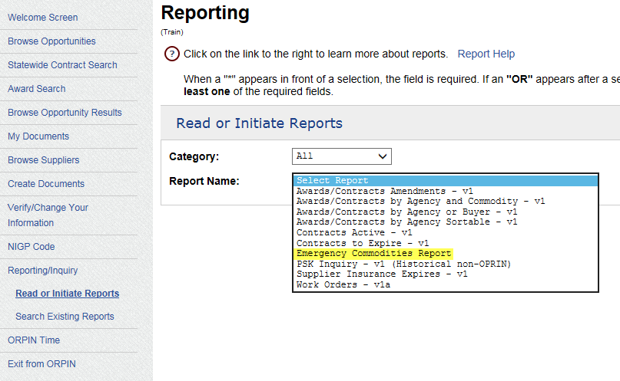

- Click Find
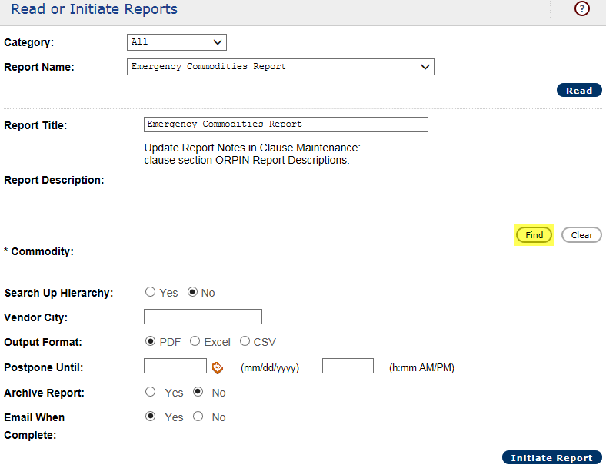

- Enter an Emergency Commodity Code from the provided list
- Click Search
- Check the box next to the found Commodity Code
- Click Return Selected
- Repeat Steps 4 – 8 to include other Emergency Commodities in this report
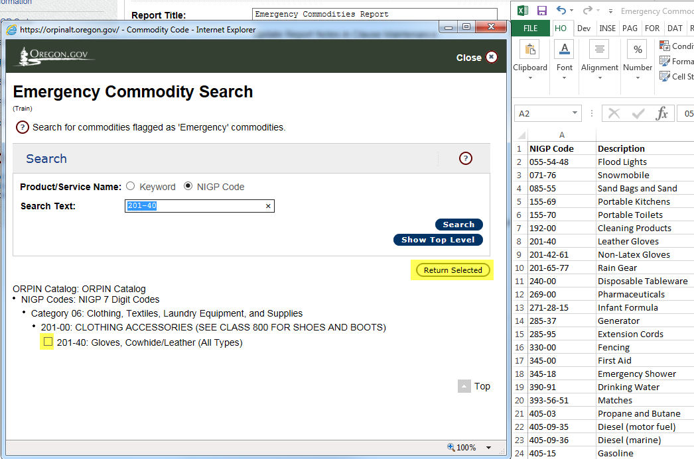

- Optional - Click Search Up Hierarchy: Yes to include Suppliers with any of the commodities in the hierarchy selected in their profile
  - In this example that would include Category 6 and 201-00
- Optional - Enter a Vendor City to limit the results to vendors with that city in their profile (not recommended)
- Optional - Enter a Date/Time to generate the report sometime in the future
- Click Output Format: Excel (recommended)
- If Email When Complete is set to Yes, ORPIN will send an email when the report is ready to download
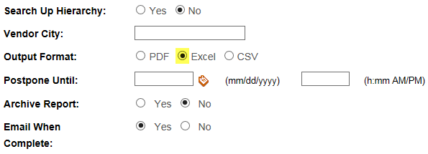
- Click Initiate Report to generate the report
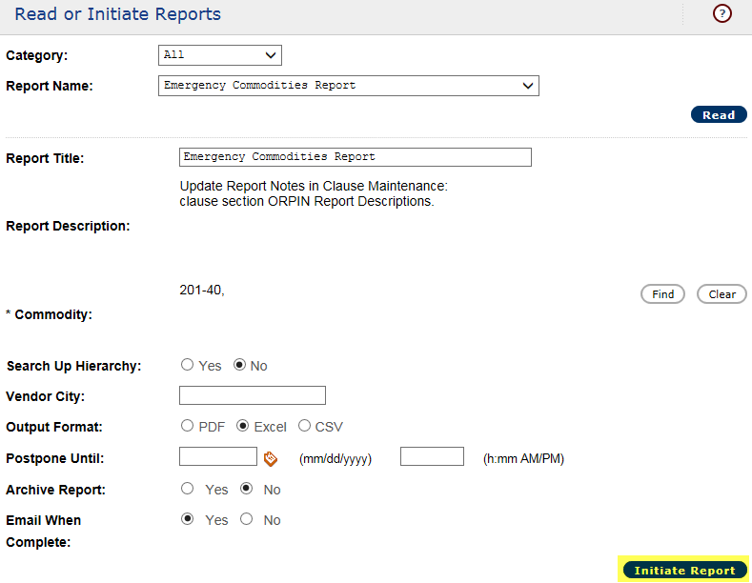

- Pending status means it is in the queue to be generated
- Active status means that the report is currently being generated
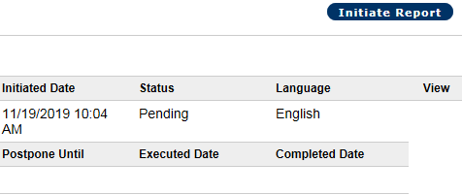
- Complete status means that the report is ready to be downloaded
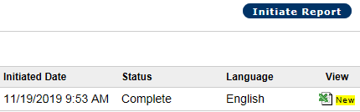
- Click the icon under View to download your report

