Oregon Department of Transportation
Human Resources
355 Capitol St. NE
Salem, Oregon 97301
(503) 986-3840

February, 2009

RE: Right of Way Issues for Local Agencies and Consultants

ODOT has scheduled a training session of “Right of Way Issues for Local Agencies and Consultants” training. The purpose of this training is to improve the knowledge base of local agencies and consultants regarding right of way acquisition process and laws. A more detailed description of the course is on the next page of this letter.
The class is scheduled for March 17th in Salem. Class hours are 9 a.m. to 4:30 p.m. Lunch, refreshments, and class materials will be provided.
The fee for the training is $45. The fee must be paid prior to taking the class. VISA, Master Charge Cards, and checks will be accepted for payment. NO PURCHASE ORDERS WILL BE ACCEPTED. (See the registration form for instructions and information.) PLEASE NOTE CANCELLATION POLICY: You must cancel at least 11 working days prior to the workshop. No refund will be made when cancellation occurs with 10 working days or less remaining before the workshop.
To register for the training, please complete the enclosed application and return to this office.
If you need more information, please feel free to contact me at the telephone number listed below.

Sincerely,
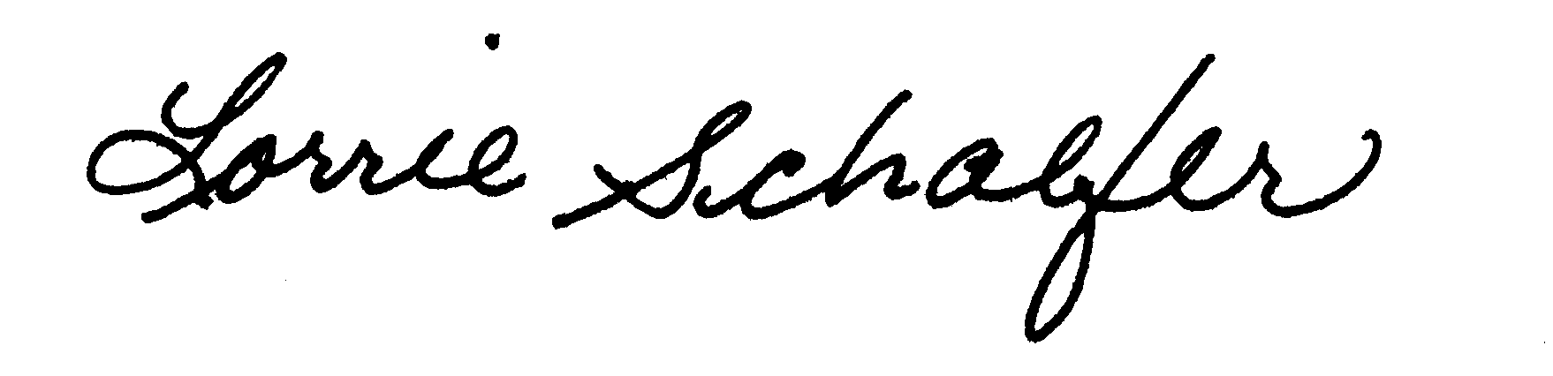
Lorrie Schaefer, Senior Training Consultant
Human Resources
Telephone: 503-986-3840
E-mail: lorrie.l.schaefer@odot.state.or.us

For a listing of other Training Opportunities, visit the Training at ODOT website at: http://www.oregon.gov/ODOT/CS/Training/index.shtml .

RIGHT OF WAY ISSUES FOR LOCAL AGENCIES AND CONSULTANTS
PURPOSE
The purpose of this training is to improve the knowledge base of local agencies and consultants regarding right of way acquisition process and laws.
LEARNING OUTCOMES
The participant will be able to:
- Explain roles and responsibilities in the right of way acquisition process, and
- Recognize process timelines and important milestones.
TOPICS
- Basic right of way laws
- FHWA involvement
- Timelines and milestones
- Appraisal, Negotiations, Condemnation, Acquisition
PREREQUISITES
None
DESIGNED FOR
Local agency and consultant staff involved in the disposition of right of way within the public domain. ODOT staff may attend.
Right Of Way Issues For Local Agencies And Consultants
Registration Form

Check here to be
Location and Date wait listed if class is full.
CCC Winema Place - Salem March 17, 2009
PERSON INFORMATION
(ODOT employees have the option of signing up online at:
(http://s-salemrev-69/stc/student/psciis.dll?class=student&loc=0000056156 http://www.oregon.gov/ODOT/CS/HR/)
Name:
Current Position:
Agency/Company:
ODOT Crew # (if app.)
Telephone Number:
E-mail Address:
Mailing Address:
City/State/Zip Code
ODOT employee registration note: Your crew will be charged after attendance
FEE: $45

PAYMENT TYPE
Check a box to indicate the type of payment you are submitting for the transaction:

CREDIT CARD
You may either submit your credit card information on this application or by telephone. If credit card information will be provided over the telephone, please provide us with the name of the person to contact and their telephone number. They will be called when we actually enroll the applicant.

VISA Master Card Credit Card Number:

Expiration Date:

Name of Card Holder
(as it appears on the card)
Please call for credit card information:
Contact Name: Telephone number:

SENDING CHECK
If you are paying by check, please make checks payable to Oregon Department of Transportation. To ensure your seat in the training class in a timely manner, FAX or E-mail a copy of the registration form to us before you send the check. Send the check payment to: Lorrie Schaefer, ODOT, 355 Capitol St. NE Room 102, Salem, Oregon 97301. Include a copy of the completed application form with the payment.
See next page for return information.

RETURN INFORMATION
Please return this registration form to ODOT:
By mail, send to: Lorrie Schaefer, ODOT, 355 Capitol Street NE, Room 102, Salem, Oregon 97301
By FAX: Attn: Lorrie Schaefer at 503-986-3895
By E-mail: ODOT.HR.Training@odot.state.or.us .

