Oregon Department of Transportation
Human Resources
355 Capitol St. NE
Salem, Oregon 97301
(503) 986-3840

January, 2009

RE: 2009 ODOT Surveyors Conference

ODOT is sponsoring “2009 ODOT Surveyors Conference.” The purpose of the Surveyors Conference is to keep highway surveyors informed and educated on current and best management practices, new policies, procedures and specifications.
The conference is scheduled for March 17 – 19, 2009. Hours are 8:00 a.m. to 5:00 p.m. each day. Location for the conference is Chemeketa Community College’s Eola Center in Salem, Oregon.
The fee for the conference is $75. The fee must be paid prior to attending the conference. VISA, Master Charge Cards, and checks will be accepted for payment. NO PURCHASE ORDERS WILL BE ACCEPTED. (See the registration form for instructions and information.) PLEASE NOTE CANCELLATION POLICY: You must cancel at least 11 working days prior to the conference. No refund will be made when cancellation occurs with 10 working days or less remaining before the conference.
There are a limited number of seats available for the conference. Conference registration closes on February 27th. To ensure a seat in the conference, send in your registration as soon as possible. Confirmation of enrollment will be sent out on March 10th. To register, complete the enclosed registration form and return it to ODOT’s Human Resources. (See the registration form for more information.)
Please contact me if you need additional information about the conference or registering.
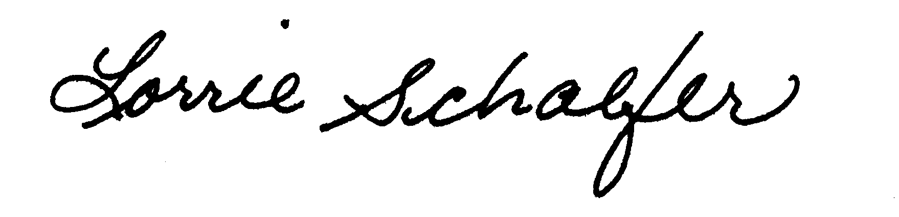
Lorrie Schaefer, Senior Training Consultant
Human Resources
Oregon Department of Transportation
503-986-3840
lorrie.l.schaefer@state.or.us
Enc.
For a listing of other Training Opportunities, visit the Training at ODOT website at: http://www.oregon.gov/ODOT/CS/Training/index.shtml .

2009 ODOT Surveyors Conference
The purpose of the Surveyors Conference is to keep highway surveyors informed and educated on current and best management practices, new policies, procedures and specifications.
TOPICS
- Digital Signatures (Signing Final Documents as Surveyors)
- The Bridges of Conde B. McCullough
- Solar Panels on the ROW
- Pioneer Mtn/ Eddyville Project
- Accessing Image Products from Oregon Image Portal, et al
- Traffic Signals from a Surveyor's Perspective
- Pole Truck Tracking
- How Did Our Highways Get Here?
- Accommodating Alternate Fuel Funding Mechanisms
- National Integrated Land System
- Geographic Coordinate Data Base for Surveyors
- Scanning (New Scanner)
- Hydrographic Surveys
- You Asked for it
PREREQUISITES
You must be a practicing surveyor.
DESIGNED FOR
Field Engineering Employees.
PROFESSIONAL DEVELOPMENT HOURS
ODOT Surveyors Conference - 2009 will satisfy 22 of the Professional Development Hours required by the Oregon State Board of Examiners for Engineering and Land Surveying (OSBEELS) to renew a Professional Land Surveyor (PLS) License.
2009 ODOT Surveyors Conference
Registration Form
March 17-19, 2009

Please register the following person for this training:

PERSON INFORMATION
Name:
Company/Agency:
Current Position:
Telephone Number:
FAX Number:
E-mail Address:
Mailing Address:
City/State/Zip Code

FEE: $75

PAYMENT TYPE
Check a box to indicate the type of payment you are submitting for the transaction:

CREDIT CARD
You may either submit your credit card information on this application or by telephone. If credit card information will be provided over the telephone, please provide us with the name of the person to contact and their telephone number. They will be called when we actually enroll the applicant.

VISA Master Card Credit Card Number:

Expiration Date:

Name of Card Holder
(as it appears on the card)
Please call for credit card information:
Contact Name: Telephone number:

SENDING CHECK
If you are paying by check, please make checks payable to Oregon Department of Transportation. To ensure your seat in the training class in a timely manner, FAX or E-mail a copy of the registration form to us before you send the check. Send the check payment to: Lorrie Schaefer, ODOT, 355 Capitol St. NE Room 102, Salem, Oregon 97301. Include a copy of the completed application form with the payment.
See next page for return information.

RETURN INFORMATION
Please return this registration form to ODOT:
By mail, send to: Lorrie Schaefer, ODOT, 355 Capitol Street NE, Room 102, Salem, Oregon 97301
By FAX: Attn: Lorrie Schaefer at 503-986-3895
By E-mail: ODOT.HR.Training@odot.state.or.us .

