MyOEBB EE Plan Management
Guide

EE Plan Management

This MyOEBB feature makes it easier for entity administrators to manage yearly benefit plans. You’ll use this page to quickly renew existing plans and rate structures, or make the changes necessary to ensure smooth transition to new plans for the upcoming plan year.

Navigating to EE Plan Management
After logging into MyOEBB, you’ll find the OEBB EE Plan Management page under the Plan Management section of the left-side navigation menu:
.
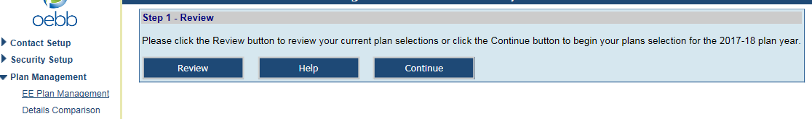

Step 1: Review Plans

The first step is to click the button in Step 1.

You’ll see a list of all your current plan selections, organized by Member Type and Employment Type.

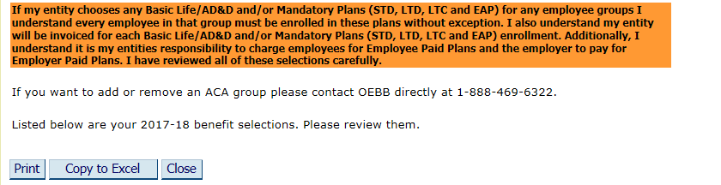

After reviewing the plans, click Close. This will take you back to Step 1. Click the Continue button.
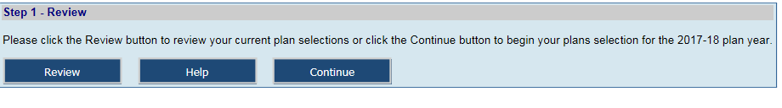

Step 2: Employee Assistance Program (EAP) Selection

Your entity can choose from three options for your educational entity. Select “Yes” and click on
Continue. If you do not choose to offer EAP, select “No”.

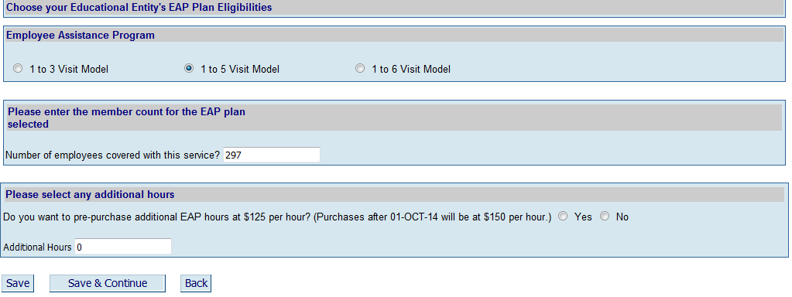

Check which plan and then enter the amount of employees your educational entity will be covering with this service. You can choose to cover your entire MyOEBB benefit eligible employees or you can also cover all your non-benefits eligible employees. You can also choose to pre-purchase additional EAP hours for training sessions at your entity.

When you have finished click Save & Continue.

Step 3: Plan Eligibilities for Active Full-Time Employees

Start by making new plan eligibility selections for active full-time employees. All current OEBB rules and restrictions will be applied to your selections.

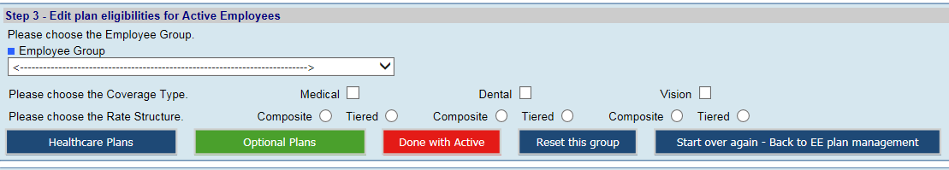

Select a Member Type/Employment Type combination for which to make changes. Click any Coverage Types you wish to change. Select any rate structure that will change for this combination. Then click the Healthcare Plans button.

(Note: selecting a change to composite rate structure from a tiered rate structure or vice versa will cause an additional screen to appear, making sure you are aware of the change you’re making, and that taking this action results in the termination of older plans for the upcoming plan year).
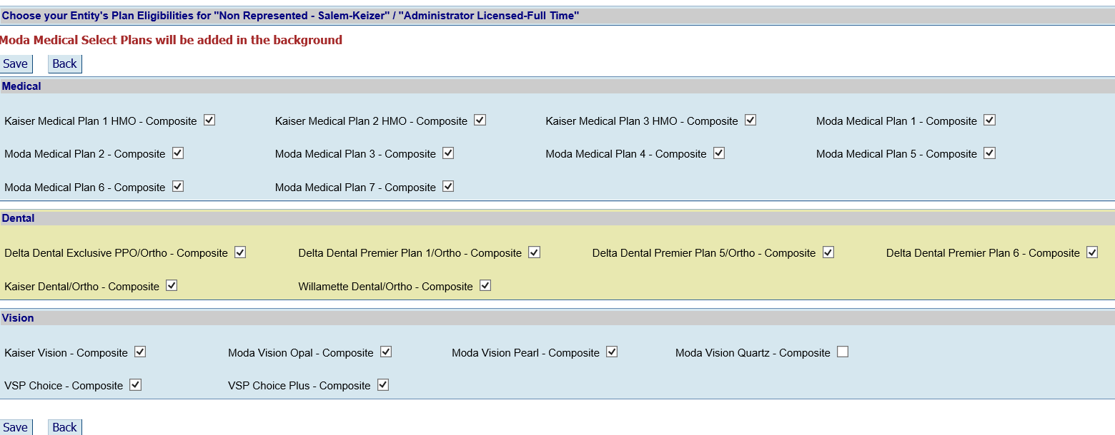

Your current plans will have a check in the box. Check boxes for any plans you choose to add or uncheck the box to remove. When you have finished, click Save at the bottom of the screen. You’ll see Record Saved Successfully! at the top left of the screen. Click to return to the EE Plan Management page.

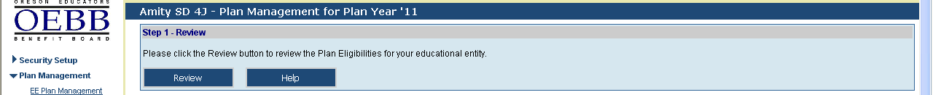

After each selection, you can click the use the Review Plans/and or Confirm button to see what changes you’ve saved thus far. Newly selected plans will appear in blue type. Plans that are no longer offered will appear in red type on the Review page.

Select optional plans the same way as you did for Medical, Dental or Vision Plans. When you have finished with all plans for this full-time Employment Type/Member Type, click the button and move back to Step 3 before selecting the next Employment Type/Member Type combination.

If you get a bit confused or make some selection mistakes, you can always click the button and to clear the screen and start again.

Even if you have saved changes and moved ahead to other steps, you can click the button to revert back to last year’s selections. As long as you have not confirmed changes in the Final Step, you can always start over.

Step 4: Retirees, and Part-Time Employees
Making changes to plans and rate structures for retirees and part-time employees is similar to those for full-time, with the added option, with one button click, you can copy the plans from the full-time selections and apply them to respective retiree and part-time plans.

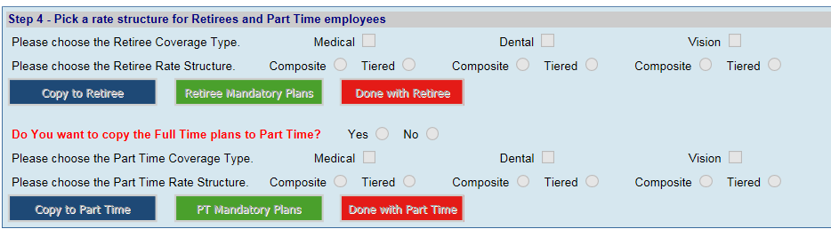

Retirees and part-time employees must have the same plans as the full-time active employees, but you do have the option to choose different rate structures for retirees and part-time employees. Select the same Coverage Type and same/different Rate Structure boxes as with the full-time selections. Then click. You will receive a dialog box as shown below confirming your request to copy plans and a confirmation that you plans were copied successfully.

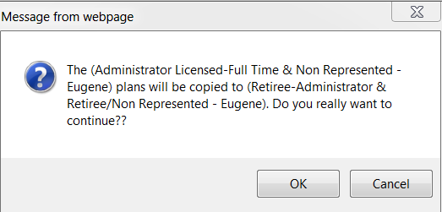

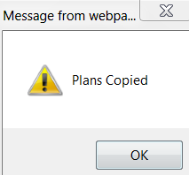
Click the button. Then repeat the same process for part-time employees.
Remember you must deliberately select Optional Plans for part-time employees, since these may or may not differ from the ones for full-time employees.

If your part-time benefits rate structures differ from the full-time selections, you can select a different rate structure for each, possibly add Optional Plans, and then click the button.

If you do not have Part Time plans then select the “No” button to move to the next employment group in Step 3.

Final Step: Confirming Your Plan Year Selections

Once you’ve made and saved all the changes for all plans, it’s time to finalize everything. Remember to use the Review button frequently throughout the process to examine the changes to your benefit program as a whole. You can use the button in the full-time member section to revert to last year’s plans at any time, even if you’ve successfully “saved” one or more sets of changes in the interim.

However: once you confirm all selections in the Final Step, you’re considered locked in for the plan year. You’ll have to call OEBB Administration for a reset of your selections.

Click at the bottom of the EE Plan Management page. Then, on the Review page that displays, click again. This will finalize your plans for the coming year.

Questions?
If you have any additional questions or concerns, don’t hesitate to contact us by phone or email at 1-888-469-6322 or oebb.benefits@state.or.us.
.

