
EE Plan Management
MyOEBB
EE Plan Management
Guide

This MyOEBB feature makes it easier for entity administrators to manage yearly benefit plans. You’ll use this page to quickly renew existing plans and rate structures, or make the changes necessary to ensure smooth transition to new plans for the upcoming plan year.

Navigating to EE Plan Management
After logging into MyOEBB, you’ll find the OEBB EE Plan Management page under the Plan Management section of the left-side navigation menu:
.
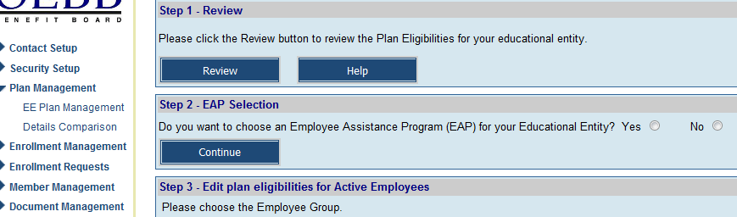

Step 1: Review Plans
Visit the EE Plan Management to review plans from the previous year. The new plan year begins on October 1st.
The first step is to click the button in Step 1.

You’ll see a list of all your current plan selections, organized by Member Type and Employment Type.
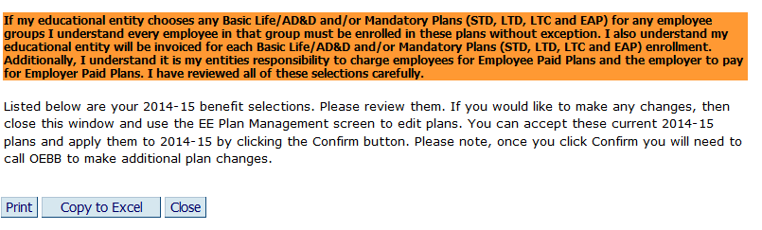

You can use the buttons to print the page, copy the contents to an Excel document for further planning, or, when you’re finished reviewing, to the page.

Only do the Final Step – “Confirm” when you are confident with your Plan Year 2014-15 choices.

Step 2: Employee Assistance Program (EAP) Selection

Your entity can choose from three options for your educational entity. Select “Yes” and click on
Continue. If you do not choose to offer EAP, select “No”.

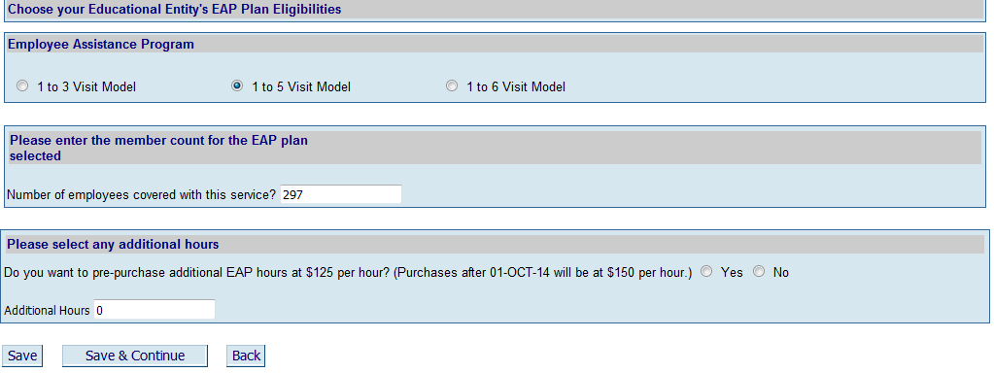

Check which plan and then enter the amount of employees your educational entity will be covering with this service. You can choose to cover your entire MyOEBB benefit eligible employees or you can also cover all your non-benefits eligible employees. You can also choose to pre-purchase additional EAP hours for training sessions at your entity.

When you have finished click Save & Continue.

Step 3: Plan Eligibilities for Active Full-Time Employees

Start by making new plan eligibility selections for active full-time employees. All current OEBB rules and restrictions will be applied to your selections, so don’t worry: you’ll see a warning message if you try to save an improper selection.

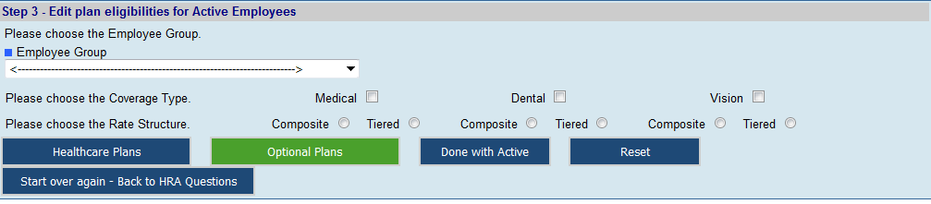

Select a Member Type/Employment Type combination for which to make changes. Click any Coverage Types you wish to change. Select any rate structure that will change for this combination. Then click the Healthcare Plans button.

(Note: selecting a change to composite rate structure from a tiered rate structure or vice versa will cause an additional screen to appear, making sure you are aware of the change you’re making, and that taking this action results in the termination of older plans for the upcoming plan year).

Click Continue to make the change, click Review if you need more information on your plan selection process, or click Back to return to the Plan Management page.

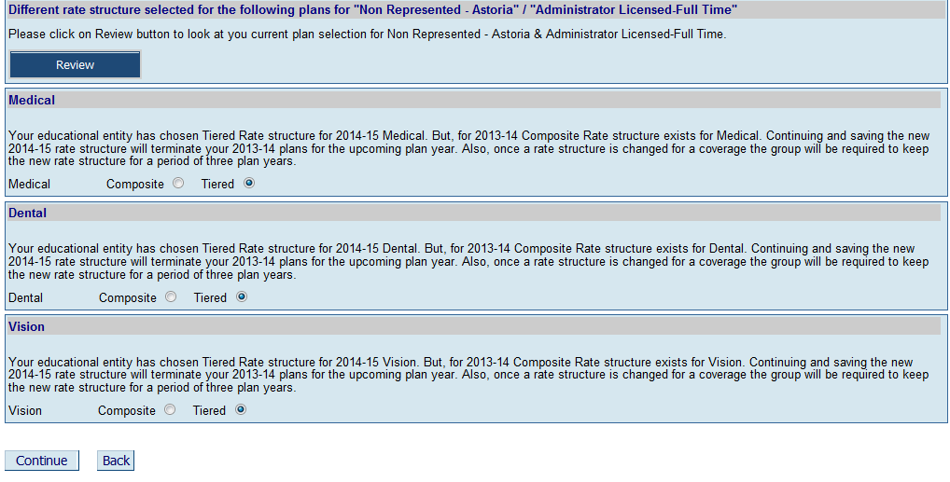

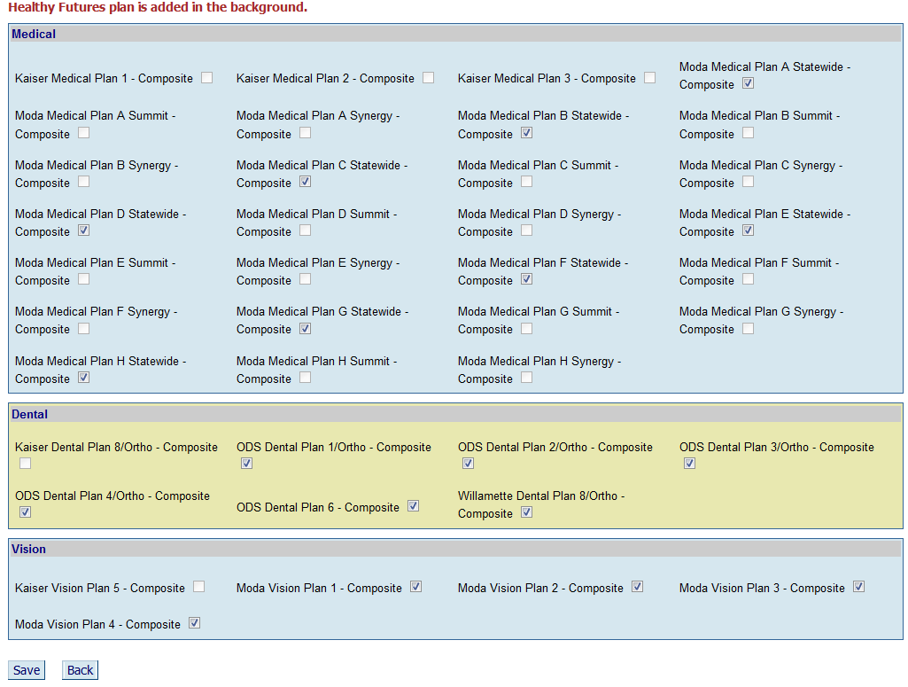

All eligible plans will have a check in the box. You must deselect the plans you do not want to offer to your employees. Check boxes for any currently selected plans will already be checked. To change a plan, uncheck the box for a current plan, and check the box of a new plan to replace it. When you have finished, click Save at the bottom of the screen. You’ll see Record Saved Successfully! at the top left of the screen. Click to return to the EE Plan Management page.

Continue the above process for each of your Member Type/Employment Type combinations.

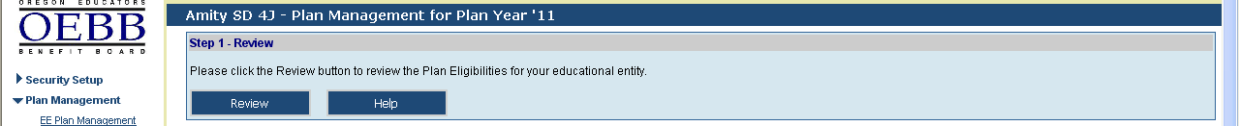

After each selection, use the Review button to see what changes you’ve saved thus far. Newly selected plans will appear in blue type. Plans that are no longer offered will appear in red type on the Review page.

If you get a bit confused or make some selection mistakes, you can always click the  button and to clear the screen and start again.

Even if you have saved changes and moved ahead to other steps, you can click the button to revert back to last year’s selections. As long as you have not confirmed changes in the Final Step, you can always start over.

Once you have finished selecting Medical, Dental and Vision for this Member Type/Employment Type, you can select Optional Plans if you have not done so in the previous years. If you have selected Optional Plans for this group in the previous years, you cannot delete any Optional Plans. At this point you can click the button.

If you have not selected Optional Plans, and wish to do so this year, click the Optional Plans button for selecting optional plans for this Member Type/Employment Type. The Plan Selection screen displays with Optional Plans. Optional Plans include, Basic Life, Optional Employee Life, Optional Spouse/Partner Life, Optional Child Life, Basic AD&D, Optional Employee AD&D, Optional Spouse/Partner AD&D, Optional Child AD&D, Employee Long Term Care, Spouse/Partner Long Term Care, Long Term Disability, and Short Term Disability. Select optional plans the same way as you did for Medical, Dental or Vision Plans. When you have finished with all plans for this full-time Employment Type/Member Type, click the button and move back to Step 3 before selecting the next Employment Type/Member Type combination.

Step 4: Retirees, COBRA and Part-Time Employees
Making changes to plans and rate structures for retirees and part-time employees is similar to those for full-time, with the added option, with one button click, you can copy the plans from the full-time selections and apply them to respective retiree and part-time plans. COBRA plans and rate structures must match your full-time active employees.

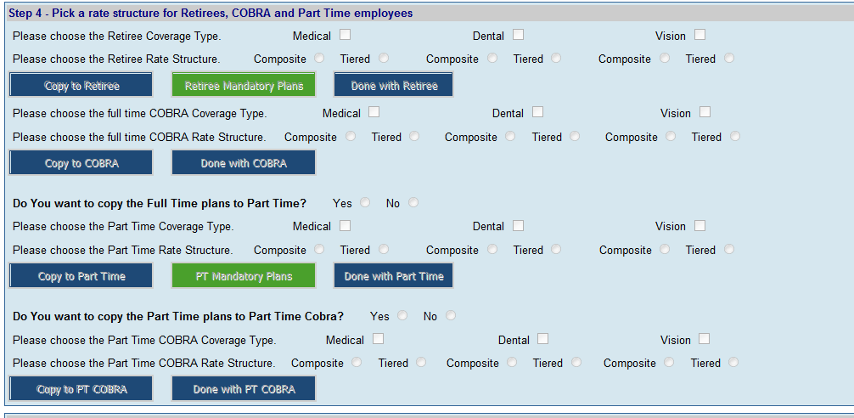

Retirees and part-time employees must have the same plans as the full-time active employees, but you do have the option to choose different rate structures for retirees and part-time employees. Select the same Coverage Type and same/different Rate Structure boxes as with the full-time selections. Then click. You will receive a dialog box as shown below confirming your request to copy plans and a confirmation that you plans were copied successfully.

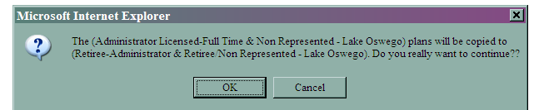

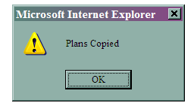
Then use the Review button at the top of the page to double-check. When you’re satisfied with the retiree selections, click the Done with Retiree button. Then repeat the same process for part-time employees.
Remember you must deliberately select Optional Plans for part-time employees, since these may or may not differ from the ones for full-time employees. Optional plans are never automatically associated with a benefits program.

COBRA participants are not eligible for Optional Plans or EAP.

If your part-time benefits rate structures differ from the full-time selections, you can select a different rate structure for each, possibly add Optional Plans, and then click the  button.

Final Step: Confirming Your Plan Year Selections

Once you’ve made and saved all the changes for all plans, it’s time to finalize everything. Remember to use the Review button frequently throughout the process to examine the changes to your benefit program as a whole. You can use the button in the full-time member section to revert to last year’s plans at any time, even if you’ve successfully “saved” one or more sets of changes in the interim.

However: once you confirm all selections in the Final Step, you’re considered locked in for the plan year. You’ll have to call OEBB Administration for a reset of your selections.

Click at the bottom of the EE Plan Management page. Then, on the Review page that displays, click again. This will finalize your plans for the coming year. You will receive a confirmation page as shown below. Please print out this page, sign it and date it and fax it to OEBB as indicated on the screen.

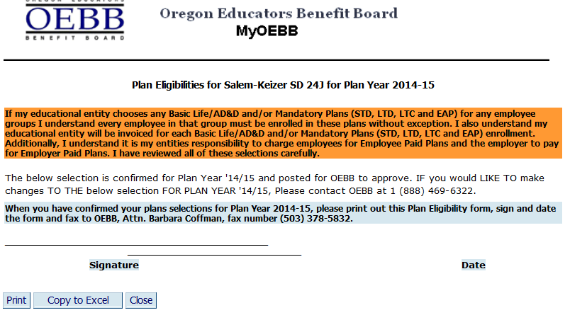

Questions?

If you have any additional questions or concerns, don’t hesitate to contact us, through the MyOEBB website (Help or Contact Us) or by phone or email:

Contact OEBB:
Business Hours: 8:00AM to 5:00PM PST
By E-mail: OEBB.benefits@oregon.gov
By Phone: 1-888-4MY-OEBB or 1-888-469-6322

