OGIC Report to JLCIMT

Purpose
This reports responds to the Legislative direction in ORS 276A.500-515 that tasks the Oregon Geographic Information Council to report and make recommendations regarding the geospatial needs of the state to the Legislature by March 30 of every odd-numbered year. This report provides:
- preliminary recommendations to enhance geospatial Framework data management and sharing among public bodies;
- preliminary recommendations for eliminating geospatial Framework data fees between public bodies by funding statewide Framework data; and,
- summary information regarding the plan and budget for collecting, using, managing, sharing and maintaining geospatial Framework data and maintaining a geospatial data library within the office of the State Chief Information Officer for the benefit of all Oregonians.

Need for Action
The development and maintenance of standardized geospatial Framework data statewide will enable the provision of consistent government services to all citizens. This will be accomplished by significantly improving the geospatial data and information available to agencies and decision makers for meeting citizen service needs. However, there is a significant shortfall between the funding that a comprehensive, statewide Framework data program needs for successful, effective operation and what public bodies are collectively able to provide now. Moreover, Council research reveals obstacles in Oregon public bodies’ collective ability to create and maintain complete, statewide Framework data. These obstacles take several forms:
- missing data or “gaps”-- Oregon lacks the comprehensive, complete geospatial Framework required to meet the state’s obligations for services provisioning;
- insufficient organizational capacity—many public bodies lack capacity (data infrastructure, staff, technology) to maintain and share Framework data;
- fees public bodies charge each other -- data development, standardization, and efficient use are hindered by overly complex data sharing practices when public bodies charge each other to sustain their data programs.

Overall Preliminary Recommendations Summary
The overall objective is to enable and fund coordinated programs across all public bodies that will develop and maintain comprehensive, standardized, statewide geospatial Framework data. The Council estimates that approximately $250 million over a ten-year startup period is necessary to cover Framework data program start-up costs. Operating costs to maintain the data assets over time and provide continual management and access to the data would require about $13 million annually during the startup period and beyond. Since there is now a shortfall between the funding that a comprehensive, statewide Framework data program needs and what public bodies collectively are now able to provide, additional funding is required. The full preliminary recommendation is described herein and consists of the following components:
- Creating additional organizational capacity for multi-jurisdictional Framework data programs
- Identifying possible funding mechanisms –
  - Existing fees--OGIC recommends that the Legislature re-allocate a portion of existing state agency-administered fees to Framework data purposes; and
  - Continue and expand assessments on state agencies (Policy Option Package) to fund the state Geospatial Enterprise Office (GEO)
- Solidifying governance and accountability mechanisms
OGIC will likely recommend using debt financing to accelerate the startup phase of the Framework data program. In addition, OGIC will continue to evaluate public/private partnerships as a part of future funding solutions.
The table below indicates the timeline and costs for Framework data development during the startup period. The funding mechanisms mentioned above and discussed in more detail in this report are intended to be an ongoing approach to fund continued maintenance of the Framework data assets.

Recommended Legislation for the 2019-2021 Biennium
A multi-year effort such as that required to build the foundational Framework data, supporting systems, and supporting organizational capacity must be well-planned. OGIC, state staff, and the many other partners in the effort will require a planning and capacity-building first step. Accordingly, OGIC recommends that the Legislature fund the Framework data program in multiple steps beginning in the 2019 session. OGIC and state staff will use the first-step funding during calendar 2019 and 2020 to complete a more-detailed work plan and budget for the remaining eight years of the startup phase and make additional recommendations/requests to the Legislature in 2021.
Table 1: Framework Data Startup Sequencing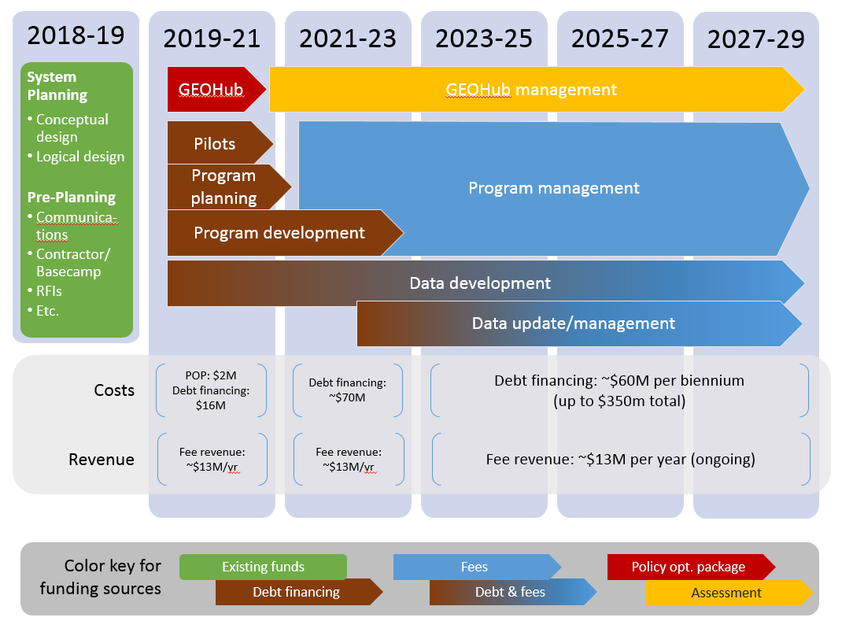
OGIC preliminarily recommends that in the 2019 session the Legislature:
- Authorize tapping existing state fees to generate $13 million of continuing annual revenue for the Framework data program (more details on the fee mechanism appear below);
- Authorize issuing General Obligation bonds funded by part of the fee revenue (not General Fund) to generate $16 million of startup money to be used in 2019 and 2020 to fund Framework data program planning and capacity-building;
- Approve the Policy Option Package (more details below) that will add capacity to the state Geospatial Enterprise Office sufficient to support the first two years of Framework data program development and implementation.

Background
Recent Oregon law (ORS276A.500-515) authorizes the Oregon Geographic Information Council (OGIC) to serve as “…the statewide governing body for sharing and managing geospatial Framework data.” Framework data are locational data used by a wide range of public bodies to accomplish their missions. OGIC submits that the development and maintenance of geospatial Framework data in a consistent manner statewide will enable the provision of consistent government services to all citizens. The law tasks OGIC with, among other responsibilities, submitting each biennium “…a plan and a budget for collecting, using, managing, sharing, and maintaining geospatial Framework data…” and recommending strategies for eliminating the fees that public bodies charge to other public bodies for geospatial Framework data under ORS 190.050 (Fees for geographic data) or 192.324 (Copies or inspection of public records). In addition, the Council is tasked in the statute with enhancing geospatial Framework data sharing and management among public bodies.
There are many examples of services provided by local and/or state agencies that are dependent on locational data. It is not always possible to get the same level of service in Burns as it is in Beaverton, or even in Eagle Point as it is in Medford, without complete, standardized locational data. For example:
- Kids can’t remain in the same schools when they are moved into or between foster homes if tax lots, address points, school attendance areas, and locations and characteristics of foster homes aren’t readily available to state and local officials,
- Permits can’t be evaluated and the permit process can’t be streamlined when land use, zoning, wildlife habitat, utilities, address points, tax lots, and floodplain boundaries aren’t readily available to state and local officials.
- Economic development zone boundaries can’t be appropriately located and used to have the greatest impact if demographics, business locations, utilities, address points, tax lots, municipal boundaries, and UGBs aren’t readily available to state and local officials.
- Locating a new fire station to optimize response time can’t be accomplished if address points, demographics, municipal boundaries, roads, streams, tax lots, and utilities aren’t available to state and local officials.
- Workforce development efforts are less effective when housing, transit, roads, address points, child care, healthcare, job opportunities, business locations, and training choices aren’t readily available to state and local officials.
The Council proposes to enhance Framework data sharing and management, and mitigate the obstacles to Oregon public bodies’ collective ability to create and maintain complete, statewide Framework data, by putting in place a data sharing program that is sustainably funded at the state level. The obstacles revealed by Council research provide key places for intervention and funding so that Framework data exists for all corners of Oregon, is well-maintained and managed over time by public bodies, and is shared at no cost among all public bodies. The Council proposes the data sharing program be maintained and managed by the Geospatial Enterprise Office (GEO) within the Office of the State CIO, the agency best positioned to do so. Once the program is functioning as described in this recommendation, Oregon public bodies will—collectively—realize significant benefits by eliminating the cost of duplicated data development and optimizing data management across all concerned public bodies.

Obstacles

Gaps in existing Framework data sets
Data gaps come in many forms. Gaps include: (a) areas where some needed data do not exist (incomplete statewide coverage); (b) data without appropriate or standardized descriptive information (e.g., zoning boundaries without codes; addresses with incorrectly spelled streets); (c) portions of data that are unstandardized or inconsistent relative to the rest of the dataset; and (d) data that are necessary, but do not yet exist.
Data gaps are one of the primary obstacles to realizing public bodies’ collective ability to create and maintain complete, statewide Framework data, and for Oregon to realize the benefits of consistent, statewide Framework data in terms of consistent, statewide provision of government services. This multifaceted obstacle results from multiple mechanisms and shortcomings including:
- lack of organizational capacity in many public bodies
- lack of coordinated governance and direction
- lack of available funding

Insufficient organizational capacity
Insufficient organizational capacity interferes with public bodies’ collective ability to create and maintain complete, statewide Framework data across all levels of government. This cascading impact becomes apparent as one considers the development of Framework data and its lifecycle. Local level public bodies (e.g., cities, counties, special districts) are the authoritative, or ordinance-directed, sources for at least 80 of the 250 Framework data sets. The table below contains a small sample of the local level data that is part of the Oregon Framework.
Table 2: Sample of Local Level Framework Data
Data Element | Local Level Custodian
Tax lots | County Assessors
Address points | City/County Planners
Zoning | City/County Planners
Land Use | City/County Planners
Roads | City/County Public Works
Utilities | City/County Public Works & Special districts
City limits | City Clerks
UGBs | County Planners
Election districts | County Clerks
School districts | Special Districts
Police/Fire stations | City/County Public Safety
State agencies also need to create and maintain Framework data to carry out their programmatic mission, but often do not have the capacity to do so.
The lack of organizational capacity is particularly noticeable and problematic in rural local governments. This is also, not coincidentally, where it is often most difficult to provide consistent government services. The data needed to support many government services simply doesn’t exist or exists in unstandardized forms in rural areas across the state. These public bodies, and in some cases their counterparts in more urbanized areas, do not have the knowledgeable, experienced staff, technology, or funding to create and maintain the data.
In order to have consistent local level data for the entire state, the data must be aggregated at a regional or state level. At the regional level, only a handful of aggregating public bodies exist and they only operate over limited geographies, not the entire state. At the state level, the many individual Framework data elements created at the other levels of government are aggregated by multiple public bodies, but no single public body is responsible for compiling all Framework data elements into a comprehensive statewide format. While it is not required that a single public body have the latter responsibility, a single public body may be able to improve the outcomes by facilitating and coordinating the activities of the public bodies participating in the Framework data program to a greater extent than is currently possible.

Fees public bodies charge each other for Framework data
Council research into how public bodies pay fees for Framework data, and how they use those fees, revealed a nuanced picture. While some public organizations already freely share data that is costly to produce, a few depend on fee revenue to partly fund data creation, aggregation, and standardization. In addition, while GEO would prefer to use regional public bodies as data aggregators and standardizers to minimize transaction costs, not all parts of the state have an organization providing such services. OGIC thus proposes to devote state revenues to mitigate multiple challenges:
- replace charges between public bodies that ORS 276A.500 will eliminate and that currently sustain a portion of all existing regional aggregators’ ongoing operations;
- create data standardization tools for the state and regional aggregators; and,
- provide funding for new aggregation and standardization capacity for regional public bodies that do not yet have such services.

Organizational Capacity Vision
The development, aggregation, and standardization of Framework data is by nature a cooperative enterprise spread across many Oregon public bodies: cities, counties, regions, and special districts. Collectively, this cooperative enterprise now spends an estimated $31 million per year to develop and maintain Framework data sets. The Council proposes to leverage the strengths provided by this distributed responsibility by enhancing existing bodies’ capacities and creating new capacities at the points in the enterprise where it will be most effective. This takes the form of:
- Empowering those “closest to the data source” (e.g. cities, counties, districts, various state agencies) to develop the primary data;
- Enabling selected regional, county, or academic organizations to aggregate and standardize the data for both the state and their own purpose; and,
- Establishing effective governance, coordination, data management, and accountability mechanisms in the state Geospatial Enterprise Office (GEO) and the Council.
Figure 1: Vision for distributed workflow and process
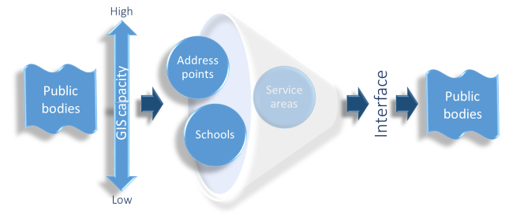

City, County, and Special District Capacity-Building
Local governments are the custodians of many of the Framework data sets. In a few instances, a state agency administers a program that helps to standardize a particular data set. In one or two instances, a state agency aggregates the local data to create a state-wide Framework data set. But in the majority of cases, the Framework data developed and maintained at the local level is not standardized or aggregated to form a state-wide data set. As noted below, there are a few places around the state where regional standardization and aggregation of local level data takes place. But there are gaps in that process, as well.
The vision of the Council is to build the capacity, where it doesn’t currently exist or where it needs to be augmented, in all local governments to develop and maintain standardized Framework data. As noted earlier, this will enable the consistent provision of government services across the state. The current gap in Framework data development corresponds to a gap in local government organizational capacity to develop and maintain Framework data.
Local governments need startup and ongoing funding support from the state. As noted earlier, many local governments, particularly in rural areas, lack the experienced staff, technology, or funding to create and maintain the data. The Council estimates the startup costs to build necessary capacity in local governments to be approximately $4 million. It is estimated that Framework data maintenance will require about $3.4 million annually in additional funding at the local government level, above current expenditures. It will not be feasible to build capacity for Framework data development and maintenance in every local government across the state; some are simply too small. In those cases, regional bodies will manage the process, as described below.

Regional Capacity-Building & Data Charge Backfill
The role of regional bodies in the overall business model is to aggregate and standardize Framework data. This vision is inspired by existing regions in the state (Metro, Lane Council of Governments) that are already doing this task. The attractions of regional data aggregation efforts are several: they meet business needs at the regional level (e.g. for transportation planning under state and federal requirements), they provide data for academic research and educational opportunities for universities and community colleges, and they make the state’s task of gathering standardized data much easier.
This proposal envisions eleven regions statewide (see map below). Metro, Lane Council of Governments (LCOG), some other COGs, some counties, and some community colleges have expressed interest in sustaining or developing the necessary capacity if the Legislature provides the support described below.
Figure 2: Proposed Geographies for Regional Aggregation/Standardization Programs
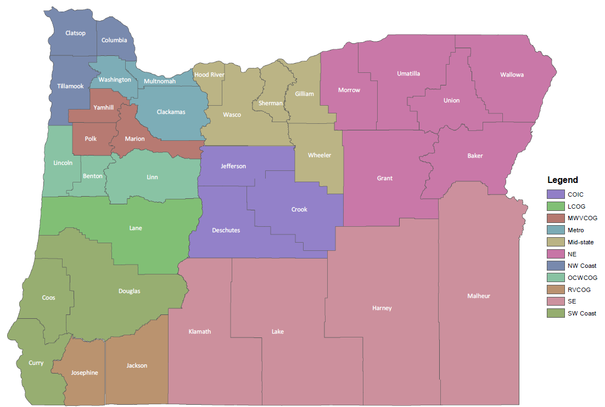
Like the other capacity-building efforts in this proposal, the regional bodies need both startup and ongoing funding support from the state as summarized in the table below. The total necessary state support is based on estimates that vary the state proportion depending upon the existing capabilities of public bodies in the eleven regions. In some cases, like the Portland Metro and Lane County areas, state investments will be only 10% to 25% of the total program costs. In other areas with no existing data aggregation programs, the state would support all startup and ongoing costs. The state investment will leverage a variety of local expenditures, catalyze new organizational capacity in parts of the state now without a regional aggregation program, and enable existing programs to create tools that can standardize data to the state format.
The regional aggregators will serve many of the small jurisdictions within their regional boundaries. But there will also be many small jurisdictions that can and should have help building the capacity to create, maintain and manage Framework data themselves, as noted earlier. The Council will work with the public bodies, through the governance and accountability mechanisms described later in this report, to determine the best approach for each public body.

Table 3: Regional Program Funding Requirements
Council research found that regional public bodies’ practice of charging other public bodies for data has actually been declining over time. Only a few regions still charge other public bodies for data (although many public bodies still charge the private sector). The ongoing funding above is sufficient to cover a state share of actual program costs and to backfill the funds lost when the Legislature decides it is time to explicitly prohibit public bodies from charging each other for data.

State Agency Capacity-Building
The State Chief Information Officer has proposed a Policy Option Package for the 2019-2021 biennium for the Geospatial Enterprise Office. This package provides the initial resources needed to (a) enable public bodies to securely share the most critical, authoritative statewide data sets that are essential to the accomplishment of virtually all the primary government missions; (b) substantially increase the usefulness of Framework data for the government business it is built to support; (c) greatly enhance access to Framework data for Oregon government to meet the outcome-based performance management needs of the public safety, natural resources, education, health, transportation and economic development communities; and (d) enable data access in underserved rural areas of the state for local government, tribal, and special district partners.
There are a number of state agencies that currently participate or lead in the development of Framework data sets, as noted below. Those agencies will benefit specifically as additional public body partners are able to participate more fully in the Framework process.

- DOR Tax lots
- ODOT/ODF Roads, city limits, survey control
- DLCD Land use, zoning, UGBs, coastline
- OWRD Surface water, wells
- DHS/OHA School Districts
- DOGAMI Elevation, hazards
- OPRD/ODF Aerial Imagery
- GEO Address points
- OSU-INR Vegetation, wetlands
- ODFW Fish/wildlife habitats
- DEQ/OEM Preparedness

Recommended Funding Mechanisms
The obstacles described above create an overall shortfall between the funding that a comprehensive, statewide Framework data program needs and what public bodies collectively are now able to provide. In this section, we describe the mechanisms for funding the Framework data program that the Council researched to support the final recommendation.
The Council makes the following funding recommendations:
- Existing fees—The Council recommends tapping a portion of existing fees to Framework data purposes. There are about 2,500 fees administered by state agencies in Oregon. Those fees generate about $2.5 billion each biennium. The Council identified three potential alternatives, but seeks direction from the Legislature on which is more feasible or desirable:
  - About half the fees require geospatial Framework data to be properly administered and those fees generate about $750 million each biennium. Tapping 3.5% of the revenue generated by fees requiring Framework data would be sufficient to meet the need. This would replace revenue being expended now by most of these fee administrators to acquire such data from a variety of data providers. The revenue would support the development, aggregation, and maintenance of required authoritative Framework data from a single secure source which all fee administrators could access, thus reducing their acquisition costs.
  - A second alternative would involve tapping a larger portion of a smaller number of fees that generate significant revenue. This approach would be calibrated so as not to negatively impact economic development or vulnerable populations.
  - All fees would benefit from more consistent, standardized Framework data statewide. The funding shortfall would be covered if 1% of all such fees were allocated for geospatial Framework expenses.
There are several different methods that could be used to tap a small portion of existing fees. See Attachment A for details on the fee options the Council has identified.
- GEO assessments on state agencies—GEO currently uses an assessment methodology on all state agencies’ budgets to fund ongoing GEO operations related to storing geospatial Framework data and providing access through the Spatial Data Library. This assessment methodology should continue to be used, but increased with a Policy Option Package to fund ongoing costs related to secure provision of Framework data to all public bodies through a central data hub. This funding package will augment the existing GEO state agency assessments to fund the following activities at GEO:
- Establish a redesigned enterprise geospatial technical architecture, including new and upgraded hardware and software, larger bandwidth, and security protocols and technology to accommodate the statutory requirement to provide secure access to upload and download Framework data for all public bodies.
- Support the expanded and formalized coordination activities and organizational infrastructure of the Council to reflect the growing and important role being played by location-based information in governmental agencies.
- Develop enterprise-level services, such as address location needed by many government business processes, including energy facility siting, hazard mitigation, transportation planning, and more.
- Expand the GEO staff to accommodate the development and management of the upgraded technical architecture and professional management of base data.
- Debt Financing - The Council recommends that debt financing be used to the greatest extent possible over a 10-year period beginning July 2019. The bonds would be repaid with the revenue generated from fee re-allocations as described above. Once the debt is repaid, the fee revenue would be continued in perpetuity to sustainably fund maintenance of Framework data by the hundreds of data providers, mostly at the local government level. This will ensure that the initial significant investment in Framework data is maintained and will not have to be repeated. There has been a preliminary determination by the DAS Chief Financial Office that most of the Framework data development work can be capitalized, in addition to the enterprise GIS software license for all public bodies, the hardware necessary to build capacity in local governments and to develop the data sharing hub at the state level, contract labor to develop the capitalizable data assets, and limited duration staff necessary during the initial start-up period. The areas where debt financing cannot be used include the ongoing data maintenance at all levels and the ongoing staff to operate the data sharing hub. Alternatively, it is possible to use General Fund or other fund mechanisms to accelerate the data development. The Council is not recommending the use of other funding mechanisms at this time, instead favoring the use of debt financing.

- Public/Private Partnership - Public/Private Partnerships (P3s) have been evaluated by the Council. There is some potential over time to augment or replace a portion of the proposed fee revenue. The basic conceptual model, currently implemented in Canada (Alberta, Ontario New Brunswick & BC) and in a few other countries, involves a private consortium of companies aggregating Framework data from all public bodies and using that aggregated data to create web-based products and services aimed at a variety of industries (e.g., energy, real estate, timber, health care, insurance). Companies in those vertical markets subscribe to the products and services and the subscription revenue is shared with all public bodies to help fund a portion of the cost for continued provision of updated Framework data. The statutory structure to enable P3s exists in Oregon and is used now by ODOT for bridge development, as an example. More research is needed to firm up this recommendation, but the Council believes it could play a role in the overall Framework funding model. The Council recommends that the Legislature direct further research, evaluation and review of the P3 concept, with the intention to implement this concept, depending on the outcome of the evaluation, at a later time.
Table 4. Funding alternatives with preferred alternatives indicated
Funding Mechanism | Budgetary need
Funding Mechanism | Framework data development | Framework data maintenance | Framework data sharing | GEO staff/admin (startup) | GEO staff/admin (ongoing O&M)
Existing Fees | preferred | preferred | preferred
DAS GEO assessments |  |  |  |  | preferred
GEO Policy Option Package |  |  |  | preferred | preferred
Debt Financing | preferred |  | preferred | preferred | software only
Public-Private Partnership | pending further research | pending further research | pending further research | pending further research | pending further research

Required Funding & Funding Source
The Council estimates that approximately $268 million over a ten-year period is necessary to cover Framework data program start-up costs, including data development, limited-duration (LD) personnel, hardware, software, and contracting services. Operating costs for personnel and operational expenses to maintain the data over time and provide continual management and access to the data would require about $13 million annually during the startup period and beyond.

Detailed Cost Structure
Start-Up, One-Time Tasks (over ten-year period)
- Technical Infrastructure design and implementation
  - The system to enable secure Framework data sharing between all public bodies will include system design, planning, testing and implementation between August 2019 and January 2020, with full implementation on January 2, 2020. This work will include effort by GEO staff and contractors, as well as assistance by some local and regional government staff.
- Data sharing program pilot projects
  - Two pilot projects will be planned and conducted to provide information that will help OGIC more precisely estimate data development and program costs for future biennia. One pilot will be planned along the coast, to complete higher-priority Framework data and data sharing within a selected area to support tsunami planning and resilience. Another pilot will be planned in an area of central or eastern Oregon to complete higher-priority Framework data creation and sharing to support wildfire response planning and operations. Both pilots will focus on returning immediate value to disaster resilience programs. This delivers value on two fronts: direct utility to resilience programs and a thorough, meaningful test of the Framework data program’s business model and data-sharing capabilities.
- Data development, statewide
  - Data development will occur in several phases. The first phase, in FY2021-23, will develop the highest priority data. The second phase, in FY2023-25, will high priority data statewide. The third phase, in FY2025-27, will develop medium priority data. The fourth phase, in FY 2027-29, will complete the lower priority data statewide. This work includes program management, planning, data validation and quality control. It also includes regional data standardization and aggregation. Regional governments and some county governments will perform data standardization and aggregation tasks for many local governments, including some small local governments where capacity building is not feasible.
- Program development and implementation
  - This includes capacity building in local and regional governments, as well as software procurement and provisioning. Capacity building will include web application development and training. The software to support this program will follow the state GIS software standard (OAR 125-600-7550). The software is currently available to state agencies through an enterprise license agreement. That agreement will be extended to include all public bodies, and various components will be provisioned and implemented as appropriate to local and regional governments to participate in data development, maintenance, standardization, aggregation and sharing.
- Program management and administration
  - This category includes overall program planning, individual project planning for data development, evaluation of all aspects of the program to inform future funding requests, and procurement of contract services for system design, data development, training, and technology provisioning. Some of this work will be done and/or supported by limited duration staff. Based on OGIC’s current recommendation, debt service will be used to accelerate the program development, particularly Framework data development. As a result, there will be costs associated with repaying the debt. The cost of debt service will be based on how much is borrowed, the type of bonds that are used, etc. At this time, this cost is unknown.
Table 5. Start-up costs will extend over 10 years to afford adequate time for data development across the state.
 | Start Up Activities | Total activity cost (millions)
A. | Technical Infrastructure design and implementation
 | System design, planning, testing and implementation | 1
B. | Data sharing program pilot projects
 | Project planning | 0.1
 | Project execution
 | Evaluation methodology development | 0.05
 | Geospatial data development | 2.75
 | Project evaluation | 0.1
C. | Data development, statewide
 | Data standardization and aggregation (regional) | 1.6
 | Phase 1: Highest priority statewide data development | 250
 | Phase 2: High and medium priority statewide data development | 250
 | Phase 3: Medium priority statewide data development | 250
 | Phase 4: Lower/remaining statewide data development | 250
D. | Program development & implementation
 | Capacity building - local & regional | 5.9
 | Software procurement and provisioning | 4.5
E. | Program management & administration
 | Program planning & establishment of work flows for program evaluation, data dev. project management, procurement, and contracting | 2
 | Debt service management & administration | TBD
 | Total cost (millions) | $ 268

Ongoing Tasks (annual)
- Software Licensing
  - The software provisioned for data sharing and data management will need to be maintained and supported on an ongoing basis to support the Framework data investment.
- Data maintenance
  - Public bodies will continue to incur costs over and above existing funding availability to maintain the Framework data in which the state is investing as a strategic asset.
- Data sharing
  - The technology to enable secure Framework data sharing among and between all public bodies will require ongoing maintenance and support. In addition, the regional bodies will incur costs to standardize and aggregate Framework data on an ongoing basis.
- GEO new and existing permanent staff
  - To support the ongoing needs of this program, GEO will need to increase its staffing levels. The policy option package includes three new staff and an increase in classification for one existing staff.
- Other (future program enhancements)
- Debt service
  - This may not be necessary after the initial start-up period. If it is, the cost for repayment of bonds will be determined at a later time.
Table 6. Ongoing activities and their associated annual costs.
 | Ongoing activities | Annual cost (millions)
A. | Software licensing | 2.5
B. | Data maintenance | 7.5
C. | Data sharing (portal maintenance) | 2
D. | GEO new and existing staff | 0.9
E. | Other (future program enhancements) | 0.2
F. | Debt service | TBD
 | Total cost (millions) | $ 13.1

Governance, Accountability Mechanisms, and Performance Measures
Any significant use of public revenue requires accountability and oversight. ORS276A.500 authorizes the Council as the main overseer of Framework data revenues and expenditures. The Council will ensure accountability and effective use of the proposed state revenues through a number of mechanisms:
- Council programs will use Oregon’s already-established “Stage Gate” oversight in the State CIO’s office to ensure effective decision-making and expenditure control;
- Council and GEO will distribute Framework funds to public bodies under the auspices of grant programs, contracts, and Intergovernmental or Interagency Agreements;
- Council will develop performance measures for its activities, including activities it funds;
- Council will report regularly to the Legislature per ORS276A.500.
Furthermore, the Council will formalize appropriate advisory committees under statutory authority to help govern the use of state revenues for the purpose of Framework development, maintenance, and management. The Council is working to secure Stage Gate 1 endorsement for the Framework program and will continue using that oversight process for planning and project management going forward.

Attachment A: Research and Methodology
The Council examined three options for existing fees, as noted in the following table.
Fee Option | Legislative Effort Required | Stakeholder Outreach Required | Potential Issues
Tap All Fees | Large – may require 3/5 vote of Legislature | Large – need to persuade all fee authorities of value | Is a 3/5 vote feasible?
Tap Mission-Aligned Fees – require Framework data | Large – requires changes to many laws and rules (1 per fee?) | Medium – need to persuade only some fee administrators | Is data needed? Is amount reasonable?
Tap a Few Mission-Aligned Fees – revenue high, controversy low | Minimal – fewer fees to change | Smaller – even fewer fee administrators to convince | Perception of fairness

Data Research
Considerable effort was expended by the OGIC Resource Work Group (RWG) and the OGIC Framework Implementation Team (FIT) to compile the information and cost estimates that were necessary to complete this report. The RWG reached out to the regional governments, county governments, city governments, and other public bodies around the state seeking information on costs related to Framework data development. That cost information was extrapolated to develop a comprehensive cost estimate for the amount of money being expended on Framework data development and maintenance from existing funding sources.
The FIT developed an estimate of the status of each Framework data element and the estimated cost for statewide completion of each Framework element, along with an estimate of the ongoing maintenance costs for each element. The combination of the work by the RWG and the FIT, summarized in the table below, provides a relatively clear picture of the amount being expended now and the amount needed going forward, thus providing an understanding of the funding gap.*

 |  | 2005 Baseline | September 7, 2018
DATA DEVELOPMENT | Total development cost |  | $376,235,500
DATA DEVELOPMENT | Cost remaining | $163,297,965 | $254,271,750
DATA DEVELOPMENT | Cost covered by stewards/custodians |  | $7,620,000
DATA DEVELOPMENT | Cost to be covered by new funds |  | $246,651,750
DATA DEVELOPMENT | Low Estimate |  | $160,323,638
DATA DEVELOPMENT | Hi Estimate |  | $332,979,863
DATA MAINTENANCE | Total annual maintenance cost |  | $17,895,300
DATA MAINTENANCE | Annual maintenance cost covered by steward/custodians |  | $8,395,000
DATA MAINTENANCE | Maintenance (annual) cost to be covered by new funds |  | $9,500,300
DATA MAINTENANCE | Low Estimate |  | $9,009,390
DATA MAINTENANCE | Hi Estimate |  | $18,711,810
*May be modified to include additional costs for specific data elements for which estimates have not been completed.

