‘X’ Marks the Spot: Officials Map a Route Out of the Pandemic
Governments and organizations around the world are using geospatial data and digital mapping tools to guide their vaccination campaigns.


Dr. Harsha Rajashekharaiah, a senior project coordinator for Suffolk County’s Covid-19 response. “One of the common questions I used to get was, ‘Where is it bad?’” he said.Credit...Kenny Holston for The New York Times
By Emily Anthes
Aug. 1, 2021
At their regular pandemic response meetings over the past year, officials in Suffolk County, N.Y., found themselves returning, again and again, to questions of geography.
“One of the common questions I used to get was, ‘Where is it bad?’” said Dr. Harsha Rajashekharaiah, the senior project coordinator for the county’s Covid-19 response. “Where is the Covid transmission bad? Where is the testing bad? Where should we improve? Where should we invest our resources?”
To find answers, Dr. Rajashekharaiah used geospatial data, brandishing brightly colored maps that pinpointed the exact neighborhoods where cases were rising or where testing rates were lagging.
And after inoculations began, he started using digital mapping tools — commonly known as geographic information system, or G.I.S., software — to explore how vaccination rates varied across the county and how they correlated with a variety of demographic factors.
ADVERTISEMENT
Continue reading the main story
Several patterns soon emerged on the color-coded maps. In March, for instance, magenta splotches on the western side of the county made it clear that vaccination rates were low in neighborhoods with a high share of residents who did not speak English well. After he presented the map to his colleagues, they quickly added Spanish and Haitian Creole language assistance to their county vaccine hotline.
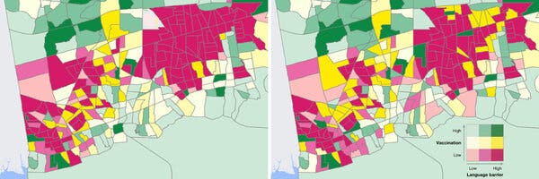
Image
Maps produced by Suffolk County show vaccination rates in late March, left, and early June. Dark pink areas show lower vaccination rates and a higher percentage of residents who do not speak English well.Credit...Suffolk County
Over the next few months, as vaccination rates rose in these neighborhoods, portions of the map turned to yellow or even green. “I cannot sit here and conclude that our G.I.S. system is the reason that this has happened,” Dr. Rajashekharaiah said. But, he added, “G.I.S. has been a very, very powerful tool for us to communicate these barriers.”
Amid the highly uneven rollout of Covid-19 vaccines, many health officials and community organizations are drawing upon geospatial data to plan their vaccination campaigns and track their progress in fine-grained detail. Esri, a California-based company that makes widely used G.I.S. software, says that hundreds of organizations around the world — including many U.S. states and more than 20 national governments — are using its digital mapping tools to help them get shots into arms.
“G.I.S. and mapping tools have been really important to helping these health departments get people vaccinated — to be more organized in the process, more streamlined and strategic and even tactical,” said Dr. Este Geraghty, the chief medical officer of Esri.

Editors’ Picks



The Best Way to Respond to Text Messages



Touring Trinity, the Birthplace of Nuclear Dread



A Cat on the Field. A Mantis on a Hat. Monday Baseball Had It All.

Continue reading the main story
ADVERTISEMENT
Continue reading the main story
By allowing officials to quickly spot vaccine deserts, pinpoint high-risk populations and target their resources more efficiently, digital maps have become crucial tools in the effort to ensure that vaccination campaigns leave no neighborhood behind.

Coronavirus Pandemic and U.S. Life Expectancy

  - 18-month drop in life expectancy. The coronavirus pandemic was largely responsible for shaving a year and a half from the life expectancy of Americans in 2020, the steepest drop in the United States since World War II, according to federal statistics released on Wednesday.
  - Disparities. Black and Latino people have been disproportionately affected by the coronavirus. Latino and African American residents of the United States have been three times as likely to become infected as their white neighbors. And Black and Latino people have been nearly twice as likely to die from the virus as white people.
  - Infection rates. Higher rates of infection and mortality among Black and Hispanic Americans have been explained by exposure on the job and at home, experts said.
  - Vaccination gaps. Communities of color, which have borne the brunt of the Covid-19 pandemic in the United States, have also received a smaller share of available vaccines.

Location, location, location
As the virus raced across Wisconsin in the spring of 2020, officials in Milwaukee County became concerned about its unequal toll. In late March and early April, for instance, Black residents accounted for 69 percent of the Covid deaths in the county despite making up just 27 percent of its population, according to a University of Wisconsin-Milwaukee report.
These disparities were front of mind when the Covid-19 vaccines were finally authorized. “We wanted to make sure that we were equitably distributing this vaccine,” said David Crowley, the Milwaukee County executive.
They began categorizing census tracts according to their vaccination rates and their scores on a national “social vulnerability index.” The index uses data on 15 different social, economic and demographic factors — including the age, minority status and education levels of residents, as well as local poverty and unemployment rates — to calculate how susceptible a given community would be in the event of some kind of disaster, like a hurricane or a pandemic.
Then the officials displayed the results online on a color-coded map. In mid-March, when the county first released it, much of the city of Milwaukee was colored dark orange, signaling that the area had high levels of social vulnerability but low vaccination rates.
On the other hand, the suburbs, where the population is wealthier and whiter, were shaded a pale yellow, indicating that they had low scores on the vulnerability index but climbing vaccination rates. “And so there was this story of the haves and have-nots, or two different cities,” said Dr. Ben Weston, who oversees the medical aspects of the county’s Covid-19 response.
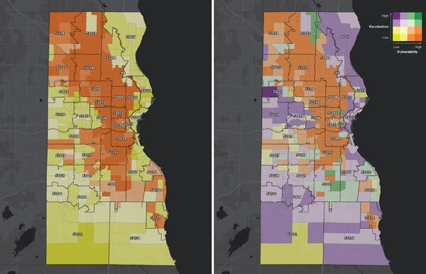
Image
Maps produced by Milwaukee County show vaccination rates in mid-March, left, and late July. Orange areas show higher levels of social vulnerability and lower vaccination rates.Credit...Milwaukee County
County and city officials began pouring resources into deep orange neighborhoods, prioritizing those residents for vaccine appointments, adding more vaccination sites in those areas and creating pop-up sites and events at churches, food pantries, libraries, schools and cultural centers. They also started a community ambassador program — the Crush Covid Crew — to train volunteers from those deep orange census tracts to talk to their neighbors about the vaccines and dispel misinformation about them.
ADVERTISEMENT
Continue reading the main story
Although vaccination rates in the most vulnerable areas still lag behind, they have more than tripled since mid-March. “The darkest orange communities are now gone,” Dr. Weston said. “So we’re making progress.”
The Coronavirus Outbreak ›

Latest Updates
Updated
Aug. 3, 2021, 10:38 a.m. ET2 hours ago
2 hours ago
- Yellen and Pelosi discuss rental assistance as an eviction crisis looms and Democrats demand answers.
- New York City will require proof of vaccination for indoor dining and fitness.
- Kaiser Permanente requires its nearly 300,000 U.S. employees to be vaccinated.
Is this helpful?

Delivering doses
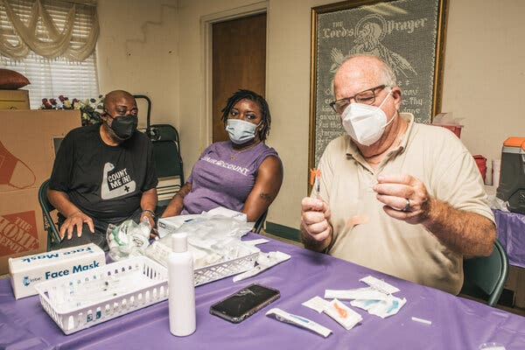
Image
A vaccine being prepared at the Grant Chapel A.M.E. Church in Moultrie, Ga., organized through the Count Me In initiative, on Saturday.Credit...Matthew Odom for The New York Times
The Count Me In initiative in Georgia — which was created by Stacey Abrams, the former Georgia Democratic candidate for governor — has taken a similar approach. But instead of focusing on vaccination rates, it mapped vaccination sites across the state and then overlaid data on potential barriers to vaccination, including a lack of computer access and low rates of car ownership.
The map revealed numerous potential trouble spots, particularly in rural, southwest Georgia. “We saw this very large concentration of folks that had very limited vaccine access,” said Ali Bustamante, a senior research associate at the Southern Economic Advancement Project, which runs the initiative with the nonprofit organization Fair Count. “There were very few vaccination sites, while at the same time they were facing huge access constraints.”
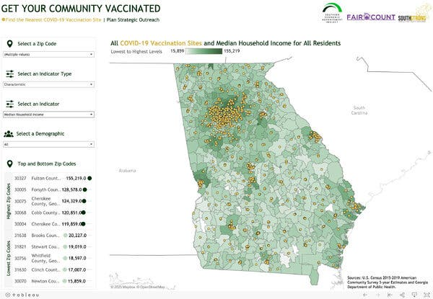
Image
The Southern Economic Advancement Project and Fair Count mapped vaccination sites in Georgia along with different types of demographic information.Credit...SEAP, via Tableau
The groups partnered with vaccine providers to send mobile clinics to some of these vaccine deserts and began an all-out canvassing effort, borrowing the tools of a political campaign to encourage people to get shots. Volunteers ultimately made 79,000 phone calls, delivered vaccine information to 17,000 doors and helped book 4,500 vaccine appointments. “Particularly in rural areas, we have seen the vaccination gap close considerably,” Dr. Bustamante said.
ADVERTISEMENT
Continue reading the main story
Geospatial data is also critical for logistics. Carto, a cloud-based platform for analyzing geospatial data, has helped dozens of logistics companies around the world optimize their vaccine storage and transportation networks to get the shots distributed more quickly and efficiently, said Luis Sanz, the company’s chief executive.
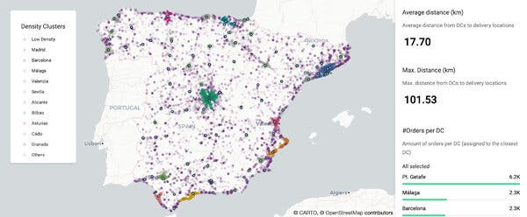
Image
A Carto map of Spain shows the optimal layout of vaccine distribution centers and delivery locations.Credit...Miguel Álvarez and Dan Rushton, Carto
And in Clackamas County in Oregon, G.I.S. data has become the backbone of efforts to vaccinate people who are homebound. “Because we are a large county with somewhat rural areas, we do have some transportation issues and access is a challenge for many of our residents,” said Kim La Croix, a public health program manager for the county. “Those mass vaccination sites were just not accessible to homebound seniors and homebound people with mental, developmental or physical disabilities.”

Understand the State of Vaccine Mandates in the U.S.

  - College and universities. More than 400 colleges and universities are requiring students to be vaccinated for Covid-19. Almost all are in states that voted for President Biden.
  - Hospitals and medical centers. Many hospitals and major health systems are requiring employees to get the Covid-19 vaccine, citing rising caseloads fueled by the Delta variant and stubbornly low vaccination rates in their communities, even within their work force. In N.Y.C., workers in city-run hospitals and health clinics will be required to get vaccinated or else get tested on a weekly basis.
  - Federal employees. President Biden announced that all civilian federal employees must be vaccinated against the coronavirus or be forced to submit to regular testing, social distancing, mask requirements and restrictions on most travel. State workers in New York will face similar restrictions.
  - Can your employer require a vaccine? Companies can require workers entering the workplace to be vaccinated against the coronavirus, according to recent U.S. government guidance.
When residents call or email the county to request an at-home vaccination, staff members log their location, which pops up on a digital map. Then, when assigning specific appointment slots, they review the map, which displays the number and type of vaccines that have been requested across the county. The goal is to reduce nurses’ travel time, maximize the number of shots they give in a day and to minimize waste, by ensuring that the number of doses a nurse gives in a shift matches the number of doses in a vial.

Following directions
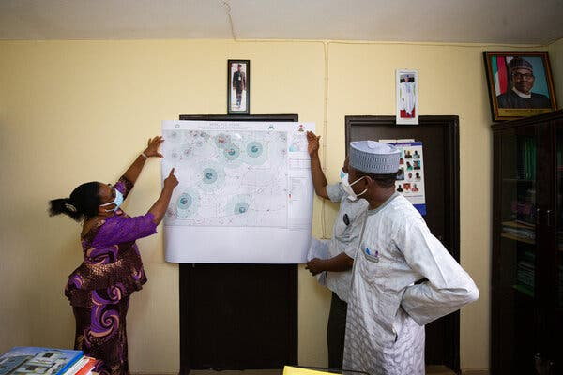
Image
Health officials examined a GRID3 map for Kuje, Nigeria.Credit...GRID3
In low and middle-income countries, basic geospatial data — about how many people need to be vaccinated and where they live — has been critical to the success of prior mass vaccination campaigns. About a decade ago, for instance, government officials and global health experts realized that polio vaccination teams in northern Nigeria were using inaccurate, hand-drawn maps.
“There were missing settlements, wrong settlement names,” said Emilie Schnarr, the Nigeria project manager for the Geo-Referenced Infrastructure and Demographic Data for Development, or GRID3, program. “And that was one of the reasons children were being missed.”
ADVERTISEMENT
Continue reading the main story
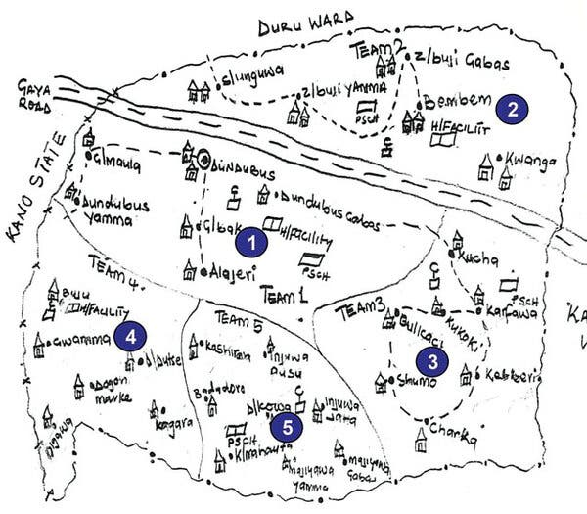
Image
A hand-drawn map used by polio vaccination teams shows settlements, health care facilities, mosques and roads near Dundubus, Nigeria.Credit...Inuwa Barau et al., Journal of Infectious Diseases
Without reaching these children, the highly contagious polio virus was likely to continue circulating. So in the years that followed, the Nigerian government, in partnership with several global health organizations, used satellite imagery and local field teams to create detailed, high resolution maps, filling in missing buildings, settlements, and local points of interest.
The maps helped Nigeria eradicate polio, which the country finally achieved last year. And GRID3, which grew out of these efforts, recently distributed updated maps to local officials across Nigeria, who are using them to help plan and track their Covid-19 vaccination campaigns.
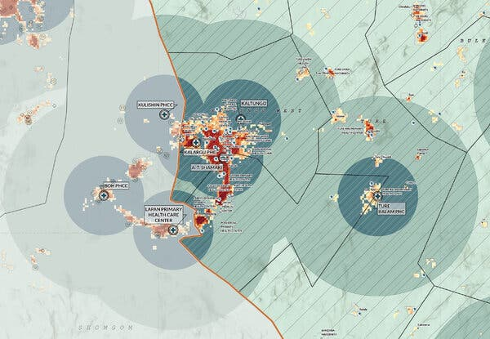
Image
A detail from a map of Kaltungo, Nigeria, shows estimated population density and distances to Covid-19 vaccination sites.Credit...National Primary Health Care Development Agency
They’re not alone. In March, five organizations that specialize in geographic data and information management — Alcis, CartONG, Humanitarian OpenStreetMap Team, iMMAP and MapAction — joined forces to launch the Geographic Information Management Initiative for Covid-19 Vaccine Delivery. Their goal is to help 15 low-income countries, including Haiti, Sudan and Bangladesh, fill gaps in their geospatial data and then harness that information to get vaccines out to their residents.
The work, the say, will be of use not just for this pandemic, but for the delivery of all sorts of essential services, ensuring that local health authorities know where their citizens live and can help them meet their needs.
“To be on the map is to be acknowledged,” said Ivan Gayton, the senior humanitarian adviser to the Humanitarian OpenStreetMap Team. “Every community in the world should be able to put themselves on the map.”

