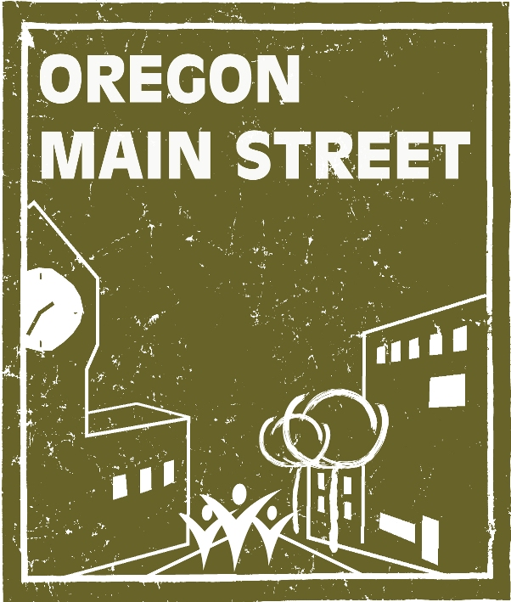

Request for Nominations
“Excellence in Downtown Revitalization Awards”
Nominations due July 15, 2011

The Oregon Main Street Program, jointly administered by the State Historic Preservation Office (Oregon Parks and Recreation Department) and Business Oregon (Oregon Business Development Department), invites you to submit nominations for outstanding achievements in comprehensive downtown revitalization efforts. Awards will be presented during a special celebration at the Oregon Main Street Conference, October 5-7, 2011, in Baker City, Oregon.

Eligibility: All levels of participants in the Oregon Main Street Network (Performing Main Street, Transforming Downtown, and Exploring Downtown) may submit applications. Call 503.986.0679 if you’re not sure whether your community is participating in the Network.

Project Timeframe: To be eligible, all projects, activities, or events submitted for recognition must have been completed between January 1, 2010 and June 30, 2011.

To be considered for an award, please complete the nomination form provided. A jury of downtown revitalization peers will review nominations to evaluate how the projects meet the criteria described under each of the following categories:

- Outstanding Partnership: Nominations should demonstrate how two or more organizations have effectively collaborated on a specific downtown preservation project or on-going downtown revitalization effort. Partners can include, but are not limited to, a Main Street program, local government, other non-profit organization, or private enterprise. How did the partnership come about? Were there obstacles or competing interests that were overcome? What will be the long-term or on-going benefit to the relationship?

- Best Economic Restructuring Story: This award recognizes a special economic restructuring project or activity with involvement from a local economic development organization (e.g., downtown organization, chamber of commerce, economic development group, local government) and takes place within a traditional downtown or neighborhood commercial district. Projects can include, but are not limited to: business recruitment or retention efforts, adaptive reuse, or special incentive programs. Be sure to describe how the project or activity was put together, its impact on the district including existing businesses, and other pertinent information including who was involved, and what was accomplished.

- Outstanding Design Project: This award recognizes design excellence in a single construction or rehabilitation project and includes public or private projects. The physical design of the project should enhance the downtown or neighborhood commercial district in appearance or function. This category also includes other design related activities. Important factors are design quality, historic preservation, creativity, and impact within budget. We’d like to hear about the problems addressed, impacts created, funding source(s), participants and process, and special design considerations. Please include before and after photos. Tips: before and after shots are most effective when taken from the exact same location/angle. It is also sometimes helpful to show the project in context to its surroundings.

- Business Success Story: This award honors a downtown or neighborhood commercial district business that has improved its volume of business through increased sales, product line, expansion, etc. by actively working with the local downtown program. Please include a written statement from the business owner stating how the local organization helped their business.

- Outstanding Organizational Project: This category is for a successful project completed by the local Main Street community’s Organization Committee. The project should be unique and focus on at least one component of the committee’s responsibilities including: volunteer management activities, volunteer recruitment and retention strategies, promotion of the local Main Street program, training opportunities for local volunteers, and/or fundraising activities. Describe the project and results and submit photographs, news articles, brochures, newsletters, web-site pages, or other information to support the nomination.

- Outstanding Achievement in Promotion: This award recognizes excellence in promoting a downtown or neighborhood commercial district through creative and effective image campaigns, special events, retail sales, and other promotional projects that help spread the word about the community’s center. Tell us about the cost, funding source(s), target audience, goal of the promotion, and the results. Describe the role of the business community before, during, and after the event (if applicable). Don’t forget to mention significant in-kind donations and sponsorships. Please attach posters, brochures, flyers, and/or image materials produced as supporting material. Please do not attach newspaper articles.

- Innovation Award: This is the all-purpose category to showcase your community’s “big idea” for your downtown. Any project, program, or promotion that has enhanced the downtown in a cutting edge fashion should be considered. This award will recognize a special one-time project or activity that affects a downtown or neighborhood commercial district revitalization effort in some way. Tell us about the type of project, and the goals of the project and how they were met or exceeded. Be sure to describe how the project was organized, who was involved, the cost, and what was accomplished.

---------------------------------------------------------------------------------------------------------------------

The Following Two Categories are for Performing Main Street or Transforming Downtown Communities Only:

- Main Street Manager of the Year: This award will be given to a Main Street Manager from a Performing Main Street or Transforming Downtown community for the overall impact he/she has had on the local downtown revitalization program. The successful entry will describe how the manager has coordinated and facilitated activities of the Board of Directors and committees, been a resource to downtown property and business owners, fostered collaboration with other organizations, and been a positive force behind the program’s success. Describe the Manager’s impact and submit photographs, news articles, statistics, or other information to support the nomination.

- Volunteer of the Year: This award will be given to a Main Street volunteer from a Performing Main Street or Transforming Downtown community for the overall impact on the local downtown revitalization program or a specific committee. The successful entry will describe how the volunteer has been an integral part of the local program. Describe the volunteer’s impact and submit photographs, news articles, number of volunteer hours, statistics, or other information to support the nomination. Submit one Volunteer of the Year nomination and photograph. Please note: this nomination can be an individual, couple, team, business or organization who has contributed to local downtown revitalization efforts.

2011 “Excellence in Downtown Revitalization”
Award Nomination Form

Award Category (select one by double clicking on appropriate box and clicking on “checked”):
Outstanding Partnership Best Economic Restructuring Story
Outstanding Design Project Business Success Story
Outstanding Achievement in Promotion Outstanding Organizational Project
Innovation Award Volunteer of the Year
Main Street Manager of the Year

Name of Nominee:

Title of Project or Activity:

Name of Person Submitting Nomination:
Address:
Telephone Number:
Email Address:

Name of the individual to accept the award, if chosen:

State Legislative District:

Project Summary: In one paragraph, please provide a brief summary of the project or activity, including the project’s purpose:

Project Background: Describe the need and context for the project.

Project Description: Describe the activities that took place to achieve the final result or product. Include the project budget and timeframe.

Local Appropriateness: How does your project reinforce and capitalize on the unique assets of the local community?

Impact: Please explain how this project has impacted your downtown or neighborhood commercial district and the businesses located there. Has the project had any effect on local policies? Are there secondary or spin off effects? For instance, did the rehabilitation of a particular building spur additional investment downtown, or have an effect on nearby businesses?

Conclusions: Tell us why you believe this project should receive an award over other projects that may be submitted in this category.

Submittal Information

- Please tell us the exact name or title of the individual/business/event or activity as you wish it to appear on the awards. PLEASE CHECK SPELLING.

- Good quality photos are very important. Provide up to ten (10) digital images on CD for each nomination submitted. If necessary, please attach an 8 ½ x 11 inch sheet with brief corresponding descriptions. Please do not insert pictures within the text portion of your nomination. Digital images submitted with your entries become the property of Oregon Main Street and may be used for future presentations and publications.

- Provide five (5) copies of each application and supporting materials described under the award category on pages 3-4. Do not send cover letters or unrequested items. Note that only one set of digital images is required for each nomination.

- Fasten together application and supporting materials with a paper clip or staple. Remember, 5 sets of each nomination packet are required. If you are submitting nominations for more than one category in the same envelope, please group the nomination packets by category. No folders, please.

- All nominations must arrive at Oregon Parks and Recreation Department by 5 PM on July 15, 2011. Late nominations will not be considered.

Address: Sheri Stuart
Oregon Main Street/Oregon Parks and Recreation Department
725 Summer Street, Suite C
Salem, OR 97301

- Faxed or emailed materials will not be accepted unless specifically requested by OMS staff.

- A maximum of two projects or activities may be nominated in each category.

- Each project or activity may only be nominated in one category.

- Projects or activities receiving awards in previous years are not eligible unless there have been substantial changes or additions made during the nomination timeframe.

- Entries and supporting material will not be returned.

- The jury reserves the right to eliminate categories if a reasonable number of worthy nominees have not been submitted in a given category. Awards judges also reserve the right to move a nomination to a different category.

- For purposes of this award, “downtown” is defined as the traditional, compact, pedestrian-oriented central commercial district of a community. Historic commercial neighborhood districts are also eligible to apply.

For additional information, contact Sheri Stuart at 503-986-0679.

