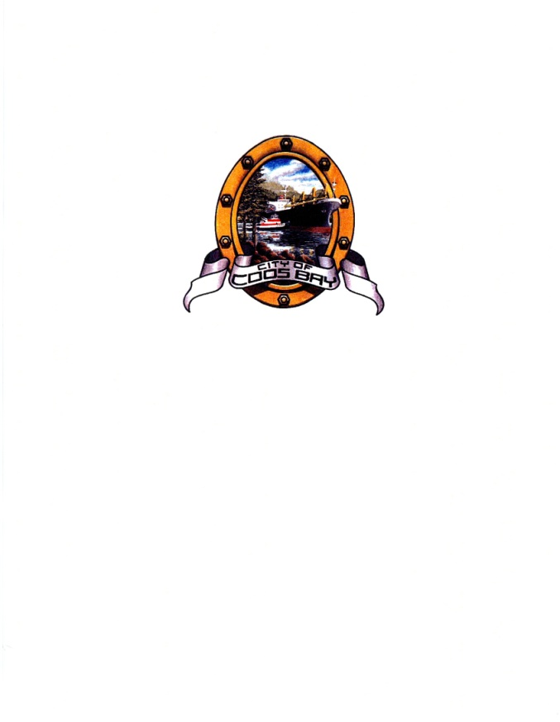CITY OF COOS BAY

Request for Qualifications
for
Grant Writing Services

The City of Coos Bay is soliciting proposals from grant writing professionals interested in providing services for administration, research, and preparation of grant applications for the Egyptian Theatre Restoration Project. The city will compile a list of no less than two (2) qualified grant writers for the project.

SUBMISSION OF PROPOSAL

To receive consideration, quotes must be submitted in accordance to the following instructions:

- All quotes shall be in a sealed envelope and delivered to the

City of Coos Bay
City Manager’s Office
500 Central Avenue
Coos Bay OR 97420

- The envelope must be clearly marked “Grant Writing Services Proposal – Egyptian Theatre Project”

- Submit three (3) copies of the proposal by 2:00 p.m. December 16, 2011.

- If you have any questions, please contact Joyce Jansen at 541-269-8924 or email jjansen@coosbay.org

- The City of Coos Bay reserves the right to reject any and all proposals, and has the right, at its sole discretion, to accept the proposal it considers most favorable to the City’s interest and the right to waive minor irregularities in procedures.

November 21, 2010

Joyce Jansen
Economic Revitalization Administrator

Phone: 541-269-8924
Email: jjansen@coosbay.org

PROJECT DESCRIPTION

The historic Egyptian Theatre is located at 229 South Broadway, Coos Bay, Oregon. The Theatre was purchased by the City of Coos Bay Urban Renewal Agency in 2006 and since that time has been operated and managed by the Egyptian Theatre Preservation Association. The Theatre was listed on the National Register of Historic Places in May 2010 and on the Historic Preservation League of Oregon’s Most Endangered Places List in May 2011.

The theatre was closed March 15, 2011 after the City received a structural report completed by ZCS. The inspection determined the building has structural issues which need to be addressed before it would be considered safe to occupy. The estimated cost to restore the historic theatre is $3.7 million. A copy of the report may be obtained from the City’s website www.coosbay.org

GENERAL INSTRUCTIONS

The City of Coos Bay invites qualified professionals to submit proposals for grant writing services for the Egyptian Theatre Restoration Project as described in the specifications set forth in this RFQ. All proposals are subject to the provisions and requirements of the City of Coos Bay Rules of Local Contract Review and the Oregon Revised Statutes, the Attorney General’s Model Public Contract Rules.

PROPOSAL REQUIREMENTS

All proposals must include a cover letter to the attention of the City Manager’s Office signed by the person legally authorized to bind the applicant to its proposal. The cover letter must include the name of the firm, the names of partners/principals and the number of local personnel, address, telephone and fax numbers of the firm, and list five references the City may contact.

PROCEDURE

- Grant writers shall submit three (3) copies of their proposals are to the City of Coos Bay, Oregon, City Manager’s Office, 500 Central Avenue, Coos Bay, OR 97420 by 2:00 p.m. December 16, 2011. Proposals submitted after 2 p.m. will not be accepted.
- Proposals shall be in a sealed envelope and clearly marked “Grant Writing Services Proposal – Egyptian Theatre Project” in the lower left corner; addressed to the City of Coos Bay as noted above, and shall have the submitters name and return address in the upper left corner. Faxed responses are not acceptable.
- Correction or withdrawal of a proposal must be made prior to the bid closing time and must be clearly labeled “Proposal Modification” or “Proposal Withdrawal”.
- The city shall evaluate all proposals; selection and award will be based on relevant past grant writing success, ability to meet the schedule, and proposed fee schedule.
- The city reserves the right to reject any and all RFQs and has the right, at its sole discretion, to accept the proposals it considers most favorable to the city’s interest, and the right to waive minor irregularities in procedure.

QUALIFICATION EVALUATION CRITERIA

- Demonstrated expertise and success in grant writing in state, federal, public and private.
- A summary of the writer’s record for the past three (3) years including the number of grants written, what they were for, the number funded, and the number unfunded.
- Estimated timeline to secure total funding for the project and associated grant writing fees within the timeline.
- Ability to build strong, positive working relationships with diverse staff and stakeholders in order to gather necessary information for the grant applications.
- Demonstrated project management skills with ability to establish and meet tight deadlines, and to manage multiple writing projects.
- Ability to work independently and with community partners and agency staff to develop successful applications.
- Fee proposal and structure will be evaluated with respect to the probable cost to the city of doing business with each submitter; cost proposals will be evaluated for realism and reasonableness of the overall cost and individual cost element estimates.

SCOPE OF WORK

- Grant writer shall research appropriate grant opportunities and prepare a grant funding strategy. The strategy will include benchmark and timelines to measure the success of the project. The document shall list a prioritized listing of funding sources along with suggested ask amounts. This will include grant deadlines, key contacts and match amounts.
- A grant calendar shall be developed from the list of potential grants.
- Grant writer shall complete grant applications in accordance with guidelines as specified by the funding sources. All applications are to be reviewed prior to submission by the City of Coos Bay.
- The grant writer shall represent the city in negotiations with grant foundation personnel; shall continue administration of all successful grant funding; and shall work with the city to closely manage the capital improvement account for the project through completion of the Egyptian Theatre Restoration Project.
- Key contacts will be maintained with Oregon State Historic Preservation office, Oregon Cultural Trust, Historic Preservation League of Oregon, and Oregon Historical Society.
- Monthly reporting on all grants will be provided. On-site meetings with the City will be included every 4 to 6 weeks or as needed.
- All grant application documents shall become the property of the City of Coos Bay.
- The total amount of funding needed to complete the project is estimated at $3.7 million. Construction will be dependent upon secured funding, and time is of the essence.
- The grant writer shall enter into a personal services contract with the City of Coos Bay. The contract shall specify fees, scope of services to be performed, and timeline for services to be performed.

SELECTION PROCESS

City staff shall review all proposals. The city may interview select qualified candidates. The selection and ranking shall be based on the following:

- Experience, capability and technical competence to perform
project grant writing 25 points
- RFP submittal specifications 10 points
- Cover letter specifications 5 points
- Knowledge of project 10 points
- Staff and resource availability (current workload) 10 points
- Cost proposal and compensation information 20 points
- Demonstrated local and regional support and collaboration 20 points

The city anticipates making the selection and award to the highest-ranked grant writers to City of Coos Bay Urban Renewal Agency, on January 3, 2012. The successful bidders and the city shall then mutually discuss and refine the scope of services for the project and shall negotiate final conditions, compensation and performance schedule for a subsequent personal services contract.

COMPLIANCE WITH RULES

Proposers responding to this RFQ must follow its procedures and requirements. Except as otherwise provided in the RFQ, applicable provisions of Oregon Administrative Rules shall apply to all personal service contacts of the city. Failure to comply with or complete any part of this RFQ may result in rejection of your proposal.

INTERVIEWS

Proposer may be invited to an interview with the Egyptian Theatre Restoration Steering Committee. Selected firms will be contacted regarding time and location of an interview.

SCHEDULE OF RQUEST FOR QUOTES

Proposal due Dec. 16, 2011
Bid opening at 2 p.m. at city hall Dec. 16, 2011
Review by the Egyptian Theatre
Restoration Steering Committee Dec. 28, 2011
City award of contract Jan. 3, 2012
Commencement of services TBA

PROPOSAL WITHDRAWAL

Any proposal may be withdrawn at any time before the “Proposal Due” date and time by providing a written request for the withdrawal to the issuing office. A duly authorized representative of the firm shall make the request. Withdrawal of a proposal will not preclude the proposer from filing a new Proposal.
APPEALS

Bidders who wish to appeal a disqualification of proposal or the award of contract my submit the appeal in writing to the City Manager’s Office within five (5) working days of the postmarked Notice of Award or disqualification. Disagreement with the process, e.g. scoring by evaluators, is not subject to appeal.

Address: City of Coos Bay
Rodger Craddock, City Manager
500 Central Avenue
Coos Bay OR 97420

OWNERSHIP OF DOCUMENTS

Any material submitted by a proposer shall become the property of the City of Coos Bay. Materials submitted after a contract is signed will be subject to the ownership provision of the executed contract.

CONFIDENTIALITY OF INFORMATION

All information and data furnished to a proposer by the city and all other documents to which the proposer’s employees have access during the preparation and submittal of the proposal shall be treated as confidential to the city. Any oral or written disclosure to unauthorized individuals is prohibited.

PUBLIC RECORD

All proposals and information submitted by proposers are not open for public inspection until after the notice of intent to award a contract is issued. Except for exempt materials, all proposals and information submitted by proposers will be available for viewing after the evaluation process is complete and the notice of intent to award is sent to all participating parties.

INDEMNITY

Contractor shall hold harmless, indemnify, and save the city, its officers, employees, and agents from any and all liability claims, losses, or damages arising or alleged to arise during the performance of the work described herein by reason or any act or omission of the Contractor or any of its agents, employees or representatives. The indemnity applies to both active and passive acts or other conduct.

EMPLOYMENT STATUS

Contractor shall perform the work required by this contract as an independent contractor. Although the city reserves the right to determine and modify the schedule for the work to be performed and to evaluate the quality of the completed performance, the city cannot and will not control the means and manner of the contractor’s performance. The contractor is responsible for determining the appropriate means and manner of performing the work.

Contractor represents and warrants that the contractor is not an employee of the City of Coos Bay and meets the specific independent contractor standards of ORS 670.600. Contractor is not an officer, employee, or agent of the city. Contractor shall be responsible for any federal or state taxes applicable to any compensation of payments paid to Contractor under this contract and, the city will not withhold form such compensation or payments any amounts to cover contractor’s federal or state tax obligations. Contractor is not eligible for any Social Security, unemployment insurance, or workers compensation, from compensation paid to Contractor under this contract except as a self-employed individual.

INSURANCE

The contractor shall maintain during the life of this contract the following minimum public liability and property damage insurance which shall protect the city and contractor from claims for injuries including accidental death, as well as from claims for property damages which may arise from the performance of work under this contract, and the limit of liability for such insurance shall be as follows:

- Commercial general liability insurance including personal injury liability, blanket contractual liability and broad form property damage liability. The coverage shall be on an occurrence form with limits not less than $1,000,000 each occurrence, $2,000,000 policy aggregate. Coverage shall be primary and noncontributory with any insurance carried by the city and shall include a waiver of subrogation endorsement in favor of the city.

- Contractor shall maintain professional errors and omission liability insurance with a limit of not less than $1,000,000 per occurrence and a deductible amount of not more than $25,000.

- Contractor shall maintain an excess/umbrella liability policy of not less than $1,000,000 each occurrence and aggregate that will provide excess limits of liability over the commercial general liability, automobile liability, and employer’s liability.

Coverage provided by the contractor must be underwritten by an insurance company deemed acceptable by the city. The city reserves the right to reject all or any insurance carrier(s) with an unacceptable financial rating.

The contractor shall provide certificates of coverage, including applicable endorsements, for such policies within ten (10) days of execution of the contract. The city shall be named as an additional insured on the policy; provided, however, that each party shall be liable for injuries or claims arising solely out of that party’s acts or omissions and no claim as an “additional insured” shall be made against the other party’s carrier for injuries or claims solely from or arising out of that party’s acts or omissions. There shall be no cancellation, material changes, reduction of limits, or intent not to renew the insurance coverage without 30 days written notice from the contractor’s insurers to the city.

\\citymansrvr\home\jjansen\my documents\joyce\purchasing contract rules\example rfps rfqs\rfq grant writing services egyptian theatre.docx

