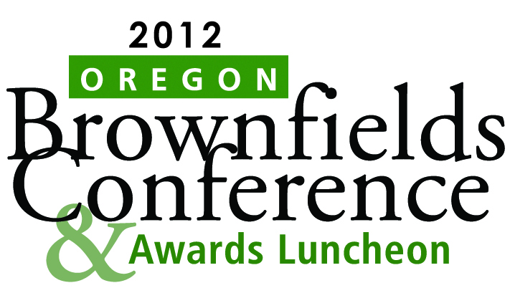

# June 13 & 14, 2012

**DoubleTree by Hilton Portland**

**1000 NE Multnomah Boulevard**

**Portland, Oregon**

**Presented by:** Oregon Business Development Department

Oregon Department of Environmental Quality

Northwest Environmental Business Council

Center for Creative Land Recycling

**Plan on Attending** the 2012 Oregon Brownfields Conference and Awards Luncheon which will provide an exceptional learning and networking opportunity for those working to make contaminated properties economically viable for reuse. The Oregon Brownfields Conference is designed to target the educational needs of brownfields practitioners – from long-time brownfields professionals to those just entering into the process of transforming contaminated sites into productive properties. The theme “Getting to Development” reflects the hands-on, practical nature of this year’s event. Work sessions will dig deep into issues associated with building on brownfields, as well as, provide a forum for discussion of “planning for revitalization” in the current economic and real estate climate of record breaking property foreclosure and bankruptcy rates.

Come prepared to hear about the outstanding brownfields projects that will be recognized during **The Fourth Oregon Brownfields Awards Program Luncheon** scheduled for June 13, 2012. **Nominations** of projects or individuals for recognition at The Fourth Oregon Brownfields Awards Program Luncheon ceremony **are being accepted through May 11, 2012**. The nomination form is available online at <http://nebc.org/Content.aspx?PageId=125> or by contacting Karen Homolac at 503-986-0191, [karen.homolac@state.or.us](mailto:karen.homolac@state.or.us).

**Who should attend?**

Local government and economic development staff, environmental lawyers, land developers/investors and real estate agents, architects, financers, insurance providers, regulated community, environmental engineers, consultants and remediation experts, county assessors, property appraisers, community leaders, property owners both public and private.

Register for the Conference at <http://www.nebc.org/Content.aspx?PageId=125>. **Scholarships** to cover registration and lodging are available for attendees traveling to attend the Conference. For more information, contact Karen Homolac at 503-986-0191 or [karen.homolac@state.or.us](mailto:karen.homolac@state.or.us).

If you would like to be **a sponsor for this event**, you can register online at [***http://www.ettend.com/id=2188***](http://www.ettend.com/id=2188)orcontact Sue Moir, Northwest Environmental Business Council, at 800-985-6322 or [Sue@NEBC.org](mailto:Sue@NEBC.org) if you wish to discuss a custom sponsorship opportunity that is not listed.