2012 “Excellence in Downtown Revitalization”
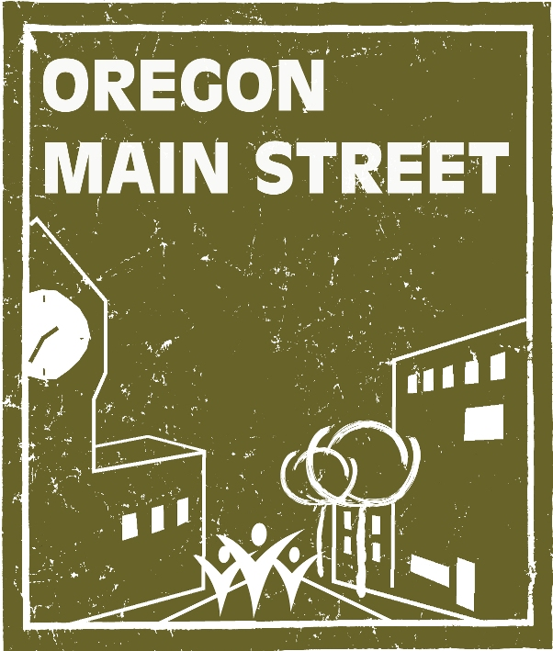
Award Nomination Form

Award Category (select one by double clicking on appropriate box and clicking on “checked”):
Outstanding Partnership Best Bus. Retention/Recruitment Program
Outstanding Façade/Bldg. RehabProject Outstanding Achievement in Promotion
Outstanding Design Project Outstanding Organizational Project
Best Public Improvement Project Innovation Award
Sustainability/Green Award Main Street Manager of the Year
Business Success Story Volunteer of the Year

Name of Nominee:

Title of Project or Activity:

Name of Person Submitting Nomination:
Address:
Telephone Number:
Email Address:

Name of the individual to accept the award, if chosen:

State Legislative District:

Project Summary: In one paragraph, please provide a brief summary of the project or activity, including the project’s purpose:

Project Background: Describe the need and context for the project.

Project Description: Describe the activities that took place to achieve the final result or product. Include the project budget and timeframe.

Local Appropriateness: How does your project reinforce and capitalize on the unique assets of the local community?

Impact: Please explain how this project has impacted your downtown or neighborhood commercial district and the businesses located there. Has the project had any effect on local policies? Are there secondary or spin off effects? For instance, did the rehabilitation of a particular building spur additional investment downtown, or have an effect on nearby businesses?

Conclusions: Tell us why you believe this project should receive an award over other projects that may be submitted in this category.

Submittal Information

- Please tell us the exact name or title of the individual/business/event or activity as you wish it to appear on the awards. PLEASE CHECK SPELLING.

- Good quality photos are very important. Provide up to ten (10) digital images as .jpg files on CD for each nomination submitted (images will be used in the awards presentation as well as part of the judging process). If necessary, please attach an 8 ½ x 11 inch sheet with brief corresponding descriptions. Please do not insert pictures within the text portion of your nomination. Digital images submitted with your entries become the property of Oregon Main Street and may be used for future presentations and publications.

- Provide five (5) copies of each application and supporting materials described under the award category on pages 3-4. Do not send cover letters or unrequested items. Note that only one set of digital images is required for each nomination.

- Fasten together application and supporting materials with a paper clip or staple. Remember, 5 sets of each nomination packet are required. If you are submitting nominations for more than one category in the same envelope, please group the nomination packets by category.

- All nominations must arrive at Oregon Parks and Recreation Department by 3 PM on July 30, 2012. Late and incomplete nominations will not be considered.

Address: Sheri Stuart
Oregon Main Street/Oregon Parks and Recreation Department
725 Summer Street, Suite C
Salem, OR 97301

- Complete applications may be emailed as word documents with attached jpegs and PDFs of supporting material (do not email zip files!).

- A maximum of two projects or activities may be nominated in each category. Each project or activity may only be nominated in one category.

- Projects or activities receiving awards in previous years are not eligible unless there have been substantial changes or additions made during the nomination timeframe.

- Entries and supporting material will not be returned.

- The jury reserves the right to eliminate categories if a reasonable number of worthy nominees have not been submitted in a given category. Awards judges also reserve the right to move a nomination to a different category.

- For purposes of this award, “downtown” is defined as the traditional, compact, pedestrian-oriented central commercial district of a community. Historic commercial neighborhood districts are also eligible to apply.

For additional information, contact Sheri Stuart at 503-986-0679.

