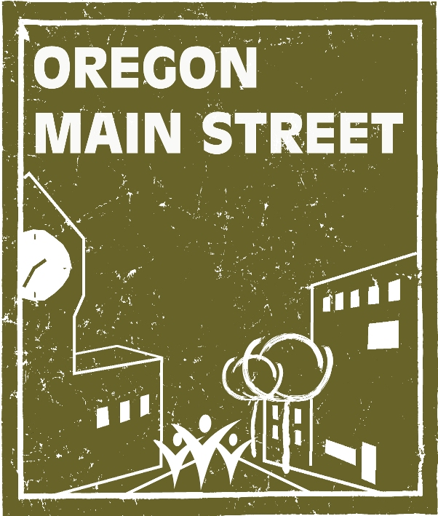

Request for Nominations
“Excellence in Downtown Revitalization Awards”
Nominations due July 30, 2012

Oregon Main Street, administered by the State Historic Preservation Office (Oregon Parks and Recreation Department), invites you to submit nominations for outstanding achievements in comprehensive downtown revitalization efforts. Awards will be presented during a special celebration at the Oregon Main Street Conference, October 3-5, 2012, in Corvallis, Oregon.

Eligibility: All levels of participants in the Oregon Main Street Network (Performing Main Street, Transforming Downtown, Exploring Downtown, and Affiliate) may submit applications. Call 503.986.0679 if you’re not sure whether your community is participating in the Network.

Project Timeframe: To be eligible, all projects, activities, or events submitted for recognition must have been completed between July 1, 2011 and June 30, 2012.

To be considered for an award, please complete the nomination form provided. Only complete applications will be accepted for consideration. A jury of downtown revitalization peers will review nominations to evaluate how the projects meet the criteria described under each of the following categories:

- Outstanding Partnership: Nominations should demonstrate how two or more organizations have effectively collaborated on a specific downtown preservation project or on-going downtown revitalization effort. Partners can include, but are not limited to, a Main Street program, local government, other non-profit organization, or private enterprise. How did the partnership come about? Were there obstacles or competing interests that were overcome? What will be the long-term or on-going benefit to the relationship?

- Outstanding Façade or Building Rehab Project: This award recognizes design excellence in a single façade improvement, adaptive re-use, or rehabilitation project and includes public or private projects. The physical design of the project should enhance the downtown or neighborhood commercial district in appearance or function. Important factors are design quality, historic preservation, creativity, and impact within budget. We’d like to hear about the problems addressed, impacts created, funding source(s), participants and process, and special design considerations. Please include before and after photos as applicable. Tips: before and after shots are most effective when taken from the exact same location/angle. It is also sometimes helpful to show the project in context to its surroundings.

- Outstanding Design Program or Project: This category includes other design related activities such as design education projects, activities, or workshops; public art project; visual merchandising or window display program; or other Design Committee related projects. Describe the project and the results, submit photographs, news articles, PDF of marketing material, etc. to support the nomination.
- Best Public Improvement Project: This award is given to the municipality or main street program that has designed and implemented attractive and sympathetic improvements for its downtown or traditional commercial neighborhood district. Improvements must be within the Main Street district. Streetscapes are included. Describe the project and results and submit photographs, news articles, or other information to support the nomination.

- Sustainability/Green Award: Successful entries in this category will demonstrate principles of sustainability and/or green building design that enhance historic downtowns or traditional commercial neighborhoods. The project or promotion submitted must achieve measurable energy-saving/efficiency standards, and have documented evidence that the project utilized sustainable products, programs, and practices. Describe the project and results; in addition, submit photographs, news articles, brochures, newsletters, web-site pages, or other information to support the nomination.

- Business Success Story: This award honors a downtown or neighborhood commercial district business that has improved its volume of business through increased sales, product line, expansion, etc. If applicable, please include a written statement from the business owner stating how the local organization helped their business.

- Best Business Retention/Recruitment Program for Downtown: Granted to the downtown organization that has created and implemented the best retention and/or business recruitment program for the downtown. Examples of retention strategies are financial incentive programs, educational programs, etc. Recruitment considerations are downtown building inventories, market analyses, recruitment packets and the actual process of recruiting new businesses. Be sure to describe how the project or activity was put together, its impact on the district including existing businesses, and other pertinent information including who was involved, and what was accomplished.

- Outstanding Organizational Project: This category is for a successful project completed by the local Main Street community’s Organization Committee. The project should be unique and focus on at least one component of the committee’s responsibilities including: volunteer development (e.g., volunteer recruitment, training, retention, or recognition activities), fundraising activities, or promotion or marketing of the overall downtown revitalization program. Describe the project and results and submit photographs, news articles, brochures, newsletters, web-site pages, or other information to support the nomination.

- Outstanding Achievement in Promotion: This award recognizes excellence in promoting a downtown or neighborhood commercial district through creative and effective image campaigns, special events, retail sales, or other promotional projects that help spread the word about the community’s center. Tell us about the cost, funding source(s), target audience, goal of the promotion, and the results. Describe the role of the business community before, during, and after the event (if applicable). Don’t forget to mention significant in-kind donations and sponsorships. Please attach photographs, and PDFs of posters, brochures, flyers, or image materials produced as supporting material.

- Innovation Award: This is the all-purpose category to showcase your community’s “big idea” for your downtown. Any project, program, or promotion that has enhanced the downtown in a cutting edge fashion should be considered. This award will recognize a special one-time project or activity that affects a downtown or neighborhood commercial district revitalization effort in some way. Tell us about the type of project, and the goals of the project and how they were met or exceeded. Be sure to describe how the project was organized, who was involved, the cost, and what was accomplished.

The Following Two Categories are for Performing Main Street or Transforming Downtown Communities Only:

- Main Street Manager of the Year: This award will be given to a Main Street Manager from a Performing Main Street or Transforming Downtown community for the overall impact he or she has had on the local downtown revitalization program. The successful entry will describe how the manager has coordinated and facilitated activities of the Board of Directors and committees, been a resource to downtown property and business owners, fostered collaboration with other organizations, and been a positive force behind the program’s success. Describe the Manager’s impact and submit photographs, news articles, statistics, or other information to support the nomination.

- Volunteer of the Year: This award will be given to a Main Street volunteer from a Performing Main Street or Transforming Downtown community for the overall impact on the local downtown revitalization program or a specific committee. All nominees will be acknowledged. The successful entry will describe how the volunteer has been an integral part of the local program. Describe the volunteer’s impact and submit photographs, news articles, number of volunteer hours, statistics, or other information to support the nomination. Submit only one Volunteer of the Year nomination and photograph per community. Please note: this nomination can be an individual, couple, team, business or organization who has contributed to local downtown revitalization efforts.

