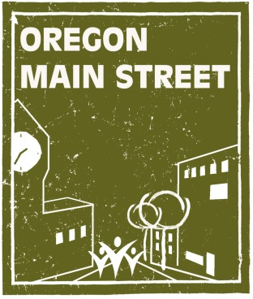
Oregon Main Street Winter Workshop
Committees to Task Squads: A Volunteer-driven Action Plan
Date: January 24, 2014
Time: 9:00 to noon
Location: Palmer Creek Lodge/Dayton Community Center
606 4th Street, Dayton, OR
To Register, cut and paste into your internet browser the following link: http://www.eventbrite.com/e/oregon-main-street-winter-workshop-committees-to-task-squads-a-volunteer-driven-action-plan-tickets-9988990339?aff=TaskSquads
Additional Information: sheri.stuart@state.or.us

Workshop Description
Volunteers are essential to every Main Street program, but it can be a struggle to attract and maintain good ones. Find out how Clovis Main Street in New Mexico, a semi-rural community of just under 40,000 found a way to engage its volunteers. Over the course of three years, the board developed a volunteer action plan to meet its needs and maintain the integrity of the Main Street Four Point Approach®. The new structure focuses on “task squads” that carry out simple events and activities that a volunteer can accomplish in short, specific time frames.

Learning Objectives:
- Understand the task squad concept.
- Learn how to develop effective volunteer-driven action plans.
- Apply this new approach in part, or in whole, in your community.
- Help volunteers develop tasks they are passionate about within the mission of Main Street.

Speakers

Robyne Beaubien is a seasoned non-profit professional with experience in organization, branding and promotions. She has spent 25 years working in and with a variety of non-profits, including MainStreet, and currently consults with the the New Mexico MainStreet Program in Promotions. In this position, Robyne works directly with MainStreet staff and volunteers in image development, branding, special events, promotional events and media relationships. She also facilitates training and strategic planning for promoting MainStreet districts. Robyne has directed the Clovis MainStreet program for more than eight years and her in the trenches experience, brings a fresh and practical approach to her speaking style.

Lisa Dunagan has been working with non-profit organizations for over 20 years that include local chamber of commerce, industrial development, United Way, and Main Street. Working on the boards of these organizations, she has helped make them stronger by using innovative ideas for fundraising, event organization, and volunteer development. Lisa currently serves as President of Clovis MainStreet in Clovis, New Mexico. In addition to her non-profit volunteer work, she has 28 years’ experience in the banking industry as a lender to small business, commercial, real estate and agriculture. She has her Graduate Degree in banking from the University of Colorado. Committing time to economic development, Lisa Currently serves by governor appointment on the Board of the New Mexico Partnership and board chair of the Main Street Revolving Loan Fund. These two appointments recruit business and industry while assisting with loans for small business. Lisa has been acknowledged for numerous awards and recently received the 2012 Citizen of the Year award by the Clovis/Portales Association of Realtors, Inc. Lisa Dunagan says, “It is a privilege and honor to be chosen to share our story with you.”

