1925
Beaver Theatre
Plaque dedicated 2012
Beaverton Downtown Association
Beaverton Downtown Historic District
Est. 1986
National Register of Historic Places

The Beaver Theatre was built for stage shows and silent pictures.
Local teenage girls played the organ to accompany the films.
Talkies arrived in 1930 when the
first all-talking movie shown here was “Broadway.”

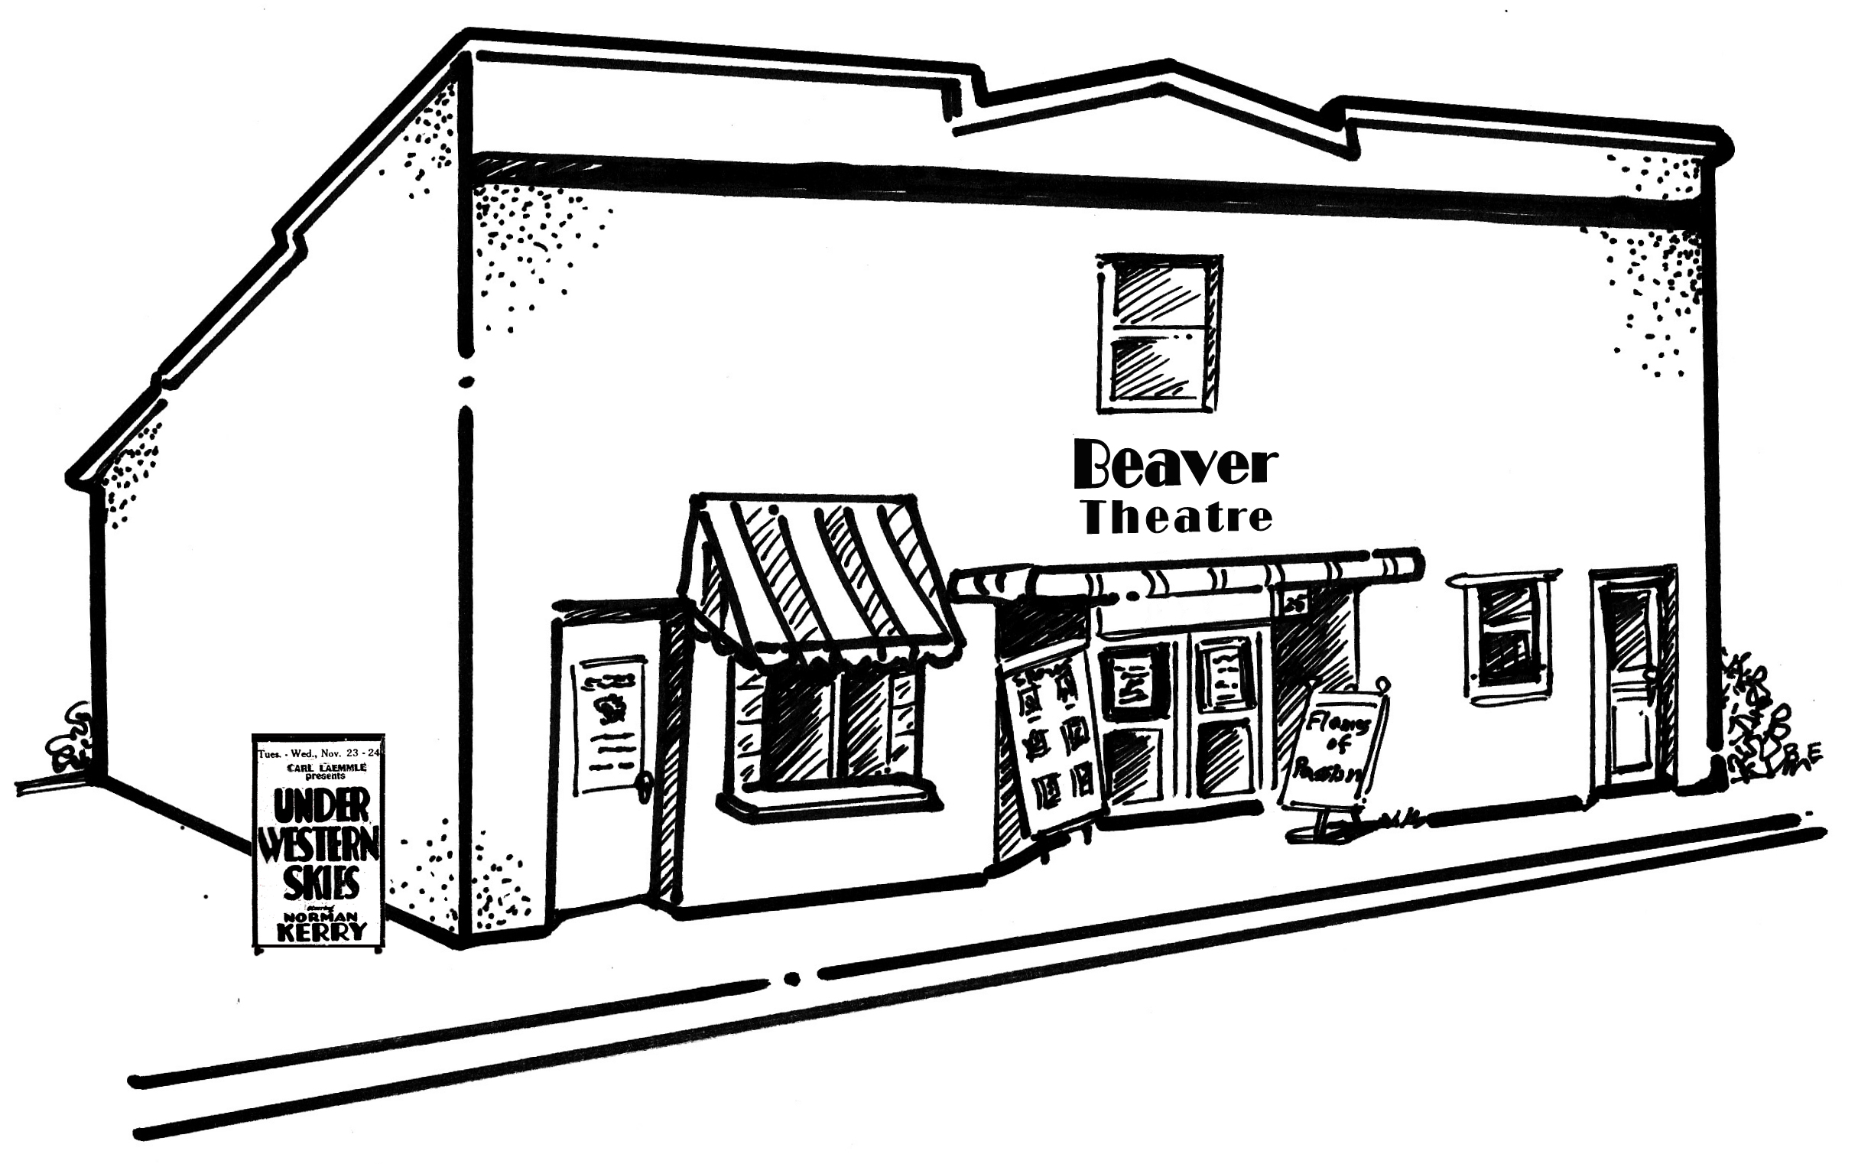
“The Flash” and “Flames of Passion” were among those
movies produced in Beaverton by
Premium Picture Productions (1921-25).
Shown locally and distributed nation-wide,
these films used local residents,
including children, as extras.

