2015

Transportation and Growth Management
Grants to Local Governments

Application Packet

Application Deadline:
4:00 p.m.
Friday, June 12, 2015

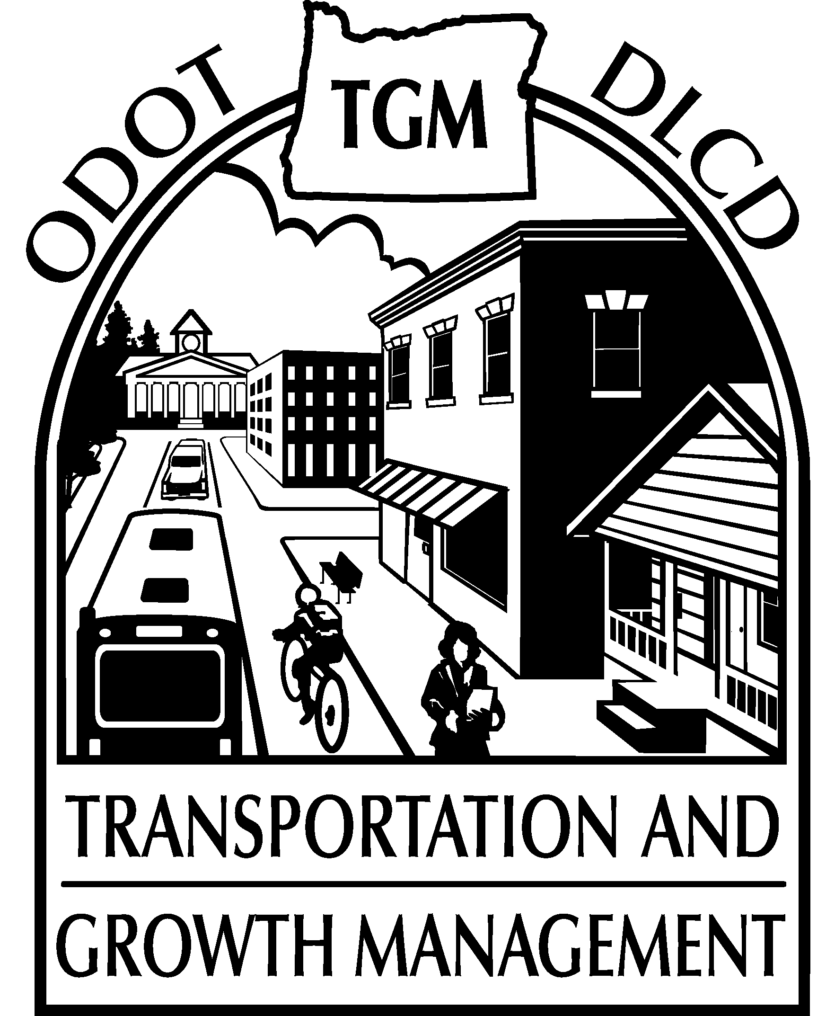 |  | Contents Page  Application Checklist 2  Introduction & Grant Basics 3  Eligible Projects 8  Eligibility & Award Criteria 10  TGM Staff Contacts 14
A joint program of the
Oregon Department of Transportation and the
Oregon Department of Land Conservation and Development
Better Ways to Better Places

TGM APPLICATION CHECKLIST
Download the Cover Sheet, Application Form, Racial and Ethnic Impact Statement, and this Application Packet at: http://egov.oregon.gov/LCD/TGM/grants.shtml
NOTE: Application materials MUST be submitted BOTH electronically and in hard copy
  - Electronically submitted application materials must include:
- Cover Sheet
- Application Form (please limit to 10 pages)
- Project area map
- Racial and Ethnic Impact Statement (now required for state grants by SB 463, from the 2013 Regular Legislative Session)
- Resolution or letter of support from governing body of applying jurisdiction(s)
- Optional additional letters of support from stakeholders (for award criterion #4).
NEW: TGM no longer accepts resolutions or support letters after the June 12th deadline .
  - You must also mail or hand-deliver 1 paper copy of all electronically submitted application materials. Paper copy must be submitted on white, three-hole punched, 8-1/2” x 11” recycled paper. NO covers or additional binding.
Consultants: Consultants may prepare the jurisdiction’s application. However, uncompensated consultants are not eligible to participate in the project itself. Consultants who are paid to prepare the application may be eligible to participate in the project. Contact Cindy Lesmeister at 503-986-4349 if you have questions.
Electronic applications are due by 4:00 p.m, Friday, June 12, 2015. Email them to TGMGrantApps@odot.state.or.us. If your materials exceed 9 MB, divide them into two emails. Put the jurisdiction name and project name in the subject line, along with 1 of 2 and 2 of 2.
Mailed applications must be be POSTMARKED by Friday, June 12, 2015 and sent to:
Cindy Lesmeister
Transportation and Growth Management Program
ODOT Mill Creek Building
555 13th Street NE, Suite 2
Salem, OR 97301
If you encounter any issues with the submittal process, contact:
Rebecca Coffelt, Planning Section Web Coordinator
Rebecca.D.COFFELT@odot.state.or.us
(503) 986-4254
Sign Up for Emailed Updates: You may subscribe to receive announcements concerning TGM services, as well as the ODOT STIP Enhance Funding Program: Subscribe to email list

Introduction & Grant Basics
The Transportation and Growth Management (TGM) Program invites you to apply for funding in the 2015 grant cycle. The TGM Program provides resources to help Oregon communities prepare transportation and land use plans to respond to pressing transportation, land use, and growth management issues.

The TGM Program is a joint effort of two state agencies: the Oregon Department of Transportation (ODOT) and the Oregon Department of Land Conservation and Development (DLCD). The mission of TGM is to support community efforts to expand transportation choices. By linking land use and transportation planning, TGM works with local governments to create vibrant, livable places in which people can walk, bike, take transit or drive where they want to go.

The TGM Program works in partnership with local governments and other stakeholders to accomplish the following goals and objectives:

- Provide transportation choices to support communities with the balanced and interconnected transportation networks necessary for mobility, equity, and economic growth.
  - A balanced, interconnected, and safe transportation system that provides a variety of transportation options and supports land uses.
  - Appropriately sited, designed, and managed local, regional, and state transportation facilities and services that support the movement of goods and provide for services.
  - Mobility choices for underserved communities and those with limited options.
  - Safe and convenient walking, biking, and public transportation opportunities to support a healthy, active lifestyle.

- Create communities composed of vibrant neighborhoods and lively centers linked by convenient transportation.
  - Livable towns and cities with a mix of housing types, work places, shops, schools, and parks for people of all ages, incomes and abilities.
  - Well-located activity centers, including schools and other government services, which are accessible to pedestrians, bicyclists, and transit users.
  - A safe and appealing physical environment supportive of the social, cultural, and health needs of all the community residents.

- Support economic vitality by planning for land uses and the movement of people and goods.
  - Thriving existing neighborhoods and centers and well-planned new growth that accommodate existing and future residents, businesses, and services.
  - Well-located and accessible industrial and employment centers.

- Save public and private costs with compact land uses and well-connected transportation patterns.
  - Urban growth accommodated within existing communities, thus minimizing, delaying, or providing an alternative to an urban growth boundary expansion.
  - Future transportation needs accommodated within the existing or improved system, thus minimizing, delaying, or providing an alternative to constructing additional major infrastructure projects.

- Promote environmental stewardship through sustainable land use and transportation planning.
  - Transportation systems and land use patterns that protect valuable natural resources, promote energy efficiency, and reduce emissions of air pollution and greenhouse gases.

The TGM Program is primarily funded by the federal transportation legislation, Moving Ahead for Progress in the 21st Century (MAP-21), under an agreement with the Federal Highway Administration, with additional staff support and funding provided by the State of Oregon. Awarded projects are administered by TGM on behalf of a local jurisdiction according to state and federal requirements.

The TGM Program awards grants on an annual basis. Grants generally have a two-year period for projects to be negotiated and completed. Award amounts generally range between $75,000 and $200,000.
The TGM Program is committed to coordinating with and supporting other state programs. TGM planning grants can help local governments compete for state funding from such programs as:
- Oregon Main Street Program (http://www.oregon.gov/OPRD/HCD/SHPO/Pages/mainstreet.aspx)
- ODOT – Enhance Funding
(http://www.oregon.gov/ODOT/TD/STIP/Pages/WhatsChanged.aspx)
- ODOT - Public Transit Division
(http://www.oregon.gov/ODOT/PT/Pages/index.aspx)
- Department of Land Conservation & Development (http://www.oregon.gov/LCD/Pages/grants.aspx)

Eligible Applicants
Cities, counties, councils of government on behalf of a city or county, and tribal governments. Certain special districts are eligible, such as transportation districts, metropolitan planning organizations, ports, mass transit districts, park and recreation districts, and metropolitan service districts. School districts may be eligible as part of a joint application with a local government for an otherwise eligible project. Eligible applicants may join together to propose a project, such as a multi-county TSP or multi-city or city-county corridor plan.

Grant Selection
Projects are selected on a competitive basis within each of the five ODOT regions (see map on page 14). Applications are scored using the criteria on page 10. A consideration when scoring is ensuring a fair distribution of grant funds to smaller communities. TGM consults with other state agencies to gain further insights about proposed projects.

In August 2015, successful applicants will receive a grant award letter. The successful applicant and a TGM grant manager will work together to prepare a project statement of work, select a consultant (as appropriate), and complete an intergovernmental agreement (IGA).

Initial project statement of work negotiations must be completed within TGM’s timeline or the grant award may be withdrawn. The grant award is not final until the intergovernmental agreement between ODOT and the local grantee is signed by all parties.

Use of Consultants
For projects using consultants, ODOT, rather than local grantees, will contract with consultants. Using ODOT policies and procedures that meet state and federal requirements, TGM staff will work with jurisdictions to select the project consultant that best fits the specific planning services needed.

Grantee Obligations
Match: TGM requires a local grant match of 12% of the total project cost. Grantees typically provide match in the form of cash or direct project costs, such as grantee staff time and materials directly related to the project. In certain cases, contract staff and certain volunteers’ time also may be counted as match. Communities defined as “distressed” by the Oregon Business Development Department may request a partial match waiver. The list of distressed communities is available online at: http://www.oregon4biz.com/Publications/Distressed-List/.
The ways to fulfill match requirements vary:
- Grantees not using consultants will bill TGM for eligible project costs, such as in-house staff labor or other eligible items. TGM will reimburse the grantee for those costs, less the required match amount.
- Grantees using consultants and not being partially reimbursed for their own work must submit match reports that document eligible local project costs to meet the match requirement.
- Grantees using consultants and being partially reimbursed for their own work will bill all of their work and be reimbursed for those costs less the required match. Consultants will bill and be paid at 100%.
- Grantees may send cash directly to TGM at signing of IGA.
Please Note: As a grant award condition, grantees who have any unmet match obligations from previous TGM grant projects must document that the match was provided or pay the balance of unmet match within three weeks of notice of new grant award, or the award will be withdrawn.
Project Management: Local commitment is the key ingredient to a successful project. As a condition of award, grantees will be asked to provide written commitment that they will meet all grantee obligations in a timely manner. Grantees must provide a project manager who will:
- serve as principal contact person for the project;
- help to develop a statement of work;
- monitor and coordinate work, including consultant work;
- keep local decision-makers informed about the project;
- make logistical arrangements;
- provide public notification for local meetings and public events;
- work with the TGM grant manager to ensure completion of all work on time and within budget;
- review consultant work products and payment requests; and,
- prepare progress reports, match reports, and reimbursement requests.
Eligible Costs: TGM grants and required match can be spent only on “direct project-related costs.” Eligible costs include salary of local government employees assigned to the project, postage, travel, supplies, and printing.

Equipment purchases and indirect costs, including general administrative overhead, are not eligible costs unless you have a federally approved indirect cost plan. Local expenses for persons or firms who contract with a local government to provide planning or other services are not eligible costs.

Costs incurred prior to signing an intergovernmental agreement are not eligible project costs. This includes costs of preparing the grant application, preparing a statement of work for the intergovernmental agreement, and selecting a consultant.
Title VI/Environmental Justice/Americans with Disabilities: Awarded projects are expected to abide by Title VI and related authorities including Executive Order 12898 (Environmental justice) which prohibit discrimination on the basis of race, color, national origin, or income, and other demographic characteristics. They are intended to make planning and decision-making more inclusive and to more equitably share the impacts and benefits of projects that receive federal funding. The public involvement program must include specific steps to provide opportunities for participation by federal Title VI communities. In addition, grants that include planning for pedestrians must consider Americans with Disabilities Act requirements.

For more information, see:
http://www.fhwa.dot.gov/environment/environmental_justice/
http://www.justice.gov/crt/about/cor/coord/titlevi.php
http://www.ada.gov//2010ADAstandards_index.htm

Timeline
June 12, 2015 Grant Applications due by 4:00 p.m.
June-August 2015 Application scoring and ranking
August 2015 Project award announcements
December 2015-January 2016 Must have agreed on a detailed statement of work sufficient to select a Consultant or prepare an IGA if no consultant will be used
April-May 2016 IGA and personal services contracts must be signed and projects underway
At time of award, grants will be designated as either Fast Track, with earlier negotiation deadlines, or Standard Timeline. Grant projects generally have a two-year period to be negotiated and completed. Projects designed to take more than two years from award to completion should be identified as such in your application and may be programmed beyond the two year grant period. Project extension is subject to available funding and continued project eligibility.

ELIGIBLE PROJECTS
An applicant may choose from two categories of grants: Transportation System Planning or Integrated Land Use and Transportation Planning.

We are particularly interested in projects that demonstrate innovation in objectives, approach, or end product. Some examples of this could include considering public health objectives and collaborating with local public health officials, doing analyses aimed at reducing transportation-related greenhouse gas emissions, or incorporating innovative multimodal analysis tools, such as bicycle level of traffic stress or pedestrian safety planning.

A list of all TGM projects that have been completed or are underway is on our TGM Grants page on the Web: TGM Grant Projects

CATEGORY 1 – TRANSPORTATION SYSTEM PLANning

Purpose
To help local governments develop and update transportation system plans (TSPs) and implementing measures that implement the Transportation Planning Rule (OAR 660-012-0045), 1999 Oregon Highway Plan, 2006 Oregon Transportation Plan, and other applicable statewide plans; that increase opportunities for walking, biking, and transit; or reduce reliance on the state highway for local travel needs.

Eligible Uses
Projects in this category plan for transportation facilities inside Urban Growth Boundaries (UGB’s), in urban unincorporated communities, and along rural highway corridors. Projects proposed for areas being considered in a UGB amendment process may be eligible, but TGM will give careful consideration to whether the proposed project is timely and reasonably achievable (TGM scoring criteria #2 and 3). Category 1 projects typically include preparation and adoption of:
- Complete Transportation System Plan preparation and adoption that results in a balanced, multi-modal system that addresses and accommodates a range of transportation needs, including movement of freight;
- Discrete portions of TSPs, including local street network plans, bike and pedestrian plans, transit plans, transportation system management plans, demand management plans, safe routes to school-related plans, parking plans, freight plans, etc.;
- TSP updates, for example, to address new needs, comply with new state or federal regulations, maintain consistency with a regional transportation plan, or plan for areas newly brought into the UGB.
- TSP implementing measures, such as street design plans, subdivision and site design standards, capital improvement plans and other funding strategies and programs, and land use regulations required by the Transportation Planning Rule;
- TSP refinements, such as plans for highway segment designation, corridor plans, or other planning to implement the 1999 Oregon Highway Plan;
- Project-level planning for facilities or improvements included in an adopted TSP that results in resolving important transportation and land uses issues required to move projects forward toward funding consideration;
- Detailed access and circulation planning for key employment centers;
- Other innovative transportation-related projects that are consistent with TGM objectives – contact our staff to discuss your ideas.

CATEGORY 2 – INTEGRATED LAND USE AND TRANSPORTATION PLANNING

Purpose
To help local governments develop integrated land use and transportation plans that promote compact, mixed-use, pedestrian-friendly development; increase walking, biking, and transit options; or reduce reliance on the state highway system for local travel needs.

Eligible Uses
Projects in this category combine land use planning with transportation facility planning to meet transportation needs inside UGBs, urban unincorporated communities, and urban reserve areas. Category 2 projects may include preparation and adoption of:
- Transportation and land use plans for an entire urban area – in metropolitan areas, such plans should be designed to address state goals for reducing greenhouse gas emissions that contribute to climate change;
- Land use and transportation concept plans for areas that have been brought into a UGB;
- Specific development, redevelopment, and area plans for a downtown, mixed-use commercial area, or neighborhood, including designation of a multimodal mixed-use area (MMA, as defined in OAR660-012-060(10)) as part of such a plan;
- Interchange Area Management Plans (if land use focused);
- Implementing measures, such as TSP amendments, code amendments, infill and redevelopment strategies, funding strategies and programs, and intergovernmental agreements;
- Transportation and land use planning related to the Oregon Main Streets Program;
- Other innovative land use and transportation planning-related projects that are consistent with TGM objectives – contact our staff to discuss your ideas.

Grant Eligibility Requirements
TGM grants are for planning work leading to local policy decisions. TGM grants cannot fund preliminary engineering, engineering, or construction work. If in doubt, discuss with your Region TGM planner about whether your proposed work is eligible.

Applications are reviewed on a pass/fail basis on each of the following criteria. Applications found to not meet each of these requirements will not be scored against the award criteria and will not be awarded a grant.
- Clear Transportation Relationship
A proposed project must have a clear transportation relationship and benefits. A project must entail research, analysis, alternatives evaluation, development of implementation measures, or public involvement that addresses a transportation problem, need, opportunity, or issue of local or regional importance.
2). Adoption of Products
A proposed project must result in adoption-ready products that directly address the project objectives, such as a transportation system plan, comprehensive plan amendment, land use regulation, or intergovernmental agreement. Projects that will primarily do outreach, research, study an issue, or compile data are not eligible. Projects are expected to include adoption hearings.
3) Support of Local Officials
A proposed project must clearly demonstrate that local officials understand the purpose of the grant application and support the outcomes of the project. A letter or resolution of support from the governing body of the applying jurisdiction is required to be submitted with the application to meet this requirement.

AWARD CRITERIA
Applications are scored on a range of criteria and receive up to 100 points. Projects are selected primarily based on the points scored; also considered are the grant amounts requested, the estimated amounts TGM believes may be required to complete a project, the amount of grant dollars available for award within a geographic region, and the balance of grant dollars between Category 1 and Category 2 projects.
1) Proposed Project Addresses a Need and Supports TGM Objectives
The project clearly and effectively addresses a local or regional transportation or transportation-related land use issue, problem, need, or opportunity through achieving one or more of the following TGM objectives.
- Provide transportation choices to support communities with the balanced and interconnected transportation networks necessary for mobility, equity, and economic growth.
  - A balanced, interconnected, and safe transportation system that provides a variety of transportation options and supports land uses.
  - Appropriately sited, designed, and managed local, regional, and state transportation facilities and services that support the movement of goods and provide for services.
  - Mobility choices for underserved communities and those with limited options.
  - Safe and convenient walking, biking, and public transportation opportunities to support a healthy, active lifestyle.
- Create communities composed of vibrant neighborhoods and lively centers linked by convenient transportation.
  - Livable towns and cities with a mix of housing types, work places, shops, schools, and parks for people of all ages, incomes and abilities.
  - Well-located activity centers, including schools and other government services, which are accessible to pedestrians, bicyclists, and transit users.
  - A safe and appealing physical environment supportive of the social, cultural, and health needs of all the community residents.
- Support economic vitality by planning for land uses and the movement of people and goods.
  - Thriving existing neighborhoods and centers and well-planned new growth that accommodate existing and future residents, businesses, and services.
  - Well-located and accessible industrial and employment centers.
- Save public and private costs with compact land uses and well-connected transportation patterns.
  - Urban growth accommodated within existing communities, thus minimizing, delaying, or providing an alternative to an urban growth boundary expansion.
  - Future transportation needs accommodated within the existing or improved system, thus minimizing, delaying, or providing an alternative to constructing additional major infrastructure projects.
- Promote environmental stewardship through sustainable land use and transportation planning.
  - Transportation systems and land use patterns that protect valuable natural resources, promote energy efficiency, and reduce emissions of air pollution and greenhouse gases.
Up to 40 points: Provide a statement of project purpose and transportation relationships and benefits, and relate them to TGM objectives. You must list the specific objective(s) your project supports. Projects that address an issue, problem, need, or opportunity with a clear expected outcome will receive more points. Projects that meet one or several TGM objectives in a substantial, integral way will receive more points than projects that meet one or more TGM objectives superficially. If applying to update your Transportation System Plan and you asked TGM to perform a TSP Assessment, what were the key Assessment recommendations and how do they relate to your proposed project?
2) Proposed Project is Timely and Urgent
The application demonstrates timeliness and urgency. The project is needed now to:
- address pressing local transportation and land use issues;
- make amendments to local plans or regulations necessitated by changes in federal regulations, state requirements, or regional plans;
- make amendments to local plans or regulations necessitated by changes that were not anticipated in previous plans including growth, changes in land use patterns, or changes in available funding;
- build on, complement, or take a necessary step toward completing other high priority community initiatives, including supporting a Governor’s Regional Solutions Team priority; or
- resolve transportation- or land use-related issues affecting the project readiness of local, regional, or state transportation projects for which funding is expected to be obligated within the near future.
Up to 25 points: To explain why it is important to do the project at this time, describe what the project will accomplish and how it relates to other initiatives. Projects that match well with the TGM grant timeline will receive more points. Projects or project elements that are not clearly timely or urgent will receive fewer points.
3) Proposed Project Approach is Reasonable
The application demonstrates a clear approach to achieving the expected outcome and results in consideration for adoption. Where substantial coordination with other local, regional, and state planning efforts occurs (or will need to occur), the mechanisms and responsibilities for the coordination are clear.
Up to 15 points: Project approaches will receive more points if they clearly address the project need, are achievable considering scope, objectives, and benefits of the project, and are at a level of detail appropriate to the community.
4) Proposed Project has Community Support
The application demonstrates that there is local support for the project objectives, a commitment to participate, and a desire to implement the expected outcome.
Up to 5 points: Projects with written support from stakeholders including partner jurisdictions, community institutions, or businesses will receive more points. Letters of support should demonstrate a clear understanding of the project. A letter of support will score higher if it shows independent understanding of the project by the signer and is not identical in text to others that are submitted for a project.
5) Proposed Project Sponsor Readiness and Capacity
The application demonstrates that the local government is ready and able to begin the project within the TGM timetable and that there is local commitment and capability to manage the project considering the complexity of the project, the size of the jurisdiction, and performance on previous TGM projects. Where substantial coordination with other local, regional, and state planning efforts occurs (or will need to occur), all of the partners are ready and able to begin the project within the TGM timetable.
Up to 5 points: Projects with a clear description of the jurisdiction’s capabilities and experience relative to the complexity of the proposed project will receive more points. Projects that lack a clear description of how they will be managed will receive fewer points. You must list any prior TGM projects your community received (grants or Community Assistance service) within the last 10 years and provide their outcomes or receive fewer points. For prior projects that were similar in subject matter or location to your proposed project, discuss why your proposed project is different. [If you are unsure what prior TGM projects your jurisdiction has received, contact Cindy Lesmeister at cindy.l.lesmeister@odot.state.or.us]
6) Proposed Project is Innovative
The application demonstrates that the project will be innovative in its subject matter, approach, or expected outcomes. For example, the project will use public health criteria or economic impact analysis as part of the evaluation of transportation alternatives or will include an innovative multimodal analysis.
Up to 10 points: By the nature of this criterion, most projects will not receive any points. Projects may receive some points for innovative project elements. Projects with innovative subject matter will receive more points.

TGM Staff Contacts
For general questions about the application process and for assistance with filling out your grant application, contact Cindy Lesmeister at 503-986-4349 or cindy.l.lesmeister@odot.state.or.us.

For specific advice on project approach and objectives, contact our lead Region TGM planners, listed below.

ODOT Region 1 Lidwien Rahman
Portland 503-731-8229
lidwien.rahman@odot.state.or.us

ODOT Region 2 Naomi Zwerdling
Salem 503-986-2836
naomi.zwerdling@odot.state.or.us

ODOT Region 3 John McDonald
Roseburg 541-957-3688
john.mcdonald@odot.state.or.us

ODOT Region 4 Devin Hearing
Bend 541-388-6388
devin.hearing@odot.state.or.us

ODOT Region 5 Cheryl Jarvis-Smith
La Grande 541-963-1574
cheryl.jarvis-smith@odot.state.or.us

DLCD - Statewide Bill Holmstrom
503-934-0040
bill.holmstrom@state.or.us
