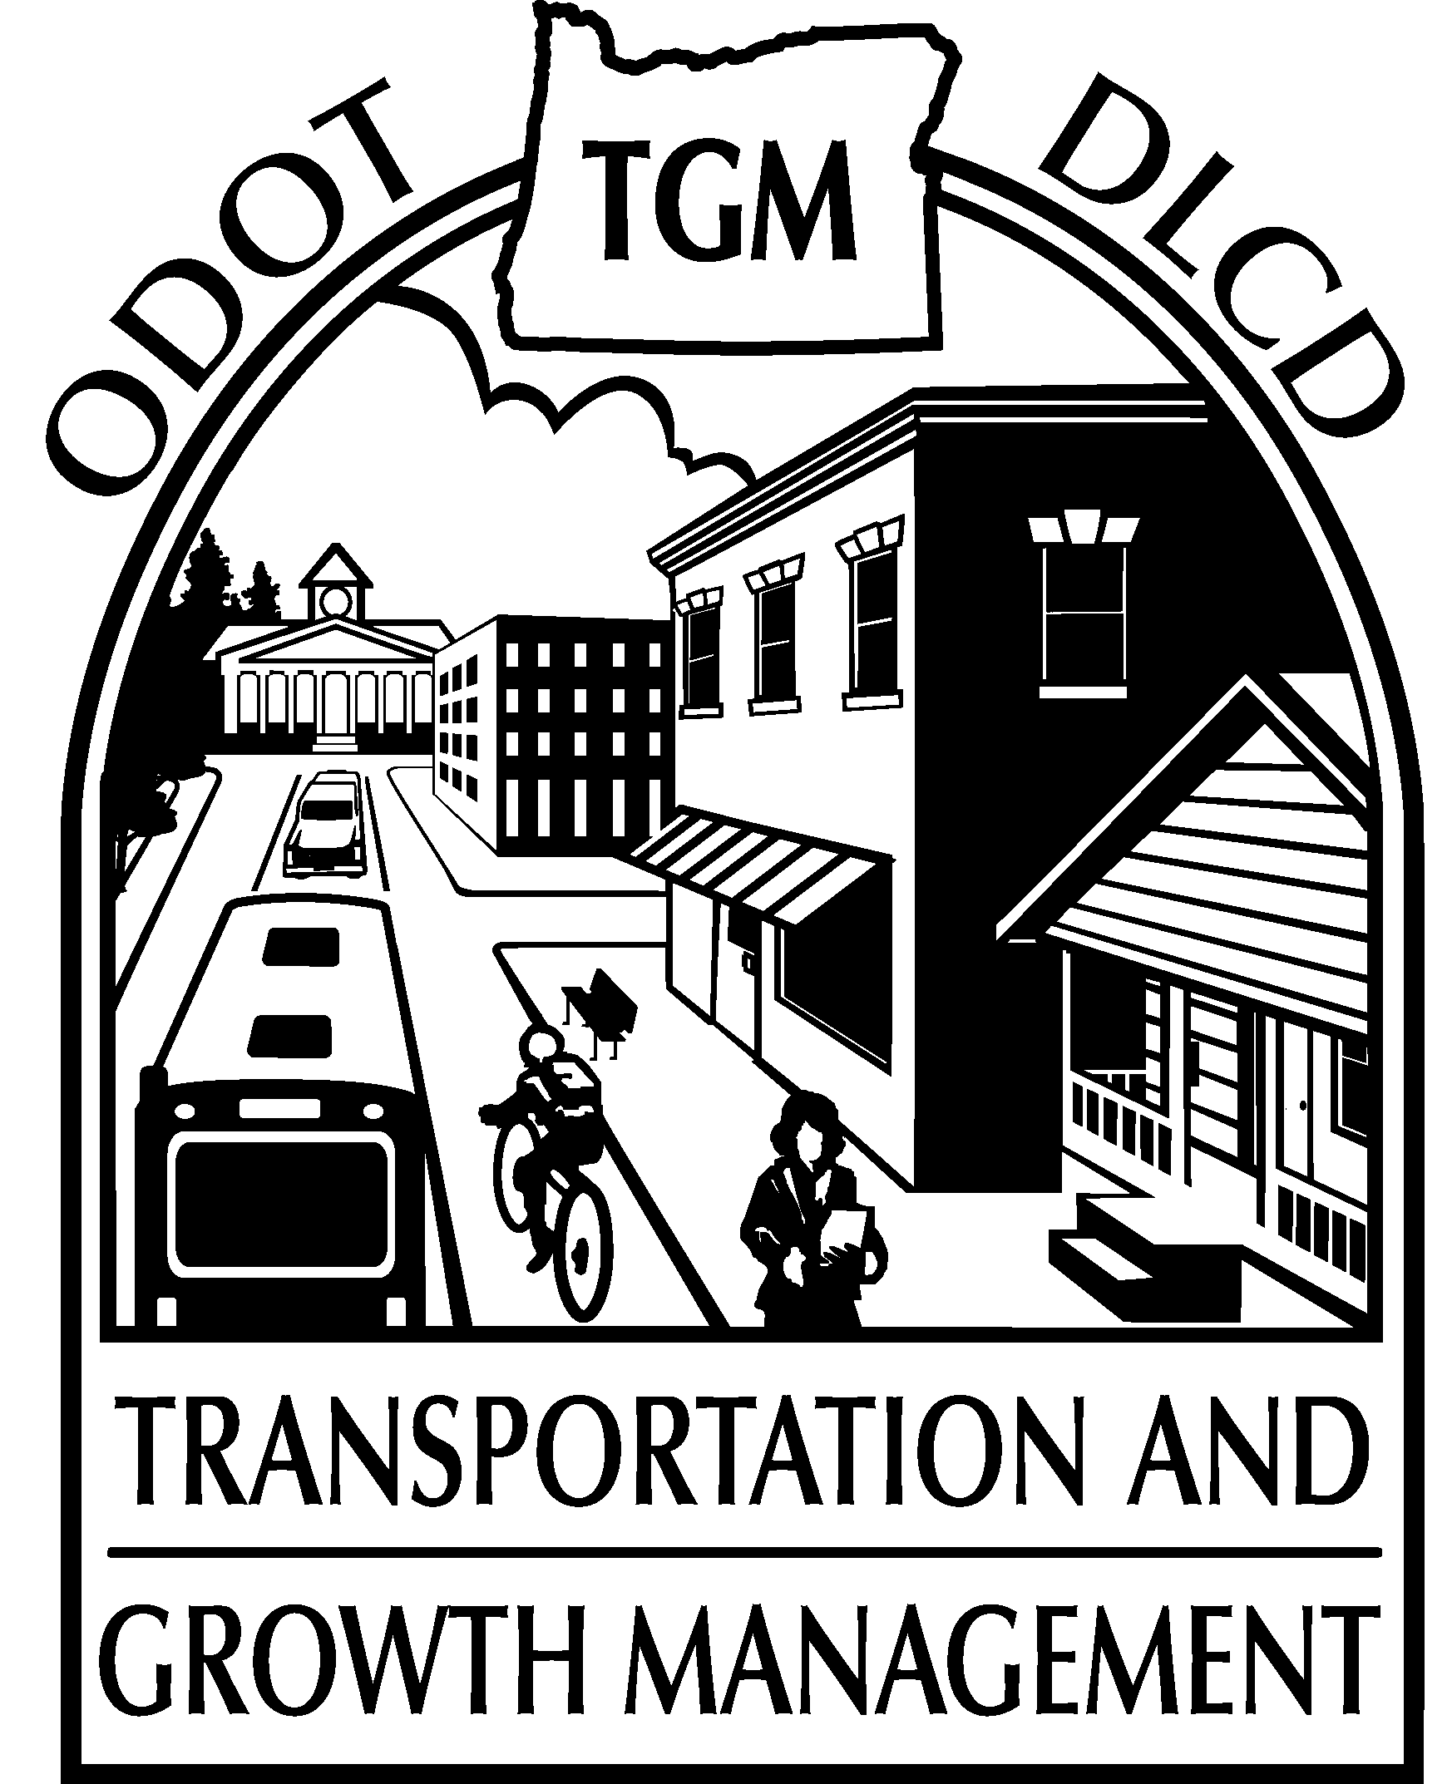 | Transportation and Growth Management (TGM)  2015 Grant Application FORM

Please read the Application Packet carefully before completing this application. You must submit your complete application both electronically and via postal mail.
Examples of successful applications and guidance on project costs are available on the TGM Grants page on the Web: egov.oregon.gov/LCD/TGM/grants.shtml.
Please limit application to 10 pages.

The answer fields below will expand as you type.

Organization name |  | phone
Contact person name and title | contact person e-mail
Project Title

Section One: GRANT ELIGIBILITY REQUIREMENTS
TGM grants are for planning work leading to local policy decisions. TGM grants cannot fund preliminary engineering, engineering, or construction work. If in doubt, discuss with your Region TGM planner about whether your proposed work is eligible.

Applications are reviewed on a pass/fail basis on each of the following criteria. Applications found to not meet each of these eligibility requirements will not be scored against the award criteria and will not be awarded a grant. Provide a brief statement of how you meet each requirement.

1. Clear Transportation Relationship
A proposed project must have a clear transportation relationship and benefits. A project must entail research, analysis, alternatives evaluation, development of implementation measures, or public involvement that addresses a transportation problem, need, opportunity, or issue of local or regional importance.

2. Adoption of Products to meet Project Objectives
A proposed project must result in adoption-ready products that directly address the project objectives, such as a transportation system plan, comprehensive plan amendment, land use regulation, or intergovernmental agreement. Projects that will primarily do outreach, research, study an issue, or compile data are not eligible. Projects are expected to include adoption hearings.

3. Support of Local Officials
A proposed project must clearly demonstrate that local officials understand the purpose of the grant application and support the outcomes of the project. A letter or resolution of support from the governing body of the applying jurisdiction is required to be submitted with the application to meet this requirement.

Section Two: Award Criteria
Applications are scored on a range of criteria and receive up to 100 points. Projects are selected primarily based on the points scored; also considered are the grant amounts requested, the estimated amounts TGM believes may be required to complete a project, the amount of grant dollars available for award within a geographic region, and the balance of grant dollars between Category 1 and Category 2 projects.

1. Proposed Project Addresses a Need and Supports TGM Objectives
The project clearly and effectively addresses a local or regional transportation or transportation-related land use issue, problem, need, or opportunity through achieving one or more of the following TGM objectives (as listed on page 10 of the Application Packet).

Up to 40 points: Provide a statement of project purpose and transportation relationships and benefits, and related them to TGM objectives. You must list the specific objective(s) your project supports. Projects that address an issue, problem, need, or opportunity with a clear expected outcome will receive more points. Projects that meet one or several TGM objectives in a substantial, integral way will receive more points than projects that meet one or more TGM objectives superficially. If applying to update your Transportation System Plan and you asked TGM to perform a TSP Assessment, what were the key Assessment recommendations and how do they relate to your proposed project?

2. Proposed Project is Timely and Urgent
The application demonstrates timeliness and urgency. The project is needed now to:
- address pressing local transportation and land use issues;
- make amendments to local plans or regulations necessitated by changes in federal regulations, state requirements, or regional plans;
- make amendments to local plans or regulations necessitated by changes that were not anticipated in previous plans including growth, changes in land use patterns, or changes in available funding;
- build on, complement, or take a necessary step toward completing other high priority community initiatives, including supporting a Governor’s Regional Solutions Team priority; or
- resolve transportation- or land use-related issues affecting the project readiness of local, regional, or state transportation projects for which funding is expected to be obligated within the near future.

Up to 25 points: To explain why it is important to do the project at this time, describe what the project will accomplish and how it relates to other initiatives. Projects that match well with the TGM grant timeline will receive more points. Projects or project elements that are not clearly timely or urgent will receive fewer points.

3. Proposed Project Approach is Reasonable
The application demonstrates a clear approach to achieving the expected outcome and results in consideration for adoption. Where substantial coordination with other local, regional, and state planning efforts occurs (or will need to occur), the mechanisms and responsibilities for the coordination are clear.

Up to 15 points: Describe the major project tasks and expected timeline. Consider data and analysis needs and elements of a public involvement process. If a consultant will be used, what are the likely roles of consultant and staff? How will coordination with other initiatives be handled? If TGM funds are proposed to leverage another outside source of funding for the project, identify discrete tasks that TGM will fund that will be completed within the TGM timetable. Project approaches will receive more points if they clearly address the project need, are achievable considering scope, objectives, and benefits of the project, and are at a level of detail appropriate to the community.

To help us understand your project, provide an estimated budget breakdown for the major tasks. If a consultant will be used, separate the costs for local staff and consultant. This budget breakdown will not be scored.

Task | Local  costs | Consultant  costs
1. | $ | $
2. | $ | $
3. | $ | $
4. | $ | $
5. | $ | $
6. | $ | $
7. | $ | $
8. | $ | $
9. | $ | $
10. | $ | $
11. | $ | $
12. | $ | $
Totals:

4. Proposed Project has Community Support
The application demonstrates that there is local support for the project objectives, a commitment to participate, and a desire to implement the expected outcome.

Up to 5 points: Projects with written support from stakeholders including partner jurisdictions, community institutions, or businesses will receive more points. Letters of support should demonstrate a clear understanding of the project. A letter of support will score higher if it shows independent understanding of the project by the signer and is not identical in text to others that are submitted for a project.
source
1.
2.
3.
4.
5.
6.
7.
8.

5. Proposed Project Sponsor Readiness and Capacity
The application demonstrates that the local government is ready and able to begin the project within the TGM timetable and that there is local commitment and capability to manage the project considering the complexity of the project, the size of the jurisdiction, and performance on previous TGM projects. Where substantial coordination with other local, regional, and state planning efforts occurs (or will need to occur), all of the partners are ready and able to begin the project within the TGM timetable.

Up to 5 points: Projects with a clear description of the jurisdiction’s capabilities and experience relative to the complexity of the proposed project will receive more points. Projects that lack a clear description of how they will be managed will receive fewer points. Applicants with prior TGM grant awards must list previous TGM projects and their performance. [If you are unsure what previous TGM grant awards your jurisdiction has received, contact Cindy Lesmeister at cindy.l.lesmeister@odot.state.or.us]

6. Proposed Project is Innovative
The application demonstrates that the project will be innovative in its subject matter, approach, or expected outcomes. For example, the project will use public health criteria or economic impact analysis as part of the evaluation of transportation alternatives or will include an innovative multimodal analysis.

Up to 10 points: By the nature of this criterion, most projects will not receive any points. Projects may receive some points for innovative project elements. Projects with innovative subject matter will receive more points.

