This 5 ½’ – 6’ diameter stained glass window is available free to a Presbyterian Church (USA) congregation or other non-profit organization. (Purchase requests will also be entertained.) Constructed in the Modern Style in 1957 by Bert Willemse, an immigrant from Holland who owned Willemse Stained Glass Studio of Scappoose, Oregon, the window was in the First Presbyterian Church of Coos Bay, Oregon for 55 years. When that church closed, it was donated to the First Presbyterian Church of Ashland, Oregon. The Ashland congregation has determined that it does not have wall space to display this window adequately.
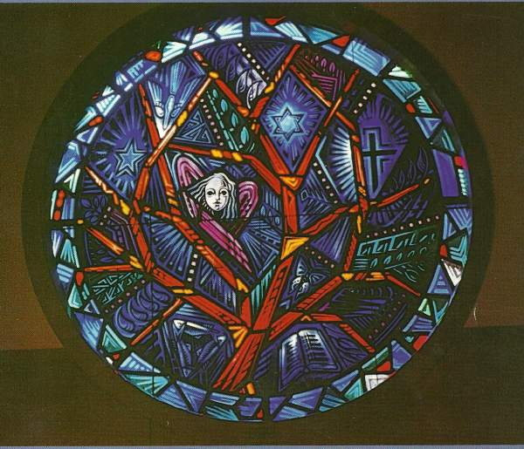
Wilmse’s artistic method consisted of the use of European glass, painting with ceramic paints and multiple firings of the glass. This method allowed him to achieve the detail depicted in the window. The method of construction is the use of lead came, cemented with putty and, for strength; there are multiple brace bars applied to the surface of the lead in the window.
Ashland stained glass restorer Dal Yockey (Canterbury Stained Glass Company) examined this quality window and determined that it should be restored if it is to be displayed with exposure to the elements. The lead caming has split in some areas. One section of the laminated round wooden framing needs to be replaced.
Mr. Yockey recommended that prior to exterior installation the whole window be traced, taken apart, old caming discarded and the window rebuilt at an estimated cost of $8,000. When restored, he estimated that the window has a replacement value of $15,000 to $17,000. (We do not know if the lead caming restoration is necessary if the window is to be installed in an interior back-lit wall.)
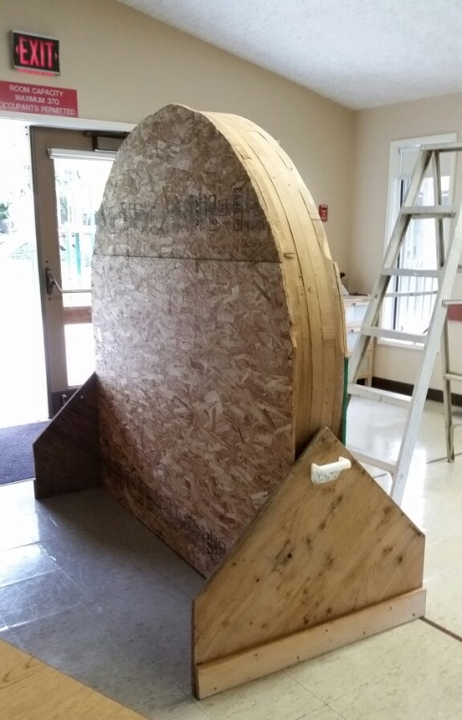
Currently, the window is packed for shipping in a heavy wooden support structure. Whomever wants the window will need to arrange for removal and shipping of this heavy item.
The symbolism in the window, while initially Christian, may be appropriate for an ecumenical setting such as a hospital or college chapel, community institution, retreat center or house of worship.
Symbols in the window include:
Tree of Life
Six-pointed star/Star of David/hexagram
Open Book/Bible/Torah
Cross
Descending Dove
Five-pointed Star
Young Angel
Butterfly
Leaves and Palms
Flames
Water Drops

If you are interested in this stained glass window, please email PresbyAshland@yahoo.com or call 541-482-3536.

First Presbyterian Church, PC(USA)
PO Box 626
Corner of Walker and Siskiyou Blvd
Ashland, OR 97520

