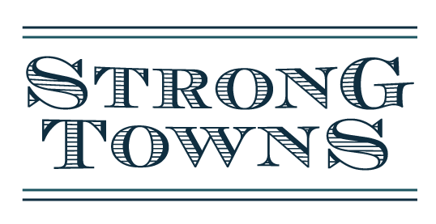

Contact: Rachel Quednau FOR IMMEDIATE RELEASE: 9/20/16
Strong Towns
quednau@strongtowns.org
844-218-1681

Strong Towns’ President Charles Marohn to Speak in Oregon in October

Charles Marohn, president of Strong Towns, a national nonprofit working to strengthen financial resilience in America’s towns and cities, will host a series of public presentations in the Portland/Salem region on October 3-5.

Mr. Marohn’s first “Curbside Chat” presentation will be held on Monday, October 3, at 5pm at Smith Memorial Union at Portland State University. This classic Strong Towns talk, which has been given in dozens of cities across the country, is centered on the question, “Why, despite all the growth America has experienced, do our cities struggle financially just to accomplish basic tasks?” The answers lie in the way we have developed; the financial productivity of our places. In the second half of the presentation, Mr. Marohn will specifically speak about issues in Portland and open the floor for discussion with attendees. Public officials and local change-advocates are especially invited to attend this free, public event, sponsored by the Portland Bureau of Transportation, in collaboration with several community organizations.

On October 4, Mr. Marohn will present in the Independence/Newburg region, in a series of events hosted by the Oregon Department of Land Conservation and Development. The first is a walking tour in Independence, beginning at 10:30am. At this interactive event, participants will learn Strong Town principles of financial solvency, incremental development, local economic growth and bottom-up activism as they apply in Independence, while identifying current challenges and discussing possible solutions for their built environment. The tour will begin at the Independence Civic Center (555 South Main Street) with a short presentation followed by a walk. At 7pm on October 4th, Mr. Marohn will also give a public presentation in Newberg at the Public Safety Building (401 E 3rd St). Mr. Marohn will speak about traditional downtowns and how they can create a more prosperous and economically productive city. He will share examples from other cities and discuss how Newberg can build a more productive downtown. Extended Q&A to follow.

Mr. Marohn’s final presentation will take place on Wednesday, October 5 at 7pm at the Loucks Auditorium at City Hall (645 Liberty St SE) in Salem. This event is sponsored by John Gear Law, Oregon PEN, Cherriots Rideshare (Salem-Keizer Transit), Salem CityWatch and Salem Community Vision. The Salem presentation is a “Curbside Chat” and will cover similar topics to the October 3 presentation, but tailored to the Salem audience, addressing specific issues in Salem. It is also free and open to the public.

In addition to these public events, Mr. Marohn will also host private meetings with local leaders to discuss improvements and growth for Portland and Salem.

About Strong Towns:
Strong Towns is a national media nonprofit whose mission is to advocate for a model of development that allows America's cities, towns and neighborhoods to grow financially strong and resilient. Strong Towns reaches an audience of more than 80,000 readers and listeners per month, and has over 1,000 members. Learn more at http://www.strongtowns.org

###

