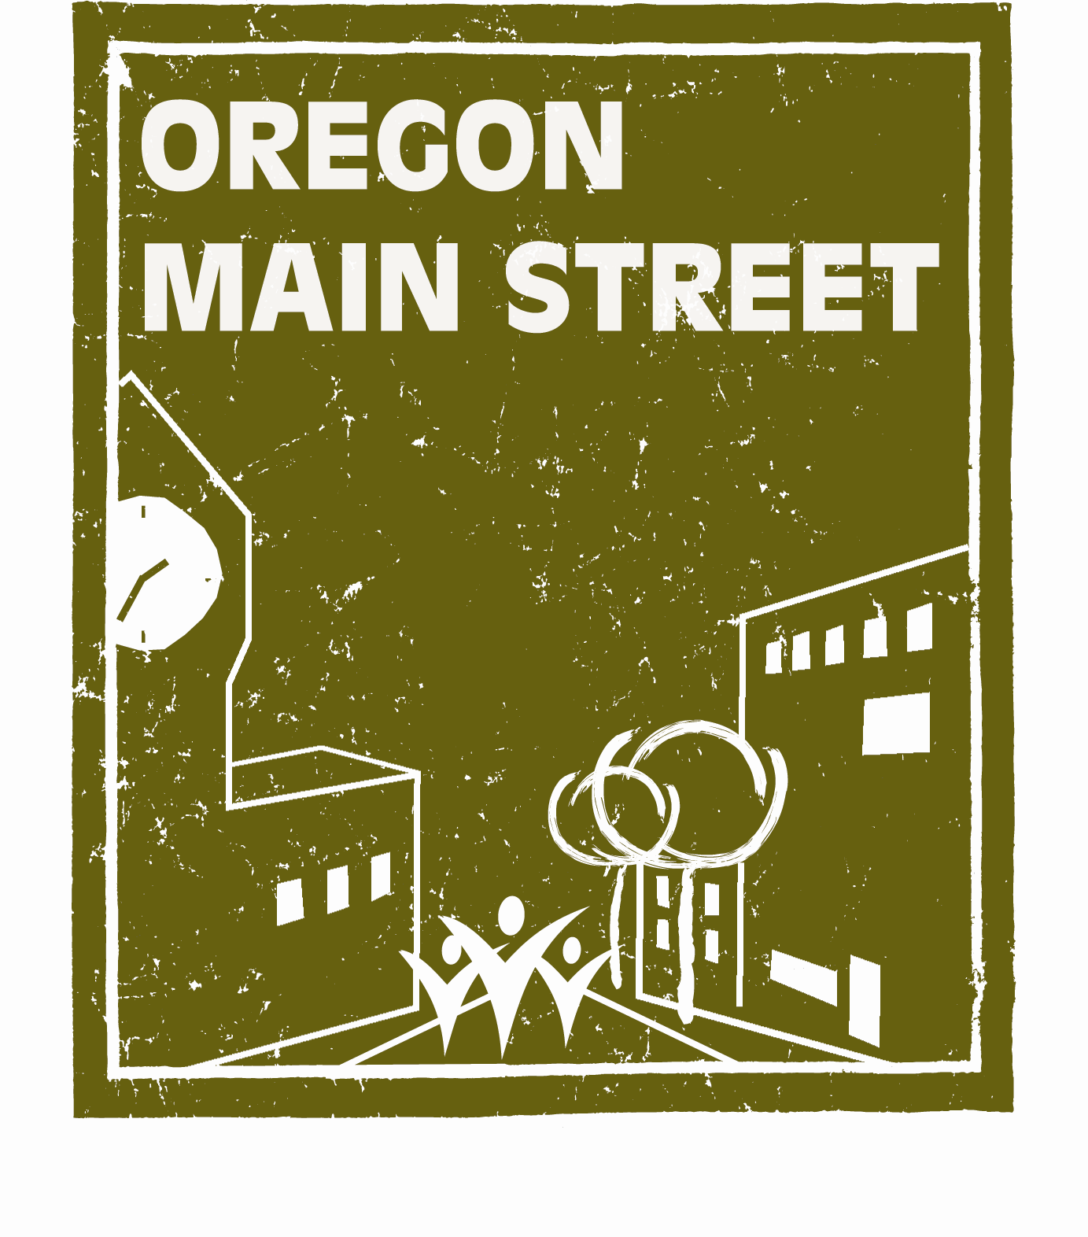
Oregon Main Street
Exploring Downtown Annual Report

Thank you for participating at the “Exploring Downtown” level of the Oregon Main Street network. Please complete this brief report and return to Oregon Main Street as partial fulfillment of the participation agreement by December 31, 2016 to:

Sheri Stuart, Coordinator
Oregon Main Street
725 Summer Street, Suite C
Salem, OR 97301
Email: sheri.stuart@oregon.gov

- What do you see as the greatest accomplishments of your downtown revitalization effort in the last year?

- What are your greatest disappointments?

- Has new leadership (at the board and committee levels) developed over the past year?

- Has your community made progress in implementing a comprehensive downtown revitalization effort using the Main Street Approach®? Please describe your activities in the following area:
Organization:

Promotion:

Design:

Economic Restructuring:

- What presentations, trainings, workshops, or conferences offered by Oregon Main Street have your volunteers attended in the past two years (2015 & 2016)?

- Have there been any façade improvements in downtown in the past year (please describe)? What is the approximate value of the investment?

- Have any new businesses opened in downtown in the past year (please list)? If yes, approximately how many full-time jobs were created?

- Have any business closed in downtown in the past year (please list)? If yes, approximately how many jobs were lost?

- Would you like to continue to participate at the “Exploring Downtown” level of the Oregon Main Street network?
_____ YES
_____ NO, please move us to the “Affiliate” level
_____ NO, please remove us from the Oregon Main Street Network

- Which of the following types of technical assistance would you like to receive from Oregon Main Street in 2016 if you choose to continue at the Exploring Downtown level:
_____Main Street Overview Presentation (Community Meeting)
_____Board Goal Setting
_____Committee Training

- Feel free to add additional comments below:

