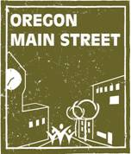
Design Assistance

Heritage Programs (Oregon Parks and Recreation Department) is pleased to offer free design assistance to communities participating in the Oregon Main Street Network.

The intent of this service is to:
- Identify likely candidates for the Oregon Main Street Revitalization Grant.
- Help property owners visualize improvements they can make to the front façade of their buildings or provide guidance in adaptive re-use of upper floors.
- Assist local programs in meeting their strategic plans to improve the character of their district by enhancing one of the key assets – historic downtown buildings.

What the service entails:
- Phone consultation with the design consultant.
- Façade drawing showing improvements to bring back the historic character.
- Paint color recommendations.
- Awning and sign placement as applicable.
- Alternately, we will be able to provide a limited number of adaptive reuse site visits. The consultant will do a walk-through of buildings with the building owner to discuss options for reuse.
Amity: After
Amity: Before

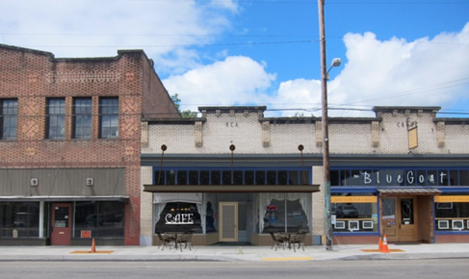
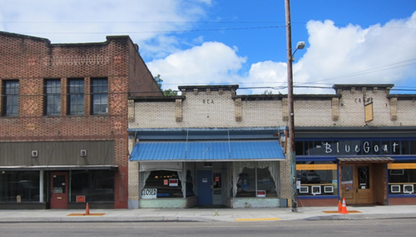
Eligibility:
- Be a current member of the Oregon Main Street Network.
- All communities participating in the OMS Network are eligible to apply, however priority will be given to the Main Street Track communities: Performing Main Street, Transforming Downtown, and Exploring Downtown.
- You must have submitted a copy of the map outlining the boundary of your downtown revitalization effort and have it approved by the main street coordinator prior to applying for design assistance. This boundary should focus on a compact and pedestrian-oriented district with a cohesive core of historic or older commercial and mixed-use buildings that represent the community’s architectural heritage and compatible in-fill.

To apply for this service, you will need to:
- Identify a property owner who would like this service. The highest priority is a historic building where the business or property owner is interested in making improvements or a property that is a high priority for the local main street organization.
- Work with the property owner to complete the design assistance request form (see below).
- Provide a brief statement why this building was selected for this service. How does the project fit in with your organization’s strategic plan or goals?
- Provide a good quality historic photo of the building. Contact us if you are having trouble finding a photo.
- Provide a high quality current photo of the front of the building taken when the building doesn’t have cars in the front or shadows covering the façade. Also provide photos from other angles/perspectives, a photo of the block, as well as detail photos of façade features to assist in the overall understanding of the building. Tips:
  - Make sure that everything in the photo is in focus.
  - Avoid distortion - try to take a level photo
  - Good lighting (sun behind photographer or on a cloudy day)
  - JPEG file type
  - File size minimum: 3-5MB
  - Avoid using a cell phone camera; try to use a Digital SLR or comparable quality point-and-shoot camera (12 Megapixels or more preferred).
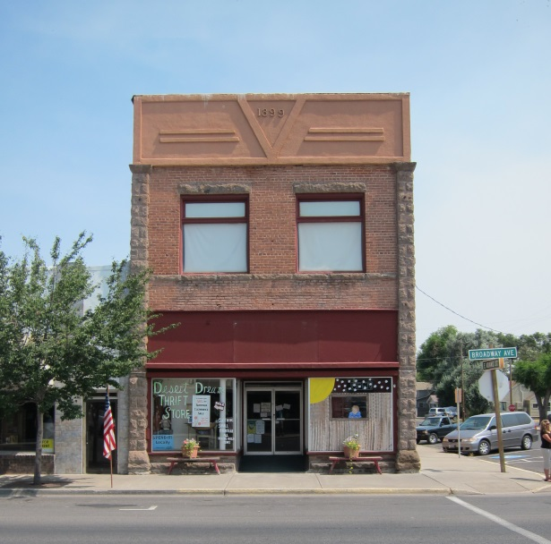

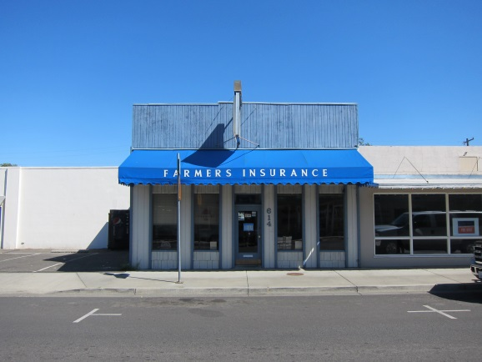

Examples of how to take photos of the facades of buildings.

Design Assistance Request Form

Applicant Information:
Local Main Street Organization: Contact Person:
Email: Phone:

Building Owner Name: Building Owner Address:
Email: Phone:

Property Information:
Building’s Historic Name: Building’s Common Name:
Building Address: Year Constructed:
Current Business Name(s) or Building Use:

Building has been listed or is nominated for listing on:
☐ National Register of Historic Buildings ☐ Local Register ☐ Is part of registered Historic District

Project Information:
Design assistance request is for (please check only one):
☐Façade drawing ☐Building site evaluation

What are the design issues you would like to have addressed? For example, I want advice on restoring the historic character of the façade, signage ideas, sun shining in the windows is a problem, people can’t see displays well, I want people to see a fun shop, I need some privacy, etc. Or if looking for adaptive re-use advice, I want to create upper floor housing or I want to rent the second floor, etc.

Condition of Existing Building:
☐ Needs no repair ☐ Needs some repair ☐ Needs stabilization

If historic building has been altered, please indicate what historic elements still exist, either exposed or covered (e.g. architectural metal, decorative cornice, tin ceiling, original windows and doors):

Additional comments on the condition of the building:

Please check the improvements made to the building in the last 5 years:
☐ Roof work ☐ Storefront rehabilitation ☐ Signs
☐ Repointing/masonry work ☐ Mechanical work ☐ Painting (exterior)
☐ Interior remodeling ☐ Electrical work ☐ Repair/replace windows
☐ Other (please specify):
Please check the improvements you are currently considering implementing:
☐ Roof work ☐ Repointing/masonry ☐ Basement/foundation
☐ Awning ☐ Entrances/doors ☐ Window repair/upgrade
☐ Painting (exterior) ☐ Façade restoration ☐ Building maintenance
☐ Signs ☐ Upper floor conversion ☐ Handicapped access
☐ Heating/cooling ☐ Electrical ☐ Interior
☐ Other (please specify

What colors are currently used by the business(es) for:
Signs:______________________________ Awnings:__________________________________
Interior:_____________________________ Marketing material:_________________________

What colors are preferred for the EXTERIOR of the building?
Signs:______________________________ Awnings:___________________________________
Siding:_____________________________ Trim:______________________________________
Other:_________________________________________________________________________

Project Budget:
☐ Below $2,500 ☐ $2,500-$10,000 ☐ $10,000-$50,000 ☐ More than $50,000

Financial incentives to be taken:
☐ 10% Rehabilitation Tax Credit for Non-Historic Commercial Buildings Built Before 1936
☐ 20% Rehabilitation Tax Credit for Historic Buildings
☐ Local Incentives
☐ 50% disabled Access Tax Credit
☐ I would like more information about tax credits.

Please provide a short narrative of the building history (one paragraph minimum). This might include building owners, occupants, notable events, or local/historic personalities associated with building:

Please discuss how this project meets or will further goals of the local main street revitalization effort:

Submittal Information:
Submit the design assistance request form, photos, and other requested information via email to:
Sheri Stuart, Coordinator, Oregon Main Street/Oregon Parks & Recreation Department
sheri.stuart@oregon.gov

Remember to provide high quality photos of the front façade, architectural details, and block in jpeg format

If you have questions or need additional information, please contact Sheri Stuart at sheri.stuart@oregon.gov.

