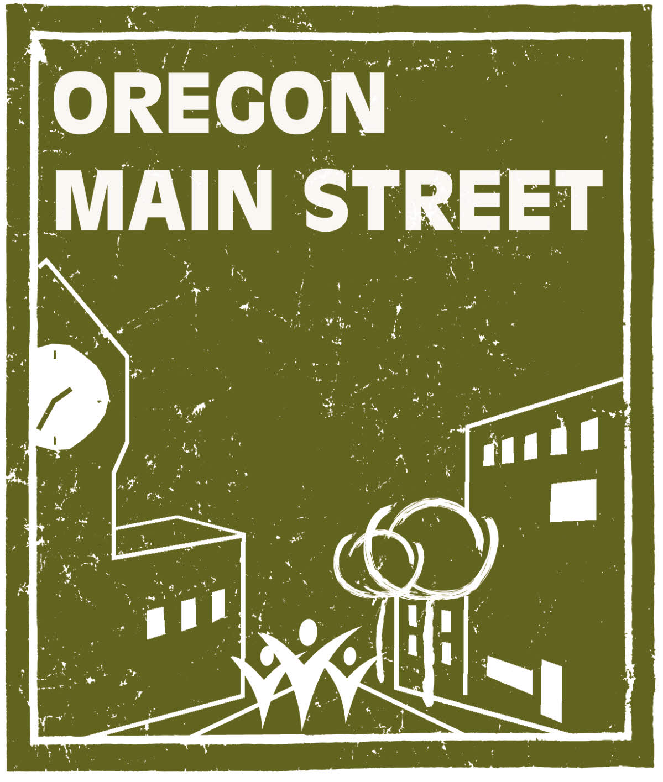

Oregon Main Street Program
2017 Transforming Downtown Application

Due Friday, March 3, 2017
Eligibility Criteria
Communities interested in becoming a Transforming Downtown Level community must complete an application and meet the following criteria:
- All cities under 50,000 in population in the State of Oregon are eligible to apply for Transforming Downtown status. In larger metropolitan areas, applications may be for distinct neighborhood commercial districts rather than for the traditional central business district. Communities larger than 50,000 population must contact the Oregon Main Street Coordinator for eligibility.
- The boundaries/primary focus area of the organization must be that of a traditional downtown or neighborhood commercial district – basically a “Main Street district.” This area must be:
- A traditional central business district and center for socio-economic interaction.
- Characterized by a cohesive core of historic or older commercial and mixed-use buildings that represent the community’s architectural heritage. It may also include compatible in-fill development.
- Have a sufficient mass of businesses, buildings, and density to be effective.
- Typically arranged with most of the buildings side-by-side and fronting the sidewalk along a main street with intersecting side streets.
- Compact, easily walkable, and pedestrian-oriented.
In general, districts containing newer low-density automobile-oriented commercial development (e.g., sprawl), strip malls, and enclosed shopping/entertainment centers will not qualify for designation unless they are fully integrated into the fabric of a traditional “Main Street district.”

- Form a downtown revitalization organization. A lasting downtown revitalization effort will only succeed in communities having a well structured, ongoing, and active downtown development organization. Such groups assume responsibility for certain tasks such as downtown promotions, facilitation of private sector building improvements and other cooperative projects. The downtown organization is responsible for establishing the overall direction of local revitalization efforts, program budget, and staffing. This organization should ultimately become a major resource for local government on all matters affecting the downtown. This entails building a certain amount of trust and understanding of each entity’s interrelated role.
- Guarantee a dedicated local program representative who will serve as the local program coordinator, dedicating a minimum of 16 hours per week to local downtown revitalization effort. This position could be volunteer but we highly recommend paid staff support. The representative will also be the primary point of contact for OMS and will represent the local program at state trainings and Network Meetings.
- Commit to learning and using the Main Street Approach® and Eight Guiding Principles. Successful downtown organizations work systematically through a work plan stating goals and objectives based on the Four-Point, eight-principle Main Street Approach® to downtown revitalization – concentrating attention on issues related to Design, Organization, Promotion, and Economic Vitality. While the approach is tailored to each community, all technical assistance is geared to this successful model.
- Enter into a Participation Agreement with Oregon Main Street. Oregon Main Street’s ability to assist a community in the revitalization of its downtown is dependent upon the level of local commitment and involvement. For this reason, Oregon Main Street asks the local government to pass a resolution that endorses the local application effort. And, if selected, have the sponsoring entity sign a Participation Agreement with Oregon Main Street that clearly specifies the responsibilities of the local program and those at the Transforming Downtown level.

Selection Criteria

- Strong commitment from the municipal government and various private sector organizations to support the local revitalization efforts and a clear understanding that the Main Street Approach is a process that will require commitment.

- The organization and community has a good understanding of the Main Street Approach® to downtown revitalization.

- Historically significant buildings or unique characteristics of the district. Your community must also be able to demonstrate a historic preservation ethic.

- The community’s need for commercial district revitalization/preservation.

- Potential for the district and organization to benefit from the types of assistance offered.

- A readiness to proceed.

- Willingness by the community to commit time and resources, and to try new ventures.

- Designate a local program representative for a minimum of 16 hours per week time commitment and provide support for the local program.

- The likelihood that demonstrable change will occur in the commercial district as a result of the community’s participation in the Transforming Downtown Program.

- Past record of community development efforts.

- The community’s readiness to begin a downtown revitalization effort.

- Broad-based community support.

Main Street® Application Information
The Main Street® application is designed to gauge and document the interest of your community in fostering a comprehensive, technical relationship, and partnership with the Oregon Main Street Program. It also demonstrates your community’s ability and interest in successfully implementing the Main Street 4-Point Approach® within your traditional downtown or neighborhood commercial district. This nationally proven approach encourages communities to develop an effective organization, promote the district, improve appearance through good design, and restructure the economic base for long-term prosperity.

INSTRUCTIONS

When filling out this application, please use 12 point type in the Times or Times New Roman font. Type directly on the application form unless an attachment is requested. For questions requiring extensive narratives, you will be given an indication of approximately how much space has been allotted for your answer. To fill in your answer, begin typing into the highlighted area following the question. Attachments should also be typed in 12 point type in the Times or Times New Roman font.

Applications and attachments should be in a format that can be handled easily and should not be stapled or permanently bound. Attachments should be labeled with the section letter and question number for reference (for example: A-30). Place attachments at the end of the application in the order they are requested. Do not include items that have not been specifically requested. Do not fax your application, attachments, or support materials.

Completed Main Street applications must be received by March 3, 2017. Please mail 4 sets of the completed application with attachments to:

Oregon Main Street
Heritage Programs/Oregon Parks and Recreation Department
725 Summer Street NE, Suite C
Salem, Oregon 97301

Tips for a good application:
• Follow directions.
• Make your points clear and concise.
• Avoid excessive narratives.
• Present an honest picture of your community and organization, both strengths and weaknesses.
• Use specific data and documentation when possible.
• Start collecting letters of support along with your city council resolution now.

Questions about this application may be directed to Sheri Stuart at 503.986.0679/ sheri.stuart@oregon.gov or Katie Henry at 503.986.0671/katie.henry@oregon.gov.

Oregon Main Street Program

Transforming Downtown Application

General Information:

City or Town: | County:
City population: | County population:

Persons involved in completing this application (please list names and positions):
Name and position:
Name and position:
Name and position:

Person to contact for questions about this application:
Name and position:
Organization:
Address:
Daytime Phone:
Fax Number:
Email Address:

Attachment checklist.
Please check below which items are being submitted with this application.
 | A-1 | Map identifying district |  | B-32 | Preservation ordinance
 | A-2 | Brief history and overview |  | B-35 | Digital images on CD
 | A-16 | Promotional items |  | B-37 | Articles of Inc., By-laws
 | B-18-a | Commitment letter, mayor |  | B-38 | List of board members
 | B-18-b | Resolution of support |  | B-39 | List of committees
 | B-19 | Letters of commitment |  | B-40-a | Financial commitment letters
 | B-20 | Letters from organizations |  | B-40-b | Other financial documents
 | B-24 | Business environment info. |  | B-41 | Membership brochure
 | B-26 | Work plan |  | B-42 | Manager’s resume
 | B-27 | Econ. dev./long-range plan

SECTION A: DOWNTOWN OR NEIGHBORHOOD COMMERCIAL DISTRICT INFORMATION

Please answer the following questions about your downtown area or neighborhood commercial district. Label requested attachments with the section letter and question number (for example: A-30).

- Attach a map, labeled A-1, that clearly outlines the proposed district/program area. What is the size of the proposed downtown or neighborhood commercial district area that will be served (i.e., the primary focus area boundaries) in square blocks?
- As A-2, provide a one to two page brief overview about your downtown or neighborhood commercial district. The overview should include information about the early history of the district, economic forces at work in the area, key turning points in the district’s decline (and rebirth), and where it is today.

- Please describe the characteristics that you feel make the district a cohesive and recognizable district with distinct features or architectural character. You will have approximately 1/2 page in which to answer.

- What is the approximate number of buildings in the district? What percentage of these buildings are owned by absentee or out-of-the-area owners?

- What is the approximate percentage of first-floor vacancies in the district?

- How many buildings in the district are partially residential? How many buildings in the district are fully residential?

- Please list the number of parking spaces in the district:

On-street public parking spaces
Off-street public parking spaces
Off-street private parking spaces
Total

- What is the total number of businesses in the district? Include retail, service, and professional. Do not include government and nonprofit institutions.

- How many businesses in the district generally fit the following categories:

Department stores |  | Jewelry |  | Books/cards
Specialty gift |  | Discount general |  | Furniture
Hotels |  | Taverns |  | Antiques/galleries
Theaters |  | Gas/convenience |  | Laundry/dry cleaning
Auto parts |  | Auto sales |  | Financial institutions
Apparel/shoes |  | Health professionals |  | Insurance
Office supply |  | Restaurants |  | Grocery stores
Beauty/barber shop |  | Legal and accounting
Others (please list):

- If there are parks or other open spaces in the district, please provide a brief description below. You will have approximately 1/4 page in which to answer.

- Please list the government buildings located in the district (i.e., post office, library, city hall, schools).

- Please list religious/nonprofit institutional structures located in the district (i.e., YMCA, churches, hospitals).

- To what extent has the district been negatively affected by the following:

 | Greatly | Somewhat | Very Little | Distance from District
Local strip shopping center
Local discount center
Other downtowns in region
Regional mall/discount centers

- Please provide information on the five largest employers in the city or market area:

Employer Name | Business Type | # of Employees | In district? (yes/no)

- What are the major attractions, festivals, and special events that bring tourists to your community? Also indicate which ones bring visitors specifically into your district. You will have approximately 1/3 page in which to answer.

- Has your organization produced any promotional literature, directories, brochures, or flyers concentrating specifically on the district or district activities in the past year? If so, please attach up to 7 samples as A-16.

- Does your municipality have the following?

(yes/no)
Economic Improvement District
Certified Local Government
Economic Development Plan
Community-wide Master Plan
Downtown Master Plan/Overlay District

SECTION B: DESIGNATION CRITERIA

The National Main Street Center places emphasis on Main Street® communities which fully utilize the Main Street Approach® and adhere to the eight guiding principles. Oregon Main Street uses these criteria in designating and recognizing Main Street® and Transforming Downtown programs in Oregon.

When completing this section of the application, please provide the requested information to indicate your community’s readiness to meet the required designation criteria.

Broad-based community support for the downtown revitalization process, with strong support from both the public and private sectors.

- Support of local government. Downtown and neighborhood commercial district revitalization efforts have little chance to succeed without the enthusiastic support of local government. Municipal government is usually the first entity to gain the benefits from a successful downtown revitalization effort.

Please attach a letter of commitment from the mayor of your community (attach as item B-18-a), and a resolution of support from the city council (attach as item B-18-b). The resolution should endorse the capacity-building purpose of the program, recognize the benefits to local government, and pledge city government cooperation and support. When possible, local government should also include their commitment to public sector funding.

- Broad-based community commitment. Your downtown or neighborhood commercial district revitalization program needs the active participation of various stakeholders representing many different segments of the community. These participants contribute financial, in-kind, and volunteer support for the revitalization program. As B-19, please attach letters indicating a commitment to being actively involved in, and to make a financial commitment to the local revitalization program. No form letters, please. Letters should be from representatives of groups that include, but are not limited to:

Financial Institutions Professionals
Merchants Owners of service businesses
Education officials Business owners from outside of district
Property owners in district Civic leaders
Utility company officials Local media representatives
Local industry officials Youth/senior representatives
Historical society officials Private citizens/consumers

- Partnerships with other organizations. A Main Street program is most successful when working in a well-integrated effort with other economic development and preservation organizations in the community. As B-20, please include a letter of support from the local Chamber of Commerce, merchant group, Economic Development Council, historic preservation group, etc.

- Previous revitalization efforts. Please describe any major revitalization efforts previously undertaken by the public and/or private sector within or adjacent to the district. Be as thorough as possible. Include dates, summary of projects, and description of outcomes. You will have approximately 3/4 page in which to answer.

Vision and mission statements relevant to community conditions and to the local Main Street® program’s organizational stage.

- Write your organization’s mission statement here. Also indicate when it was developed and by whom. If you don’t currently have a mission statement, please leave this space blank.

- If there has been a vision statement developed for your district, write it here. Also indicate when it was developed and by whom. If you don’t currently have a vision statement, please leave this space blank.

- As B-24, please describe the existing commercial, retail, and industrial facilities in the district and surrounding area. Include new investment, new competition, opportunities, and problems. Ideally the statement should include both strengths and weaknesses. Please limit your response to one page or less.

- How do you believe the community and your organization will benefit from being selected at the Transforming Downtown level of the Tier System. Please answer in the space below. You will have approximately 1/2 page in which to answer.

Comprehensive Main Street® work plan.

The Main Street Approach® requires local revitalization organizations to develop a comprehensive work plan that includes committees working on organization, promotion, design, and economic restructuring activities and projects. Assistance with work plan development can be part of the ongoing technical assistance provided through the state program. However, some communities may already have a work plan established for the organization. If you have this in place, please answer the following questions about your plan. If you have not done this, please leave question 26 blank.

- As B-26, attach current work plan. When was this work plan developed and by who? Has the work plan been officially approved by the board of directors? If so, when was it approved? How often do you update your work plan?

- Is the district included in an overall community economic development plan or is there a long range plan in place for your downtown or neighborhood commercial district? If so, when was the plan developed and by whom?

As item B-27, please include a copy of the section(s) of the plan that pertains to your downtown or neighborhood commercial district.

Historic preservation ethic.

- If any part of the district is listed on the National Register of Historic Places as a National Historic District, please list the year that designation was received.

- List any buildings in the district that are listed individually on the National Register of Historic Places.

- List other structures in your district not on the National Register that are considered “historic” by the community. Please indicate if any of these structures have an official local landmarks designation.

- What other cultural or special features are in the district that you feel are important to consider when reviewing your application? You will have approximately 1/4 page in which to answer.

- In general, how would you describe the condition of buildings in the district?

If your town has a local preservation ordinance in place, please attach copies of the ordinance or any other design ordinances or regulations that may apply to the district as item B-32.

- Approximately how many buildings in the district have been demolished in the past five years? Please also indicate the primary reason for the demolition.

- List and describe the purpose of any active preservation groups in your community.

- Enclose up to 30 digital images of your district in jpeg or tif format on a CD. As Attachment B-35, provide a print-out and label the images with a brief identifying title. Include pictures showing both strengths and weaknesses. [These digital images become the property of OMS/OPRD and may be used in future presentations and publications.]

Active board of directors and committees.

The state program assists communities in developing and maintaining long-term downtown and neighborhood commercial district revitalization organizations. If your downtown does not already have a formal organization in place, please leave this section blank.

- What is the organization’s IRS status (501c3, 501c6, don’t know)? Also, when was it incorporated?

- As B-37, please attach a copy of the organization’s Articles of Incorporation and Bylaws.

- As B-38, attach a list of the officers and board members of the organization. Also list their term limit and business affiliation or position in the community.

- As B-39, please list any committees operating within the organization and indicate the general purpose of each. List committee members and business affiliation or position in the community.
Adequate operating budget.

40.Projected revenue. Please indicate the approximate amount of projected revenue to be collected from the following sources:

SOURCE | Yr. 1 | Yr. 2 | Yr. 3
Local government | $ | $ | $
Downtown business and property owners | $ | $ | $
Events | $ | $ | $
Other sources please list: | $  $ | $  $ | $  $
TOTAL PROJECTED ANNUAL REVENUE | $ | $ | $

As B-40-a, please attach letters showing financial commitment from government, organizations, businesses, industries, property owners, and other sources not already included in the letters of support requested in items B-17a, B-18, and B-19. Also attach as B-40-b, other supportive documents demonstrating current and/or future financial stability. This can be done by showing previous records indicating income flow and stability, including membership dues or cash in hand.

41. If your organization has a membership brochure, please attach as B-41. Please indicate below the number of current members from within the district and the number of “other” members you have.

Volunteer program manager (Executive Director).

- Experience has shown that it is critical to provide a dedicated individual to assist with the development of the downtown program when enrolled at the Transforming Downtown level. This requirement can be met in a variety of ways: by having a part- or full-time staff person, identifying a volunteer who can commit at least 16 hours per week, or the staff from a partnering organization or public employee who is committed to an average of 16 hours per week of their time to coordinate and focus on the downtown program. This individual will be the primary contact for the Oregon Main Street Coordinator. Please describe how your community will meet this requirement. You will have approximately 1/2 page in which to answer.

If your organization currently employs a professional manager to coordinate the local program, how long has he or she been in this position and what is his or her salary? As B-42, please attach a copy of the manager’s resume.

Program of ongoing training for staff and volunteers.

Education and training of the program manager and downtown leaders is critical to the success of a local Main Street® program. The entire community, not just the person or persons completing this application, should be aware of the time commitment that will be required of participating Main Street® board and committee members, as well as the program manager, in the first and subsequent years of the program.

- Please check the spaces below as an indication of your commitment to the education and training component of the state program.

Required basic training for board and committee members within 3 months of acceptance at the Transforming Downtown level.
Quarterly Main Street Network meetings. Attendance at these meetings will be required for your manager and encouraged for board members.
Annual Main Street Manager Retreat. Attendance at this three day meeting and training is required for your manager when offered.
Oregon Main Street Conference (biannual two to three day statewide conference). At a minimum you will be required to send your manager and at least one board member.
The biannual fall Oregon Main Street workshop (usually a one day workshop held in two locations in the state). When offered, you will be required to send your manager and at least one other person representing the organization at either the board or committee level depending on the workshop topic.
The National Main Street Conference, the National Main Street Center’s annual three day conference, held in various locations throughout the country. Attendance is not required, but encouraged.
On-site training sessions held in your community including day-long board retreats and committee action planning sessions. High attendance is required of your manager, board, and committee members.

Every effort is made to keep costs for state sponsored training sessions at a minimum. It is the responsibility of the local program to cover registration fees, travel, lodging, and meals.

- Have you sent representatives from your organization to workshops and conferences sponsored by the Oregon Main Street Program and/or to the “National Main Streets Conference” in the past two years? If yes, please list the workshop and/or conference title, date(s), and who attended.

Name of Workshop or Conference and Date(s) | Name of Participant

Reporting of key statistics.

To document and track the success of the downtown program at the local, state, and national levels, the state program requires that brief quarterly reports be submitted. Information requested in the report includes statistics on jobs, businesses, building renovation and construction costs, public improvement projects, etc. Other community information may also be requested on an as-needed basis by the state program or the National Main Street Center.

Submission of this application indicates your agreement to the quarterly reporting requirements and that you will adhere to deadlines for submitting these reports.

Current membership in the National Main Street Network.

- Membership in the National Main Street Network gives the community access to a wealth of information and resources on downtown revitalization. If you have already joined the National Main Street Network, please indicate your membership number and expiration date below. Additional information can be found at the National Main Street Center’s website (www.mainstreet.org).

SECTION C: MISCELLANEOUS

- Please provide a brief history of your organization. Also, include current sentiment and perceptions that are held by various stakeholder groups. You will have approximately 3/4 page in which to answer.

- Is there any additional information that you feel we should know about? For example, major issues affecting the downtown or neighborhood commercial district, your community, or your organization). You will have approximately 3/4 page in which to answer.

