Financing Historic Theater Redevelopment

Four case studies will be presented from across the country representing a variety of financial solutions to rehabilitating historic Theaters

Financing Historic Theater Redevelopment

|  |  |
| --- | --- |
| B Street Theater.jpg | **B Street Theater, Sacramento, California**  The B Street Theatre is a 501(c)(3) nonprofit theater founded in 1986 by Timothy Busfield. Its mission is to promote education, literacy, social interaction, and cultural enrichment by engaging children and adults in the arts. The theatre is currently undergoing a $29 million renovation that includes bond financing, loans, guarantees, and grants. The new theater complex will include the 365-seat Sutter Children’s Theater and the 250-seat Mainstage Theater. B Street estimates that the new complex will allow them to serve 35,000 more children and families than their current venue. |
| RiNo Arts District.jpg | **RiNo Arts District, Denver, Colorado**  The River North (RiNo) Arts District is located in Denver’s five points neighborhood; a historically industrial part of the city. As industry moved out of the city towards the turn of the century, the neighborhood was plagued with vacant buildings and poor infrastructure. In 2004 local neighborhood leaders started devising a plan to revitalize the area. This plan has been realized through the creation of a Business Improvement District and General Improvement District. The RiNo Arts District is now home to a bustling arts community that includes galleries, architects, and myriad creative businesses. |
| Capitol Theater.jpg | **Capitol Theatre, Cleveland, Ohio**  The Capitol Theatre first opened its doors on April 8, 1921 as a silent film house. The theatre remained a centerpiece of the Gordon Square neighborhood, but began to fall into disrepair following the outmigration of people from Cleveland after World War II. The Theatre was nearly torn down in 1978, but for the work of Detroit Shoreway Dev julieamujic@gmail.com elopment Corporation to save it. The theatre was eventually closed in 1985 due to its poor condition. However, Detroit Shoreway continued to work to save this theatre and through the use loans, grants, historic tax credits, and New Markets Tax Credits, were able to reopen the fully renovated theatre in 2009. The three-stage, 602 seat theatre is now used as a cinema. |
| Next Stage Arts.jpg | **Next Stage Arts, Putney, Vermont**  Next Stage is located inside 15 Kimball Hall, a beautiful, historic church built in 1841 in the heart of Putney, Vermont. The theater re-opened in 2016 as a fully accessible venue with an elevator and hearing assist technology. Other upgrades include air-conditioning and brand new seating. The 180 seat venue attracted hundreds of thousands of dollars of investment in the way of grants in order to support its renovation. The theater now holds events such as spoken word, independent film showings, and concerts. |

Presenters:

**California**

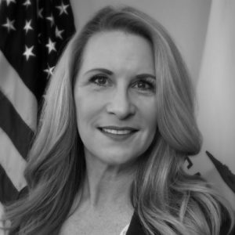Nancee Trombley is the Chief Deputy Executive Director for the California Infrastructure and Economic Development Bank (iBank) a division of the Governor’s Office of Business and Economic Development. She oversees IBank’s Infrastructure State Revolving Fund, the Bond Unit, and the Small Business Finance Center. Nancee earner a BS in Communications from California State University at Sacramento and an Executive MBA from California State University at Monterey Bay.

**Colorado**

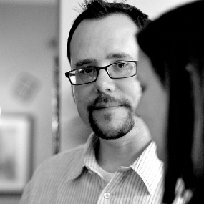Co-Founder and Creative Director of the RiNo Art District, Artist Tracy Weil specializes in building community. The RiNo Art District is booming as Denver's new creative community. Weil has been a driving force in the development of this creative district. Weil is also an visual artist painting for over 25 years, Weil continues to pursue his consulting practice as an advocate for artists and creating vibrant art focused communities.

**Ohio**

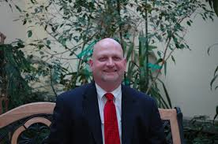Jeff Ramsey, executive director of the Detroit Shoreway Community Development Organization. DSCDO is responsible for the emergence of the **Gordon Square** Arts District, construction of thousands of new and restored housing units

**Vermont**

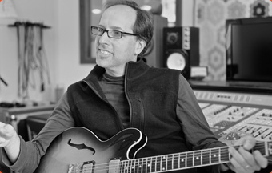**Billy Straus** is an American music producer and songwriter. He is known for his work in children's television including the [Disney](https://en.wikipedia.org/wiki/Disney) series [*Little Einsteins*](https://en.wikipedia.org/wiki/Little_Einsteins) and [*Where in the World Is Carmen Sandiego?*](https://en.wikipedia.org/wiki/Where_in_the_World_Is_Carmen_Sandiego%3F_(album))*.* He produced and mixed original Broadway cast albums for [*The Full Monty*](https://en.wikipedia.org/wiki/The_Full_Monty_(musical)) and [*Dirty Rotten Scoundrels*](https://en.wikipedia.org/wiki/Dirty_Rotten_Scoundrels:_Original_Broadway_Cast_Recording). He won an [Emmy Award](https://en.wikipedia.org/wiki/Daytime_Emmy_Award) for his work on [*Where in the World Is Carmen Sandiego?*](https://en.wikipedia.org/wiki/Where_in_the_World_Is_Carmen_Sandiego%3F_(album)) He founded Rock River Communications to introduce the concept of non-traditional music distribution into the retail marketplace