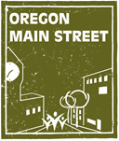
Technical Assistance: Story Development and Training

Communities throughout Oregon participating in the Oregon Main Street Network are using the highly successful National Main Street Approach® to revitalize their historic commercial neighborhoods and downtowns. This is a comprehensive model that works on many different fronts to bring vitality to these important community centers. It is often challenging for organizations to communicate the impact of their efforts because the work is broad. This is systemic throughout our Network, and, indeed, throughout communities across the country. This can impact an organization’s ability to attract funders and volunteers – the very foundation of a thriving revitalization effort. To help address this issue, Oregon Main Street is offering free technical assistance to develop compelling stories that inspire new support and commitment to Oregon Main Street communities. Up to five communities will be selected for this offer based on this application.

Working with a marketing and PR consultant, selected communities will receive:
- Webinar on the art and science of storytelling.
- One-on-one storytelling counsel to develop a story.
- A completed compelling story to integrate in communications.
- Opportunity to share your story at a plenary breakfast at the Oregon Main Street Conference, October 6, 2017.

Eligibility:
- Participate in the Main Street Track of Oregon Main Street (Exploring Downtown, Transforming Downtown, or Performing Main Street levels).
- Complete and submit this Story Development Technical Assistance Application no later than August 2nd, 2017 to sheri.stuart@oregon.gov.
Technical Assistance: Story Development and Training
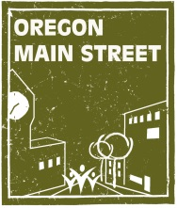
Application

Applicant Information:
Organization Name: Dallas Downtown Association
Contact Person: Liz Garrow
Title: Executive Board Member/Secretary
Email Address: lizgarrowdda@gmail.com
Telephone Number: 503-930-0735
City: Dallas
County: Polk
Population: 15,345
Main Street Track Level:
Exploring Downtown Transforming Downtown Performing Main Street

Commitment:
We agree to have at least 75% of our board members participate in the Webinar Training
during the week of August 28, 2017.
We agree to fully engage our board and others in the one-on-one storytelling counseling as
requested.
We agree to tell our story at the Plenary Breakfast during the Oregon Main Street
Conference.

Application Questions: Please answer the following questions in no more than two pages.

- Please tell us your goal for telling a compelling story about your work (select all that apply).
Recruit new volunteers
Secure new funding from private sources
Secure new funding from public sources
Increase attendance to Main Street events
Attract to tourists to your Main Street community
Attract new businesses to your Main Street community
Attract new residents to your Main Street community
Increase request for your programs, grants, and other offerings

- Please tell us about a recent time you saw your work at its best. What happened, who was involved, and what change resulted from your efforts?

As an article of faith, small, historic Oregon downtowns can most successfully reinvent themselves by embracing the arts, culture, entertainment and their history. The embrace of these threads comes through weaving the community story into a matrix, a vibrant downtown where art, history, creativity and myth intersect.
Community story lines create vivid images. Rome had its Romulus and Remus, Chicago was built on the ashes of the Great Fire. Pendleton’s exuberant story (Let ‘er Buck!) - possibly slightly embellished over the years - has created an almost mythical cowboy paradise of imagination and action.

Dallas recently hired professionals to find our “brand” - our story. To summarize their roundabout language, they couldn’t really find one. No myth, no self-image, no there, there. Predictably, their product was an artificial construct, a construct devoid of our history, our great but lost enterprises, our central theme as the County seat and our well-preserved century-old downtown.

The Dallas Downtown Association must, of necessity, develop our story in order to achieve relevance. An old Oregon town without a self-image and a sense of its history can’t really succeed. Vibrant and imaginative storytelling thus becomes imperative, not optional.

The DDA embraces this challenge. It was most evident recently by its taking an historic 1890 black-and-white photograph of a cowcatchered, steam log train taken circa 1890 two blocks from Main Street. The DDA, through grants (City Urban Renewal, Oregon Arts Commission), local donations and hard work of many souls in the community turned a large, derelict wall into a beautiful, full-sized mural capturing this train in its glory days. It not only evokes the image of the train and its old-growth logs, it captures the frontier spirit and the exuberance our growing community.

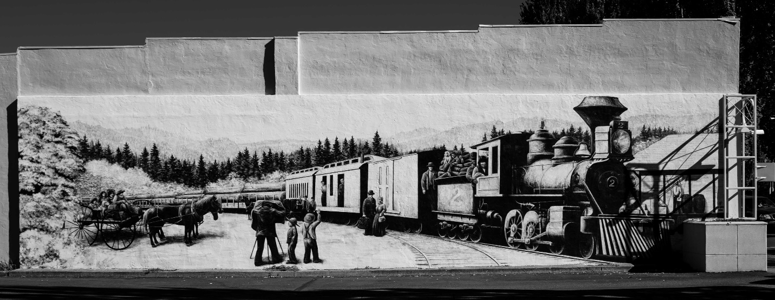

This beautiful and symbolic mural has come to represent the DDA’s embrace of the past and has leveraged itself in historic displays of turn-of-the-last-century photographs and artwork throughout the community. The DDA’s notion of story-telling is to rebuild our historic reputation, glory-of-the-old-days if you will, into a compelling narrative which comingles placemaking with art and entertainment, the aforementioned salvation of small, historic rural Oregon downtowns.

Our choice here is to age poorly, neglected and decaying; age gracefully, keeping the paint and appearances up; or to age dynamically, bringing art, culture, creativity and history together in a reinvented downtown that begins the life of our community anew. To the DDA, reinvention is our only way forward.

This then is our challenge and our necessity. Crafting our story to capture the imagination and heartbeat of Dallas for the region, for Oregon and points beyond. Making Dallas, just “THE” place to be out of all the others, our story writ large in the imagination.

- Please tell us how you will share a compelling story in your efforts. Who will hear it, and how will you reach them?

Our fundamental story must be a part of the DNA of a community. It can’t be merely a public relations exercise or marketing tool or artificial contrivance that seem forced and alien to the feelings of the community. It has to be true to the soul of who we are and hope to be. We are not going to be Disneyland North or a Bavarian Alpine village, we’re going to be Dallas, Oregon with a proud and interesting history well told. Our beautiful century-old buildings speak volumes. We don’t need to create replicas, just enhance what we’ve already got. Our story line is in their façades and sidewalks and open doors.

To reach our audience, locally and far and wide, we first must envision the narrative. Who are we? Where did we come from? What characterizes our glory days? What do we draw from that era where downtown was vibrant and all the shops were full? We know we can’t re-create that exact milieu, but what is its modern version? What we visualize is what we will become. That is our story, our magnum opus.

How to disseminate? We have ways. The modern social networks, Facebook, the web via our website, our newsletter, et al,. The media, newspapers, books and beyond as they evolve. Also, in collaboration with other civic organizations carrying the torch for Dallas in all the ways that they do. Full stories, press releases, interviews, show and tell, lectures, and ultimately, relentless engagement, telling our true and interesting story.

Frankly, in crafting our narrative, in the back of our minds we must realize that there is a counter narrative out there. If any myth of our history has resonance, both in the community, and well beyond, it is the fantasy the Dallas has been and possibly remains the hotbed of the Klu Klux Klan. Not true, so we can certainly profit by a more contemporary, more positive, and more believable rendition of who we are that supplants this corrosive nonsense.

Thus, our narrative needs to reach broadly and deeply, with resonance, organic believability and exuberance.

3. Please describe three ways you feel your organization will benefit from this assistance.

#1. To recruit new DDA members and volunteers – An interesting and advancing narrative pulls in the imaginative souls who will further recruit like minds. The modern term for the phenomena we are creating is FOMO - Fear of Missing Out. No one wants to be left on the wharf when the party boat pulls away.

#2. Revitalizing our historic downtown creates the synergy which further lifts the Downtown Association in a virtuous cycle. Success breeds success, restored buildings bring more development, more development brings new businesses, new businesses bring people downtown day and night - all this together brings new life to the Downtown Association.

#3. Success ultimately brings financing and dollars to the situation, summed up as prosperity. Mark Twain said, “the lack of money is the root of all evil.” We would be most happy to demonstrate the reverse of that principle via our narrative, ultimately putting Dallas on the map as a “must-see” destination.

4. How can other Main Street communities learn from your story?

If it works the way we envision, Dallas will have one of those great, come-from-behind stories that Americans so treasure. Once prosperous - architecturally, commercially and industrially - Dallas has fallen on economic hard times in the past few years.
Though treasured as a place to live (we’ve never lost population in the decennial census dating back to 1880), our community has yet to recover its industry and commerce, especially downtown, since the Great Recession hit us hard. We have greatness in us, in our infrastructure, buildable land, location and historic fabric, it just needs the proper magic to bring it to life. A compelling, organic storyline encapsulating our history, attributes and vision cannot help but move us forward.

Our history, narrative and unfolding potential will make a great learning tool for other communities, many of which in rural Oregon face our same challenges and opportunities. Our story, well told, should evolve as a beacon in the rough seas of small-town America.

Attachments: Please attach samples of the following communication tools you currently use as applicable.
Organization brochure
Membership brochure
Volunteer recruitment brochure or info sheet
Annual report
Newsletter
Other types of communication tools you use: website, Facebook, twitter, etc:
_Website, Facebook_________________________________

__________________________________________________

