Business Clustering
by Mark Miller, Small Business Consultant

A key factor often overlooked by communities interested in revitalizing their downtowns and making them more consumer friendly is the concept of business clustering. Business clus­ tering is a development tool used by shopping malls to increase traffic flow and consumer dollar expenditures. Businesses are grouped together in such a way that they complement each other. By doing this, they are able to benefit from each other's sales and customer base. The groups of busi­ nesses are able to act in unison to draw a much larger market share than any one business acting independently.

There are two ways to increase sales. The first is for a business to increase the size of its customer base. The second way is to increase the average dollar expenditures made by consumers while they are at a location. Business clustering effectively addresses both of these challenges.

Clustering can increase the size of the customer base because customers are more likely to go to a location where they can satisfy multiple shopping needs in one trip. This one-stop­ shopping is becoming more important with each passing day as working families and individuals want to take advantage of what little relaxation time they have. "Supercenters" can at­ tribute their success to this strategy.

Customers are mar(' likely to spend larger dollar amounts in business clusters because they can find complementary goods and services · there. For example, a customer buying
a new dress downtown is also likely to purchase a new pair of shoes and accessories if those businesses are properly located and the storefronts are aesthetically appealing to draw the customers in. Likewise, a customer
buying a new pair of shoes might also go into a clothing shop to find something to go with his new purchase.

There are several factors that must be taken into consideration when thinking about business clustering. The business clusters should be located in ways that are consistent with customer shopping patterns and should encourage custom­ ers to make multiple purchases. The clusters should also serve -or at least have the potential to serve- similar or overlapping market segments. An example of successful clustering would be a health food shop; fitness training center/dance studio, and sports apparel store all located within general proximity of each other. Each business would enhance the others and draw off the business of the others.

- The clustering concept can also be tied into existing businesses. Example: A furniture store that leases out part of its space to an interior designer. This sort of partnership is beneficial to both parties involved. Both types of business complement each other and provide supplemental customer traffic to one another. Other examples include a fabric store that leases out its back room to a clothing alteration business or an antique store that has a furniture refinishing business located in the same building. The possibilities are endless. Any new complementary businesses brought downtown will help to build a stronger, more appealing shopping environment.

It is more difficult to create business clusters in established business districts than in new developments. New developments have the advantage of vacant buildings where the leasing agent can often handpick whom they want in their developments. In established business districts you have to deal with
multiple ownership problems and pre­ existing leasing terms. These problems lengthen the amount of time required to obtain a good business cluster.

Those towns interested in transforming their downtown into business clusters should ask their Economic Restructur­ ing Committees to be responsible for conducting marketing research to identify current and potential target marketing opportunities for current and prospective downtown merchants. This group would help to orchestrate the "clustering process" and aid iu guiding future businesses to their targeted downtown locations.

Business clustering strengthens the downtown as a whole and increases its chances of success against supercenters and shopping malls. Obtaining an optimal business cluster downtown requires a lot of hard work, cooperation, and insight, but the end result is beneficial to the community and merchants involved.

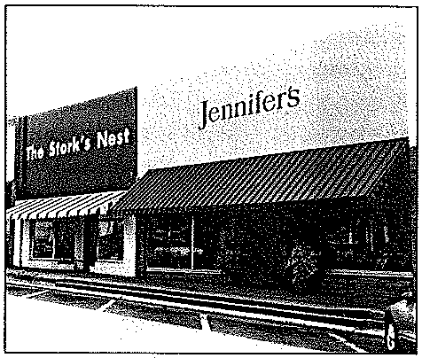
One-stopshopping: IndowntownMagno­ lia, Mom can find clothes for herself at Jennifer's, thenrunnextdoortothe Stork's Nest toget clothesfor herkids.If she needs work-out clothes, she can zip over to the Shoebox and find both sneakers and sweats. DolrntownMagnolia 'sclustering of clothing stores, gift stores, and home furnishing stores makes one-stop shop­ ping a real possibility.

