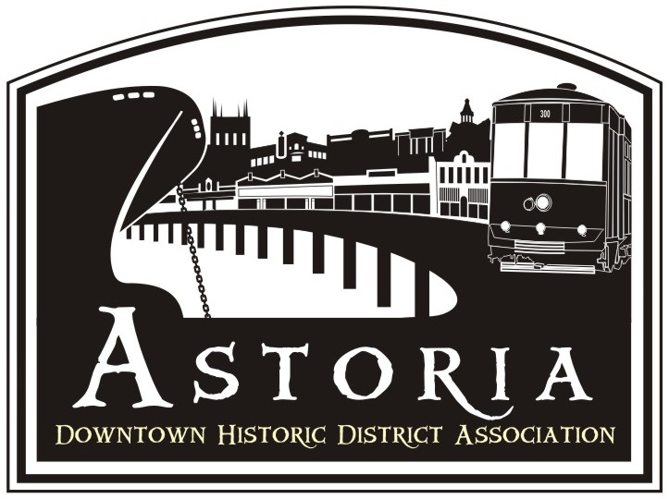

STREET LIGHT POLE BANNER DISPLAY PROGRAM
ASTORIA DOWNTOWN HISTORIC DISTRICT ASSOCIATION
The Astoria Downtown Historic District Association (ADHDA) in agreement with the City of Astoria manages and processes permits for the installation of banners on street light poles. Organizations will be allowed to hang banners on these poles under certain conditions and specifications.
Banners may not be installed without a permit.

Contact:

Sarah Lu Heath - Executive Director
Astoria Downtown Historic District Association (ADHDA)
c/o Light Pole Banner Program
Office: No.1-12th Street, Suite 114
Mailing: PO Box 261
Astoria, OR 97103
Phone: (503) 791-7940

Goal and Purpose
Astoria Downtown Historic District Association and the City of Astoria has a Street Light Pole Banner Program that allows area organizations to display banners on the light poles currently installed along Commercial between 8th and 14th, and on Marine Drive between 8th and 14th.

The goal of this program is to increase awareness of downtown events, activities and organizations as well as add color and excitement to the downtown streetscape.
The purpose of this program is to allow non-profit organizations to promote events, occasions or organizations that have a direct and substantial civic benefit. The event or occasion should:
- be reasonably available to all citizens (as spectators or participants);
- benefit locally-based nonprofit organizations;
- be significant and large enough that it will be of interest to many citizens;
- be appropriate for display on city-owned street light poles.
The banner program is open to area non-profit organizations. Eligible banners are those that match the above stated goals of the Banner Program. Banners may not advertise or promote commercial products or services, or religious, political or social viewpoints.

The event or occasion using the banners should NOT be political, religious, or commercial, except for seasonal holiday decorations. Examples of eligible events or occasions could include the Astoria Regatta, Astoria Scandinavian Festival, Pacific Northwest Brew Cup, and Astoria Music Festival. In accordance with City Development Code Section 8.040.A.4, “Official informational signs, traffic signs, kiosks, signals, notices, and decorative and event banners” are exempt from the Sign Code regulation and do not require a Sign Permit.
Profit making organizations may hold permits if the organization is acting as the agent providing insurance, sponsorship, management, etc. for a nonprofit organization. Banners may display corporate logos or similar endorsements if they are not the dominant element in the composition of the banner.
The City Community Development Director or designee, may regulate the composition, content of the banners, and impose other conditions or regulations necessary in the interest of the appearance of the street and the public's safety. The banners shall be in compliance with Oregon Department of Transportation rules and regulations.
Application Process
Banner installations will be allowed on a "first come, first serve" basis. Applicants for the permit must request banner locations three (3) months in advance of the event, to provide adequate processing time.
• A completed banner application (Exhibit A) must be submitted to ADHDA at least 60 days before the display period. The application must include a full color design of the banner artwork – front and back.
• Once the complete application is received, ADHDA staff and Design Committee will review and approve the design and schedule of the banners to be displayed.
• ADHDA will submit the complete application to the City for review and approval.
• ADHDA will contact the applicant within 10 business days of receiving the complete application and inform the applicant of the ADHDA’s decision. Banner approval is based upon adherence to program guidelines in accordance with requirements established by the City of Astoria, Oregon.
• Upon approval, a Banner Use agreement will be issued to the applicant.
• Applicant may then begin fabricating the banners.

Note: Applicant is responsible for all costs associated with production of the banners.
The request will be processed within 10 business days of receipt. ADHDA will send a completed permit and acceptance of terms and conditions form (Exhibit B), and require the signature of the contact person. Please sign and return the permit with the proper insurance certificate and additional insured endorsement. If the necessary documents (permit and insurance endorsement) are not in the possession of the ADHDA at least 2 weeks before the banners are to be installed, the permittee will not be allowed to hang the banners.
For the permit to be valid, it must be signed by the City Community Development Director or designee. ADHDA will submit the application to the City for review and approval.
Application Processing Fee
There is a $50 processing fee, payable to ADHDA.
Quantity
• Number of poles available on Commercial Street – 22
between Commercial and Duane Streets - 2
• Number of poles available on Marine Drive – 5
between Marine and the River - 9
Minimum Banner Quantity on Commercial Street: 8
Minimum Banner Quantity on Marine Drive: 5
Minimum Banner Quantity between Commercial and Duane Streets: 2

Specifications
Size: Height x Width ratio- 30” x 18”

Material: Banners should be made of at least 15 oz. rip-stop type vinyl that is weather resistant. Two double stitched 2.75” banner arm pockets must be included at top and bottom of banner, with grommets for attachment. Banners must be two sided.

Display Time
Banners will be displayed for a minimum of 7 days and a maximum of 60 days. Extensions to the display period can be given if the applicant submits a written request to ADHDA stating the reasons for the extension. Scheduling of the banners will be done on a first come basis.

Disclaimer
ADHDA reserves the right to revise or amend the guidelines of the Light Pole Banner Display program at any time. Additional fees or charges may be added if deemed necessary.
Banner Installation and Removal
Installation of the banners is the responsibility of the permittee - the ADHDA nor City will do this installation.
Banners must be installed according to the City's specifications: Banners not installed per City specification and deemed to be a hazard will be removed, and the cost of the removal will be the permittee's responsibility.
Removal of the banners is the responsibility of the permittee, and should be removed the day after the approved banner display dates. Banners displayed after the display date will be removed at the cost of the permittee.
Maintenance
The permittee will be responsible for the maintenance, replacement, and upkeep of quality banners while installed on the street light poles. The permittee will be responsible for all costs to repair damages to the street lights caused by installation, while installed, and removal of the banners on the street light poles. Banners that are faded, ripped, or are in poor condition need to be replaced prior to installation
Insurance Requirement
The permittee shall provide satisfactory evidence of public liability insurance, endorsed to name as additional insureds the City, its officers, agents, and employees as to any claim or claims for damage or injury resulting from or growing out of the operations of the applicant under the permit applied for, and containing a further endorsement that the policy shall not be canceled without 30 days prior written notice to the City Planner.
The endorsement shall be either (1) in the form attached with Exhibit B; or (2) in the form of Insurance Services Organization (ISO) Form CG 2012. The insurance shall provide coverage of not less than $1,000,000 (one million dollars) per occurrence. Proof of such insurance must be submitted to ADHDA and approved 2 weeks prior to installation of banners.
Revocable Permit
The permit will be revocable at any time at the sole discretion of the City Community Development Director or designee. Should the permit be revoked, the permittee shall remove its banners from the street area as directed by and to the satisfaction of the City Community Development Director or designee. If the permittee fails to remove its banners as directed and to the City’s satisfaction, the City or its contractors may remove the permittee's banners; in this case, the permittee shall be responsible for all costs incurred by the City or its contractors in removing the banners. Furthermore, if the permit is revoked, the City shall not be liable for any costs of whatever nature incurred or suffered by the permittee or anyone else arising from the revocation of the permit.

Exhibit A
LIGHT POLE BANNER PROGRAM APPLICATION

Applicant’s Name: _____________________________________________________________________________________________

Organization/Business: _______________________________________________________________________________________

Contact Address: ______________________________________________________________________________________________

City/State/Zip: ________________________________________________________________________________________________

Applicant’s Phone (daytime): _______________________ Fax:_________________________________________________

Applicant’s Email: _____________________________________________________________________________________________

Event Name: ___________________________________________________________________________________________________

Briefly describe the event: ____________________________________________________________________________________

Event Date(s) From: _____________________ To: ____________________________

Banner display dates From: _____________________ To: ____________________________
(Min. of 7 days/Max. of 60 days)

Note: Attach a full color version of the banner design (front & back) with this application. You can attach a hard copy of the design or email a PDF or Jpeg to sarah@astoriadowntown.com

I have reviewed this application and understand the Banner Display Program requirements and agree to the terms and conditions of the program as stated.

__________________________________________________________________________________________________________________
Signature Printed Name Date

Mail completed applications to:
Sarah Lu Heath
Astoria Downtown Historic District Association (ADHDA)
c/o Light Pole Banner Program
Phone: 503.791.7940

Office: No.1-12th Street, Suite 114
Mailing: PO Box 261
Astoria, OR 97103
sarah@astoriadowntown.com
www.astoriadowntown.com

For Office Use

Date Received: _____________ Date Application Complete: Approved by: _______________________________
Payment Received: __________ on _________________________________________ Check # _____________________________________

Permit Form
Exhibit B
(For Office Use)

Applicant’s Name: _____________________________________________________________________________________________

Organization/Business: _______________________________________________________________________________________

Event Name: ___________________________________________________________________________________________________

Banner display dates From: _______________________________ To: ___________________________________
(Min. of 7 days/Max. of 60 days)

ADHDA Approved by:________________________________________________________________ Date: __________________

City Approved by: ____________________________________________________________________ Date: __________________

Acceptance of Terms and Conditions
(To be completed by the Applicant)
I, ________________________________________, on behalf of ________________________________________, understand that __________________________________________ (organization) is responsible for the installation of the banners, and must be installed according to the City's specifications; banners not installed per City specification and deemed to be a hazard will be removed at the cost of the permittee.
Banners will be displayed during the above, specified dates.
Extensions to the display period can be given if the applicant submits a written request to ADHDA stating the reasons for the extension. Extensions will be approved as available.
The permittee/organization will be responsible for the maintenance, replacement, and upkeep of banners while installed on the street light poles. The permittee will be responsible for all costs to repair damages to the street lights caused by installation, while installed, and removal of the banners on the street light poles.

Insurance: ______________________________________________Policy #:______________________________________________

Organization/Business: _______________________________________________________________________________________

Event Name: ___________________________________________________________________________________________________

Applicant’s Signature: _____________________________________________________ Date: __________________________

