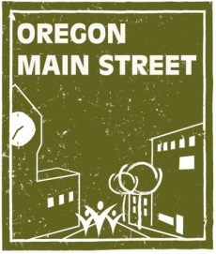
2019
Report Prepared By:
Mary Bosch, Marketek
Sheri Stuart, Oregon Main Street
Katie Henry, Oregon Heritage
Main Street Refresh: Roseburg
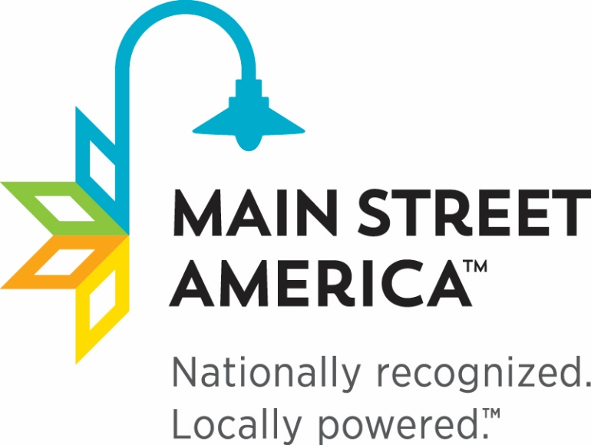
The Main Street Approach
Over the past 35 years, the National Main Street Center has led the development of a national network of over 2,000 historic downtowns and neighborhood commercial districts – what we refer to as Main Streets - all united by these communities’ tireless dedication to create vibrant, people-centered places to live, work, and play. The people who make up the Main Street network are passionate advocates, dedicated volunteers, influential stakeholders, and community organizers who work every day to turn the tide in their communities - catalyzing reinvestment, creating jobs, and fostering pride of place.

Main Street-style transformation is a combination of art and science: communities first need to learn about the local economy, its primary drivers, and its regional context (the science), but they also need to convey that special sense of place through storytelling, preserving the older and historic structures that set it apart, broad and inclusive civic engagement, and marketing (the art). To support this powerful network, the National Main Street Center has a revitalization framework – the Main Street Approach - that helps communities leverage both the art and science of downtown revitalization to create a better quality of life for all.

The Main Street Approach is most effective in places where community residents have a strong emotional, social, and civic connection and are motivated to get involved and make a difference. This approach works where existing assets – such as older and historic buildings and local independent businesses – can be leveraged. Throughout the country, both small-city downtowns and urban neighborhoods throughout the nation are renewing their community centers with Main Street methodology.

Ultimately, the result of these community-driven efforts are places with strong social cohesion and economic opportunity; they are places that support and sustain innovation and opportunity; places where people of diverse perspectives and backgrounds come together to shape the future.

Refreshed Main Street Approach®
The Refreshed Main Street Approach® builds upon the successful model for downtown revitalization developed by the National Main Street Center but encourages communities to identify two to three overarching strategies the program will focus on and to use the Main Street Four Points in a more collaborative way to achieve the community’s vision for the downtown. The Refresh includes:
- Identifying Community Vision: The Main Street Approach begins with creating a vision for success on Main Street. Main Street promotes a community-driven process that brings diverse stakeholders from all sectors together, inviting them to be proactive participants in the revitalization process. This essential step provides a foundation for outlining the community’s own identity, expectations, and ideals while confirming real and perceived perceptions, needs and opportunities.
- Creating Overarching Strategies: A vision of success alone is not enough. Communities must work together to identify key strategies that will provide a clear sense of priorities and direction for the revitalization efforts. Typically communities will find two to three Community Transformation Strategies are needed to help reach a community vision. These strategies will focus on both long and short-term actions that will move a community closer to achieving its goals. Work on these strategies would align with the four key areas Main Streets have been using as a guiding framework for over 35 years: Economic Vitality, Effective Promotion, Quality Design, and Sustainable Organization, known collectively as the Main Street Four Points.
- Implementation and Measurement: To succeed, Main Street must show visible results that can only come from completing projects with both short and long term activities creating meaningful change.

Assessing Downtown Roseburg
Downtown Roseburg Association (DRA) was selected as one of the communities to receive the Main Street Refresh technical assistance visit from Oregon Main Street in 2019. This technical assistance helps communities articulate and develop a Transformation Strategy to catalyze long-term change. With a strategy in place, the organization will then assess the kinds of activities, resources, and people-power across the Four Points (Design, Economic Vitality, Promotion, and Organization) that will be necessary to bring that strategy to life. Progress will be measured by economic metrics and on qualitative outcomes. Members of the Refresh Team for Roseburg included Mary Bosch, principal, Marketek Inc.; Sheri Stuart, coordinator, Oregon Main Street; and Katie Henry, Outreach Specialist, Oregon Parks and Recreation. The initial service included:
- On-line community survey.
- Review of materials including previous planning documents, and demographic and market data.
- Focus groups with city representatives, business and property owners, partner organizations, residents, and youth organizations.
- Community meeting.
- Working session with board members to identify the overarching transformation strategy for downtown Roseburg.
Oregon Main Street will continue to work with DRA over the next few months to build organizational capacity and develop action plans to achieve the community vision for downtown.

Summary of Top Survey Responses
Prior to the on-site visit and as an important component in the development of the overall Transformation Strategy, a pre-visit survey was conducted to gauge attitudes, presumptions, and habits of area shoppers. In total 551 community surveys were collected using the online survey tool Survey Monkey. While there are definitely challenges facing downtown Roseburg, there are many positive attributes that community members cherish. Many shared their hopes for the future to see downtown be a welcoming and inviting place for residents and visitors to enjoy.

What three words come to mind when you think about downtown Roseburg?
The top ten responses are:

Homeless/Homelessness/Transients – 235
Restaurants /Food/Dining - 95
Empty/Vacancies/Closed/Dead – 93
Dirty/Trash - 83
Potential - 72
Historic /History/Old – 89
Unsafe/Scary -62
Parking - 43
Quaint/Charming/Friendly – 42
Drugs -35
Shopping - 27

The top 3 issues facing downtown are?
The top ten responses are:

Homeless/Transients/Vagrants – 402
Parking – 148
Vacancies/Empty/Closures – 128
Safety/Unsafe/Crime – 74
Drugs – 68
Businesses/Shopping – 63
Cleanliness/Trash/Dirty – 57
Hours – 14
Variety – 12
Boring – 12

What are three great things about downtown Roseburg? The top ten responses are:
The top ten responses are:

Restaurants/Food – 232
Historic/History – 107
Businesses/Shops – 71
Flowers/Trees - 52
Potential – 48
Walkable – 37
Parking – 33
Location – 29
Friendly – 20
Community - 19

What downtown businesses do you most commonly visit?
The top ten responses are:
Brix 159

Restaurants 87
True 68
North 40 – 60
Bank(s) 42
Post Office 38
Hair 34
Salud 25
Fitness 22
Knotty Lady 20

What 3 business types would you like to see, or see more of, within the downtown?

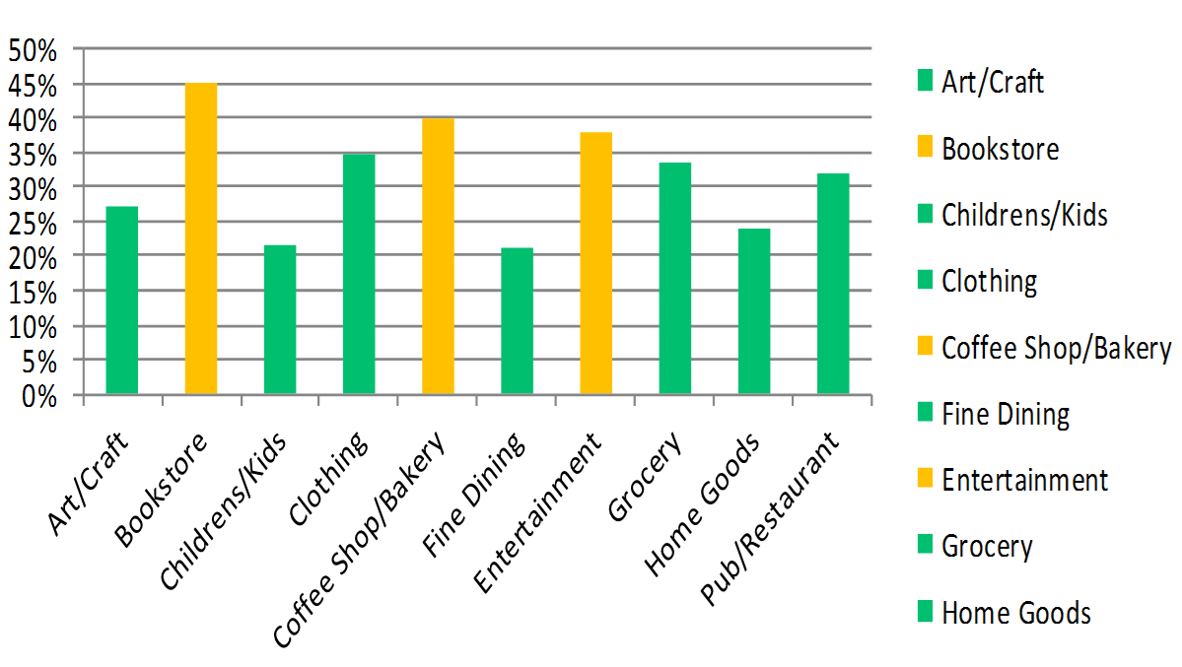
What time of day do you shop most often (not just downtown)?
7 to 9 am: 0.55%
9 to 11 am: 14.94%
11 am to 1 pm: 18.27%
1 pm to 5 pm: 36.16%
After 5 pm: 30.07%

What day of the week do you most commonly shop (not just downtown)?

Monday 7.81%
Tuesday 10.29%
Wednesday 12.0%
Thursday 12.95%
Friday 11.43%
Saturday 38.29%
Sunday 7.24%

Where do you live?

Downtown Roseburg 11.66%
Elsewhere in Roseburg 57.79%
Elsewhere in Douglas Co. 27.5%
Outside Douglas Co. 3.10%
Would you live in downtown Roseburg if you could?

Yes 11.74%
No 50.09%
Maybe 14.68%
Although most people prefer not to live in downtown, over 25% of respondents said, “Yes or Maybe”. This should be a positive sign that downtown is a desirable place to live for some with shopping, dining and other businesses within walking distance. People who live in downtown typically spend a greater portion of their disposable income in downtown. So increasing housing options is good for any community. This might include upper story housing above existing storefronts and even hotels. More residents in downtown would mean they are looking for shopping and entertainment beyond 5PM. Some businesses that close at 5PM, might consider extended hours as residential density increases.
In a follow-up question, we asked, if you do not want to live in downtown, why not? The following were the most common responses:

- Perceptions of safety
- If there were more upper floor apartments
- “Almost” live downtown
- Like where I live
- If there was a grocery store w/n walking distance

- Most of those that do live downtown love it

Where do you work?

Downtown Roseburg 16.97%
Elsewhere in Roseburg 36.67%
Elsewhere in Douglas Co. 10.89%
Outside Douglas Co. 2.03%
Retired 28.04%
Student 2.40%
How old are you?

Under 18 1.10%

10 to 24 2.76%
15 to 34 13.60%
35 to 44 19.12%
45 to 54 16.91%
55 to 64 24.26%
65 to 74 19.30%
Over 74 2.94%
The last question asked in the community survey was “In one sentence, describe your hope for the future of downtown.” A wide variety of responses were gathered. Here is a short sampling of those answers. The complete set of answers was provided to DRA.
- A vibrant place where people come to enjoy an experience, support the local economy, and get to experience a part of Roseburg.
- A vibrant core with people young and old, residents and visitors, walking the street, spending hours down here because there is so much to see and do.
- A thriving, safe, family-friendly environment, rich in culture, dining, and prosperity.
- Unique, all inclusive, downtown experience.
- I would like to see everybody working together to make downtown Roseburg a great place for all.
- The businesses will come together and help each other out with the help of people who will think outside the box.
- I hope to see some hustle and bustle. I think more activities, like weekly markets would bring more people, and with more use of downtown, we would see fewer problems.

Key Findings
In addition to the surveys and focus groups, a few other documents were reviewed including the Creative Roseburg Report (2016), Homeless Transitions Action Group Goals and Priorities (2016), Heart of Roseburg Marketing Plan (2015), Southeast Roseburg Community Impact Measurement (2013), Downtown Grocery Market Study (2011), Resource Team Report (2009), and Downtown Roseburg Master Plan (1999). We also heard from the City on several key initiatives that are on the horizon or in the works including, funding support for an Arts Coordinator to build on the Creative Roseburg effort, streetscape improvements like lighting and garbage enclosures, funding for façade renderings, and cleanup at the old Safeway site among others. Some of the key findings pertinent to downtown between the surveys and the reports reviewed include:
- There is a strong opportunity to build on the creative cluster that is already emerging in downtown Roseburg and includes everything from craft businesses like The Knotty Lady to salons like the Hair Garage to retail businesses like Umpqua Sweets & Treats to breweries like North 40.
- Roseburg’s location is a key attribute for people who live in the community and for travelers. Proximity to the coast and mountains and overall beauty of the area are some of the reasons people cited for living in Roseburg.
- DRA has forged strong partnerships with many groups and organizations including, among many others, the City of Roseburg, NeighborWorks Umpqua, and H-Tag.
- Homelessness is at the forefront of community members’ minds with a wide range of perspectives on what actions need to be undertaken to address the needs and issues. There are a wide variety of groups already focused on this topic.

Market Analysis

The market overview section evaluates the market based on identifying the inherent competitive advantages of downtown Roseburg. Balanced with input from the community as well as current place-based assets and district anchors we can develop an overarching Transformation Strategy. The following represents summary charts of collected market data of the trade area for downtown Roseburg. All data is also provided in attachments for further review.

Trade Area
Primary residents of Roseburg’s trade area represent the largest customer group for downtown Roseburg. The concentration of retail and large discounters like Costco enables Roseburg to serve as a regional shopping hub. As such, the retail trade area in the map below reflects that Roseburg pulls shoppers from at least a 10-mile radius for shoppers goods, restaurants/entertainment and many convenience goods and services as well.

Demographic and Psychographic Characteristics Summary
The data that follows represents Roseburg trade area residents. More detailed demographics appear in the Appendix.

Demographics
- The market or trade area is home to over twice the number of residents (58,620) as the City of Roseburg (24,800).
- Population growth is steady (0.67% annually), which is attractive to retail and service businesses seeking to locate or grow.
- Median household incomes at $44,038 are below the state average ($60,212), but are forecast for good growth to over $50,000 by 2023.
- Median age is 46 years, higher than Oregon overall at 39 years.
- Demographic profiles do not account for tourists

Roseburg 10-mile Trade Area
Summary | Census 2010 | 2018 | 2023
Population | 55,858 | 58,620 | 60,598
Households | 23,032 | 24,157 | 24,971
Families | 15,192 | 15,763 | 16,228
Average Household Size | 2.38 | 2 | 2.38
Owner Occupied Housing Units | 61.2% |  | 59.8%
Renter Occupied Housing Units | 31.8% |  | 33.4%
Median Age | 44.1 | 46 | 46.6
Median Household Income |  | $44,038 | $50,097

Source: ESRI BIS, US Census

Business and Employees: In addition to resident shoppers, downtown Roseburg also benefits from a large area business base that contributes to shopping potential. Within the 10-mile radius are 2,429 businesses with a total of 29,481 employees.

Visitor Market: Visitor/travel information provided by Travel Oregon from Dean Runyan Associates reveals that in 2018 Douglas County had $244M in visitor spending, a healthy increase over $204M in 2010. Roseburg area attractions and lodging are key drivers of this spending. Overall, the area’s visitor market is experiencing an uptick as both interest in recreation tourism and the wine industry are on the rise.

Psychographics
Psychographics is the study of personality, values, opinions, attitudes, interests, and lifestyles. Tapestry psychographic data helps communities and businesses understand consumer lifestyle choices, what they buy, and how they spend their free time. Tapestry classifies US residential neighborhoods into 67 unique segments based on demographic and socioeconomic characteristics. The top psychographic profiles for Roseburg are used to gauge possible shopping characteristics of downtown’s largest potential shopping demographic. The following outlines the top categories based on psychographic data for Roseburg are: Old & Newcomers (18% of hh); Retirement Communities (9.4%); Midlife Constants (9.2%); Senior Escapes (8.8%); and Front Porches (7%).
“Old & Newcomers” have a median age of 38.5 with a median income ($39,000) and net worth ($23,000) well below US average. They are predominately single households with a mix of married couples without children. Neighborhoods are in transition, populated by renters who are just beginning their careers or retiring. The focus is more on convenience than consumerism, economy over acquisition. Residents are strong supporters of environmental organizations. They prefer cell phones to landlines.
“Retirement Communities” have a median age of 53.9 with a median household income of $40,800. Over half the homes are renter occupied with nearly one in five households without a car. The enjoy going to the movies, fishing, taking vacations, and prefer dining out to cooking at home. They have brand loyalty but they are frugal. They are health conscious. They do enjoy playing cards and reading books and watching TV. They tend to read magazines over interacting with computers.
“Midlife Constants” have a median age of 47 and are leaning into retirement. They have above average net worth ($138K) compared to the US average ($93K). Although located in predominantly metropolitan areas, they live outside the central cities, in smaller communities. Their lifestyle is more country than urban. They are generous, but not spendthrifts. They are traditional, not trendy and opt for convenience and comfort, not cutting-edge. Technology has its uses, but the bells and whistles are a bother. Attentive to price, but not at the expense of quality, they prefer to buy American and natural products. Radio and newspapers are the media of choice (after television).
“Senior Escapes” have a median age of 54.6 with a median household income of $38,700. More than 1/3 of the households are married couples without children and 1/3 are single-person households. ¾ of all homes are owner occupied. They enjoy gardening, spend the majority of their time with their spouse or alone, and tend to spend within their means. They get most of their information from TV and the Sunday newspaper and are light users of computers and the internet. Like playing trivia games, bicycling, boating, and fishing. They are very health conscious.
“Front Porches” have a median age of 34.9 with a median income ($43,700) and net worth ($24,800) well below US average. They are a blend of households with more young families with children and single family households than average. Composed of a blue-collar work force, price is more important than brand names or style to these consumers. With limited incomes, these are not adventurous shoppers and they would rather cook a meal at home than dine out. They seek adventure and strive to have fun. They prefer cellphones over landlines, and use their mobile devices for entertainment such as streaming movies and music.

The report segments as described by ESRI for the top categories are included in the attachments.

Business District Characteristics
In this particular area, we are visually and through data points seeking to better understand strengths and/or voids within the downtown marketplace of certain business related clusters. Some key points to take-away about the local business base follow.

Demographics
The immediate downtown Roseburg district appearing below is home to 3,045 residents, 3,892 employees and over 400 businesses. This is a good snapshot of the customers who can walk to and through downtown within 15-20 minutes.

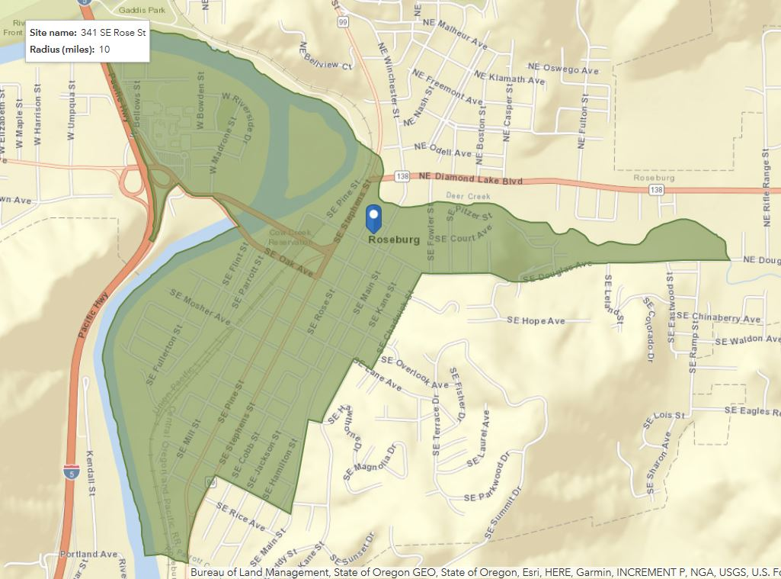
Sales Void Analysis
The Leakage/Surplus report provided for Roseburg’s10-mile trade area measures the balance between the volume of retail sales (Supply) generated by retail businesses and the retail potential (Demand) produced by households within the trade area for spending on goods and services.
Leakage in a trade area represents a condition where demand exceeds supply. In other words, retailers outside the trade area are fulfilling a portion of the demand for retail products that could be captured by businesses within the trade area, therefore, demand is “Leaking” out of the trade area. Such a condition can on one hand highlight a potential opportunity to recapture those “leaked” sales or suggests an inherent weakness within the trade area that may prove too difficult for business attraction. Leakage appears in the right column on the chart below. For the Roseburg trade area, there is a general oversupply of retail, Supply (retail $ales) or $104M/annually exceeds Demand (retail potential) $63.7M/annually. However, examining specific retail categories points to some significant gaps or leakage as listed below.
- Electronics - $10M
- Clothing/accessories - $21.5M
- Home furnishings - $5.6M
Surplus in an area represents a condition where supply exceeds the area’s demand. Retailers are attracting shoppers that reside outside the trade area, which is most certainly the case for grocery, drugstores, and home goods/building materials for Roseburg. The “Surplus” on the left column in the chart below is in market supply of goods. The following graphic looks at leakages and surpluses for the Roseburg primary trade area. This data provides insight to retail and service opportunities that downtown Roseburg may be able to capture.

Source: ESRI and Infogroup, 2018

Current Downtown Place-Based Assets

The third area of focus in helping to clarify and define a potential Transformation Strategy for downtown Roseburg is in evaluating your current place-based assets. These current assets directly demonstrate current or potential traffic draws to downtown as well as market strengths:
- Emerging business clusters in a few segments:
  - Restaurants/breweries/wine tasting (over 20 businesses)
  - “Creative” businesses (arts co-op, candy-making, yarn/sew shop, marketing, pottery-making, screen-printing)
  - Destination businesses
  - Health, beauty and wellness (over 20 salons, fitness/yoga businesses + Blue Zones)
- Downtown still serves as the civic center of the community with the location of city and county government offices and services.
- Downtown Roseburg has a really terrific collection of historic building stock that is currently underutilized but is full of potential. Several building improvement projects are improving the look and function of downtown.
- Walkable downtown with one of the most interesting intersection/street improvement projects in the state. This characteristic will be an important defining character of downtown as the district continues to revitalize.
- Really amazing views from the upper floors of buildings and parking structures
- Geographic location and access.

Market Data Summary
In evaluating Transformation Strategies, market data never truly pinpoints the exact market for downtown. However, it can both support the Transformation Strategies as well as provide the themes that help to define.
For Roseburg and many other downtowns across the country, market data for the trade area is limited to assessing a more localized consumer. In the case of Roseburg, based on interviews, business mix, key downtown traffic generators, and geography, it is fairly obvious that downtown supports a regional market with restaurants, government, business services and selected retail anchors.
As we develop Transformation Strategies by looking for strategies that provide for the potential of “overlay” consumer markets in which multiple product categories and/or consumer groups are supported. This creates a more robust shopping environment so that if one of the consumer markets or product categories is down the others can bolster and vice versa.

Recommended Strategy
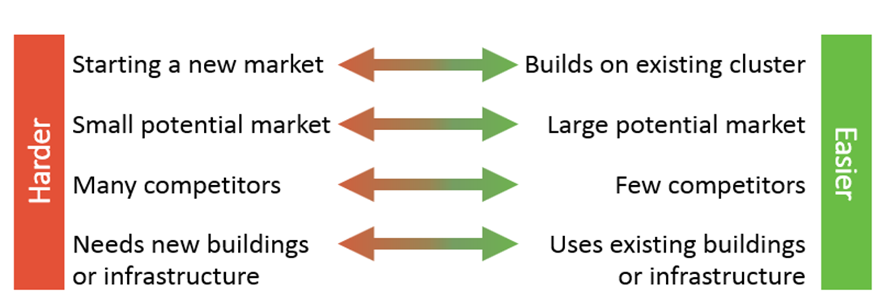
Based on community feedback and survey input, coupled with market data and review of the current business mix, we evaluated some early considerations by asking a few key questions to ensure that the Transformation Strategy could provide unique, competitive positioning for downtown Roseburg. It is really up to the community which direction they would like to go, but it is easier and quicker when the adopted strategy builds off existing assets and business clusters with few competitors for that particular niche.

We offered a few strategies at the community meeting including Arts & Creative Hub, Restaurant & Entertainment, Umpqua Experience (local food, agriculture, fishing & recreation), Health & Wellness, or something else. The overarching strategy that had universal appeal was “Umpqua Experience.” This concept was first mentioned in one of the focus groups. A business owner mentioned that he would like people to experience the bounty of the area in downtown Roseburg (e.g., restaurants would feature locally produced food). We then met with the board and discussed the potential of using this as the Transformation Strategy.

After further refinement, the board felt: Downtown Roseburg, Authentically Umpqua was more inclusive and representative of the wide range of businesses and stakeholders of downtown. Authenticity isn’t just a buzz word. A recent article by Urban Land Institute notes that authenticity is “a must-have component of successful placemaking, whether you are creating resorts, one-off hotels, or full-scale communities.” And, the article further notes that research shows that millennials value authenticity above all else and that gen Z have carefully tuned radars for the fake and disingenuous.

Why this is a good fit for downtown Roseburg
- “Umpqua” is a recognizable brand due to Umpqua Dairy, Umpqua Valley Wine Association, the Umpqua River, and other outdoor recreational opportunities and UV Magazine, promoting/branding the relaxed lifestyle of the Umpqua Valley.
- People said this is a “friendly” community rich in history and creativity. This can be incorporated as part of the “authentic” experience that people feel who live and visit the area.
- The vast majority of downtown businesses are owned and operated by Umpqua Valley entrepreneurs.
- Several businesses are already using locally produced items or are local producers themselves:
  - Umpqua Sweets & Treats picks hazelnuts and berries locally that they use in the production of their chocolates.
  - Old Soul Pizza uses Nickabob’s meat products.
  - The Knotty Lady gets wool from local producers.
  - New businesses like North 40 are local producers.
  - Many locally operated service businesses are in downtown.
- In line with several of the goals the board established at their recent retreat.
- Frankly, the board and others immediately started formulating ideas for marketing and other activities when this concept was mentioned – a clear indication this resonates locally!

Who are the customers for this strategy?
As noted most of downtown Roseburg’s existing and potential customers reside in the immediate community or larger trade area. As focus group participants noted downtown is improving with many young entrepreneurs opening new businesses and investment happening in building and public sector improvements. People really want to see a healthy and vibrant downtown with a variety of shopping, social, and entertainment uses.
Visitors are also an important secondary market for the transformation strategy. Shopping is the #1 experience that visitors seek in their travels and of course, eating 3x a day. Travel Oregon promotes Oregon’s ‘one-of-kind’ unique shopping and markets to visitors, who often seek authentic and eclectic retail and other experiences in their travels. And, we heard about the number of people that travel and stay in the area to enjoy nearby outdoor recreational opportunities. They are seeking other experiences while in the area such as your downtown can and does provide.
Employees of local businesses who commute from out of town are also a target customer group. If they are made aware of downtown’s offerings through direct promotion, they too will be ready to spend time and money there.

DRA Downtown Vision
The DRA recently conducted a goal setting session and developed the following vision statement:
“A downtown that continues cultivating a fun, safe, welcoming and livable community for everyone to thrive.”

Measurable Goals:
The following goals are adapted and updated from the recent pre-Refresh board retreat:

Organization: Maintain a sustainable funding stream and develop a communication strategy that supports events and members.
- Increase Membership.
- Define Critical Partners.
- Develop internal, external, community at large communication.
- Accountability and information sharing.
- Identify stakeholders.

Promotions: Downtown becomes “the venue” for hosting events in Roseburg.
- Formalize a process for hosting an event or renting space.
- Increase attendance at events downtown.

Design: Downtown is a safe and healthy place with livable infrastructure.
- Improved walkability and livability.
- Increase safety in the parking garage.
- Partner with organizations on clean-ups.

Economic Vitality: Form partnerships to support local entrepreneurs and engage with property owners.
- Facilitate partnerships between property owners.
- Increase vacant space occupancy by pop-up shops 2x’s per year.

Next Steps
The DRA board needs to review the recommended strategy and adopt. Host a meeting with the participants of the focus groups and community meeting, respondents to the survey, and invite others that might be interested in participating. Form working groups based on the recommended strategies. Discuss key goals for each work group based on the strategies. Coming together as one group to decide will help everyone align and connect their point to the strategies. Oregon Main Street staff is available to help facilitate this meeting if desired.
After this, the individual work groups will need to meet to develop their work plans. At that meeting, the chairs will need to review the selected strategies and project goals from the previous meetings:
- Review current activities and identify what fits under the recommended strategies. You may already be doing a lot of work that aligns with the strategies.
- Some activities may be part of your core functions that don’t necessary align with the strategies but are important to keep. That is fine as well.
- Some activities may not align with the strategies nor are meeting organization goals or serving an important function. It might be time to let them go.
- Consider other “partner” organizations and stakeholders the work they are doing that enhances the strategies. While not the result of the main street group’s efforts, this does represent the leveraging of capacity and resources in support of your strategies so you definitely want to capture this information.
- Develop your written work plans that outline who is responsible, budgets, timelines, etc. Remember to include metrics for each – what defines success as it relates to each strategy? Some sample metrics include:
  - Conduct on-street customer and business surveys when you implement the strategies – then, conduct surveys one year, three years, and five years later. Ask the same questions. Are more people patronizing the district? Are their impressions and perceptions of the district improving? Your surveys should include questions in four specific categories:
  - Attitudes and perceptions about the district
  - Current shopping habits
  - Additional products and services shoppers would like to be able to buy within the district
  - Demographic characteristics of those participating in the survey including home zip code
- Track the number of square feet devoted to business uses based on the strategies over time.
- Ask the owners or managers of a representative sample of businesses in each of the strategies to keep an informal tally of foot traffic, average transaction amount, and gross sales. Interview at regular intervals and hold an annual focus group. Are the numbers increasing?
- Track the number of changes (in business hours, service offerings, or product mix) that businesses have made to serve the target markets of each of the strategies.
- Choose several intersections or entry points in the district and count the number of people who walk by during 30 minute intervals. Do this at two or three key points in the day (e.g., morning, noon, and evening). Repeat the pedestrian counts at least twice a year, at the same times of day. Are the numbers increasing?
- Remember to take the work plans to the board for approval before beginning any new project or activity.
- Utilize the customer surveys and sales gap information to promote downtown’s business opportunities (see sample).
- Strategize with property owners eager to fill vacant spaces about the types of businesses that may offer the best fit for the location and property characteristics and in light of downtown’s market theme. Help organize business expansion and attraction efforts to develop interest in downtown Roseburg.
Sample Ideas to Implement Authentically Umpqua
Promotion
- Taste of Umpqua Restaurant Event(s)—could be part of street festival or a winter time promotion
- Promote downtown business owners/businesses with a continuous story-telling campaign, ‘I am Authentically Umpqua’ because….
- Map out a PR campaign to infuse Authentically Umpqua into promotion materials, news stories, event marketing, store windows, etc.
- Review the 2016 Creative District Plan prepared for the downtown Roseburg area to leverage ideas that build on the Umpqua theme and leverage local Umpqua assets
Economic Vitality
- Add info on vacant properties to the website.
- Build on the Creative/Arts of Umpqua with pop-up spaces that are occupied by entrepreneurs featuring locally made goods. Consider a theme around apparel and accessories to fill this retail gap and to complement the strong businesses in this niche (e.g.. Brown’s Shoes, Lifestyle NW).
- Activate one of the large property vacancies with holiday festival of Umpqua Local Goods and/or by bringing together multiple creative vendors under one roof like the Marketplace in downtown Stayton.
- Sponsor a business start-up contest to entice a new Umpqua entrepreneur with a unique local product mix to join the downtown business community
Design
- As noted earlier in the report, the streetscape design beautifully incorporates Authentically Umpqua elements such as fish and forests. Weave these unique features into the brand story and look for ways to reinforce them in other streetscape elements from garbage cans to benches
- Prepare a self-guided historic walking tour map for the downtown that portrays the unique times in the history of the Umpqua Valley
- Inventory large vacant or underutilized properties as potential sites for a Local Marketplace concept (indoor/outdoor Farmers’ Market, holiday pop-ups, Makerspace, etc.)
Organization
- Friendraiser-type activity to help build volunteers for projects and activities.
- Collaborate with the Umpqua Valley Farmer’s Market to evaluate potential downtown market sites.
- Develop messaging around Downtown Roseburg, Authentically Umpqua – as a start, this should be developing stories about downtown businesses as mentioned above, but also includes the assets that make downtown unique.

Appendix
Roseburg 10-mile radius Trade Area Population: Income and Age Distribution

