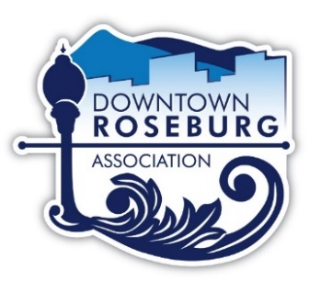
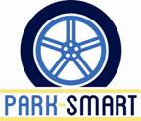

Downtown Roseburg Association ~ Park-Smart
Code of Ethics

As a member of the Downtown Roseburg Association (DRA) staff, I will exemplify the highest standards of honesty, commitment, and accountability (per ORS Chapter 244 and OAR Chapter 199), and, hereby, state the following:

- I will know my authority well and use it wisely. I will neither exceed nor abuse it.

- I will place team and organizational success ahead of my own. I will work diligently at all tasks assigned to me, meeting my responsibilities to the best of my abilities.

- I will conduct myself with the highest degree of integrity and honesty. I will conduct myself in a manner which consistently maintains the public trust and the trust of my fellow supporters.

- I will be intolerant of dishonorable or unethical conduct or behavior by any person working for DRA or Park-Smart, whether paid or volunteer.

- I will not become a party to conduct that is likely to, or does, bring disrespect to myself, my fellow employees, or DRA/Park-Smart. To that end, I will not engage in personal conduct that affects, or could be perceived to affect, impartiality or favor in my official capacity.

- I will avoid all conflicts of interest, perceived or real. I will not use my position or authority for any personal gain or benefit. I will refrain from seeking or accepting any gift, gratuity, or favor that is tendered, or could reasonably be perceived as being tendered, as an attempt to influence impartiality in my official capacity.

- I will serve the public, Board members, and DRA/Park-Smart staff with due respect, concern, civility, courtesy, and responsiveness without prejudice. I recognize that service to the public and to my team is beyond service to myself.

I recognize that violating these ethics will result in the termination of my position.

_____________________________________ _____________________________________
Printed Name Signature

_____________________________________ ______________
Witness Date

