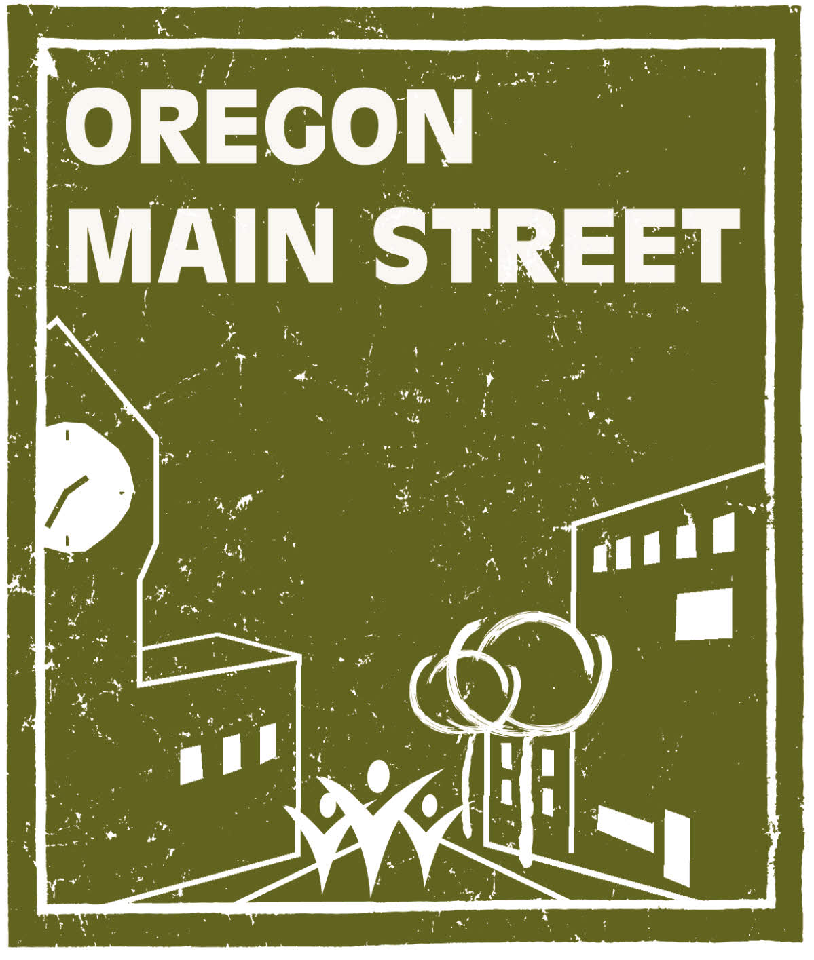
2020 Performing Main Street Application

Due Thursday, March 12, 2020

Performing Main Street is the most prestigious of the three levels of the Main Street Track and is for organizations that are successfully using the Main Street Approach® as the basis for their downtown revitalization efforts. Communities at this level are recognized by Main Street America™ and are eligible for National Accreditation. All cities under 50,000 in population in the State of Oregon are eligible to apply for Performing Main Street status. In larger metropolitan areas, applications may be for distinct neighborhood commercial districts rather than for the traditional downtown business district. Communities larger than 50,000 population must contact the OMS Coordinator for eligibility.
For communities participating at the Performing Main Street level, the boundaries/primary focus area of the organization must be that of a traditional downtown or neighborhood commercial district. A “traditional downtown” or “traditional neighborhood commercial district” is defined as a grouping of 20 or more contiguous commercial parcels containing buildings of historical or architectural significance. The area must have been zoned, planned, built, or used for commercial purposes for more than 50 years. This area must be:
- A traditional central business district and center for socio-economic interaction.
- Characterized by a cohesive core of historic or older commercial and mixed-use buildings that represent the community’s architectural heritage. It may also include compatible in-fill development.
- Have a sufficient mass of businesses, buildings, and density to be effective.
- Typically arranged with most of the buildings side-by-side and fronting the sidewalk along a main street with intersecting side streets.
- Compact, easily walkable, and pedestrian-oriented.
In general, districts containing newer low-density automobile-oriented commercial development (e.g., sprawl), strip malls, and enclosed shopping/entertainment centers will not qualify for designation unless they are fully integrated into the fabric of a traditional “Main Street district.”

Prerequisites

To become a Performing Main Street level community, the community must first meet all of the following prerequisites and then submit an application. All communities must submit the application unless they are currently participating at the Transforming Downtown level. Current designated Transforming Downtown level communities may complete the National Accreditation Self-Evaluation form rather than the full application.
- Have a formal local program organizational structure. It is highly recommended that this is an independent, nonprofit 501c3 or 501c6 organization. Other organizational structures must have the approval of Oregon Main Street staff.
- Have an active board of directors. The board of directors is a diverse and representative group who are selected for their skills, connections, and knowledge. They should have enough time to commit and be passionate about Main Street and its mission. The board of directors will be the main advocates for the program, help with strategic visioning, maintain public relations, and sustain revenue.
- Has broad-based community support for the commercial district revitalization process, with strong support from both the public and private sectors.
- Has developed vision and mission statements relevant to community conditions and to the local Main Street program’s organizational stage.
- Has a comprehensive Main Street work plan.
- Possesses an historic preservation ethic.
- Has an adequate operating budget.
- Has a paid, professional executive director (minimum requirement is part-time for communities under 5,000, full-time for communities over 5,000).
- Conducts program of ongoing training for staff and volunteers.
- Reports key revitalization statistics.
- Current member of the Main Street America™ Network.
- Representation from the local organization is mandatory at the following: Oregon Main Street Conference, Oregon Main Street Network Meetings (three times per year at various locations), and Oregon Main Street Trainings (typically in conjunction with the Network Meetings).
- Meet Main Street America’s accreditation requirements by year three of participation in the OMS Network.
- Maintain a Main Street America Network membership.

Requirements

In addition to meeting the prerequisites, the following requirements must be met to maintain status as Performing Main Street level community. Oregon Main Street staff will provide services to meet some of these requirements. These requirements are incorporated in the biennial Participation Agreements.
- Follow the Main Street Approach®.
- Have support and participation of the local government.
- Attend quarterly Main Street trainings and Network meetings.
- Attend additional trainings.
- Host an annual visit by Oregon Main Street staff.
- Sign a biennial Participation Agreement with Oregon Main Street.
- Sign an annual Sublicense Agreement to use the Main Street America™ brand.
- Submit quarterly reports and reinvestment statistics.
- Submit an annual work plan demonstrating activity in each of the Four Points of Main Street.
- Present an annual report to the local elected body.
- Host an annual board retreat.
- Fill vacant executive director positions within three months of staff turn-over.
- Meet National Accreditation criteria at least once every three years (see Attachments).
- Provide mentorship to Transforming Downtown and Exploring Downtown level communities as requested by the State Coordinator.

Selection Criteria

- Broad-based community support and cooperation in undertaking a comprehensive revitalization program using the Main Street Approach®, with strong commitment from both the public and private sectors. This includes support for maintaining the nonprofit downtown or neighborhood commercial district revitalization organization as an independent entity.
- The organization and community has a good understanding of the Main Street Approach® to downtown revitalization.
- Historically significant buildings or unique characteristics of the district. Your community must also be able to demonstrate a historic preservation ethic.
- Potential for the district and organization to benefit from the types of assistance offered.
- A readiness to proceed.
- Willingness by the community to commit time and resources, and to try new ventures. This includes maintaining an adequate operating budget containing diversified and sustainable funds (see general guidelines below), an active board of directors and committees, and a paid professional program manager.

 | Population of City or Town | Commitment to Hire and Maintain Professional Staff | Recommended Minimum Annual Operating Budget
small town | Up to 5,000 | Minimum of part-time salaried manager at 25 hours a week | $45,000
mid-sized city or town | 5,000-50,000 | Minimum of full-time salaried manager at 40 hours a week | $80,000
LARGER CITY/ neighborhood commercial district | 50,000-100,000  or neighborhood commercial district within larger city | Minimum of full-time salaried manager at 40 hours a week | $100,000
OMS looks at an initial minimum funding period of three years to correspond with the intensive services offered to newly designated Main Street communities. Applications showing proof of a diversified and sustainable financial commitment from both the public and private sectors will rank higher. An adequate budget is required to maintain Main Street status and to receive on-going services.

Please call us for clarification or to discuss your individual situation if you have any questions.

Main Street® Application Information
The Main Street® application is designed to gauge and document the interest of your community in fostering a comprehensive, technical relationship, and partnership with Oregon Main Street. It also demonstrates your community’s ability and interest in successfully implementing the Main Street 4-Point Approach® within your traditional downtown or neighborhood commercial district. This nationally proven approach encourages communities to develop an effective organization, promote the district, improve appearance through good design, and restructure the economic base for long-term prosperity.

INSTRUCTIONS

When filling out this application, please use 12 point type in the Times or Times New Roman font. Type directly on the application form unless an attachment is requested. For questions requiring extensive narratives, you will be given an indication of approximately how much space has been allotted for your answer. To fill in your answer, begin typing into the highlighted area following the question. Attachments should also be typed in 12 point type in the Times or Times New Roman font.

Applications and attachments should be in a format that can be handled easily – please do not staple or permanently bind. Attachments should be labeled with the section letter and question number for reference (for example: A-30). Place attachments at the end of the application in the order they are requested. Do not include items that have not been specifically requested. Do not fax your application, attachments, or support materials.

Completed Main Street applications must be received by March 12, 2020. Please mail 3 sets of the completed application with attachments to:

Sheri Stuart, Oregon Main Street
Heritage Programs/Oregon Parks and Recreation Department
725 Summer Street NE, Suite C
Salem, Oregon 97301

Tips for a good application:
• Follow directions.
• Make your points clear and concise.
• Avoid excessive narratives.
• Present an honest picture of your community and organization, both strengths and weaknesses.
• Use specific data and documentation when possible.
• Start collecting letters of support along with your city council resolution now – don’t wait until the last moment!

Questions about this application may be directed to Sheri Stuart at 503.986.0679/ sheri.stuart@oregon.gov or Katie Henry at 503.986.0671/katie.henry@oregon.gov.

Oregon Main Street Program

Performing Main Street® Application

General Information:

City or Town: | County:
City population: | County population:
State Legislative District - House: | Congressional District – House:
State Legislative District – Senate: | Congressional District – Senate:
Persons involved in completing this application (please list names and positions):
Name and position:
Name and position:
Name and position:

Person to contact for questions about this application:
Name and position:
Organization:
Address:
Daytime Phone:
Fax Number:
Email Address:

Attachment checklist.
Please check below which items are being submitted with this application.
 | A-1 | Map identifying district |  | B-32 | Preservation ordinance
 | A-2 | Brief history and overview |  | B-35 | Digital images on CD
 | A-16 | Promotional items |  | B-37 | Articles of Inc., By-laws
 | B-18-a | Commitment letter, mayor |  | B-38 | List of board members
 | B-18-b | Resolution of support |  | B-39 | List of committees
 | B-19 | Letters of commitment |  | B-40-a | Financial commitment letters
 | B-20 | Letters from organizations |  | B-40-b | Other financial documents
 | B-24 | Business environment info. |  | B-41 | Membership brochure
 | B-26 | Work plan |  | B-42 | Manager’s resume
 | B-27 | Econ. dev./long-range plan

SECTION A: DOWNTOWN OR NEIGHBORHOOD COMMERCIAL DISTRICT INFORMATION

Please answer the following questions about your downtown area or neighborhood commercial district. Label requested attachments with the section letter and question number (for example: A-30).

- Attach a map, labeled A-1, that clearly outlines the proposed district/program area. What is the size of the proposed downtown or neighborhood commercial district area that will be served (i.e., the primary focus area boundaries) in square blocks?
- As A-2, provide a one to two page brief overview about your downtown or neighborhood commercial district. The overview should include information about the early history of the district, economic forces at work in the area, key turning points in the district’s decline (and rebirth), and where it is today.

- Please describe the characteristics that you feel make the district a cohesive and recognizable district with distinct features or architectural character. You will have approximately 1/2 page in which to answer.

- What is the approximate number of buildings in the district? What percentage of these buildings are owned by absentee or out-of-the-area owners?

- What is the approximate percentage of first-floor vacancies in the district?

- How many buildings in the district are partially residential? How many buildings in the district are fully residential?

- Please list the number of parking spaces in the district:

On-street public parking spaces
Off-street public parking spaces
Off-street private parking spaces
Total

- What is the total number of businesses in the district? Include retail, service, and professional. Do not include government and nonprofit institutions.

- How many businesses in the district generally fit the following categories:

Department stores |  | Jewelry |  | Books/cards
Specialty gift |  | Discount general |  | Furniture
Hotels |  | Taverns |  | Antiques/galleries
Theaters |  | Gas/convenience |  | Laundry/dry cleaning
Auto parts |  | Auto sales |  | Financial institutions
Apparel/shoes |  | Health professionals |  | Insurance
Office supply |  | Restaurants |  | Grocery stores
Beauty/barber shop |  | Legal and accounting
Others (please list):

- If there are parks or other open spaces in the district, please provide a brief description below. You will have approximately 1/4 page in which to answer.

- Please list the government buildings located in the district (i.e., post office, library, city hall, schools).

- Please list religious/nonprofit institutional structures located in the district (i.e., YMCA, churches, hospitals).

- To what extent has the district been negatively affected by the following:

 | Greatly | Somewhat | Very Little | Distance from District
Local strip shopping center
Local discount center
Other downtowns in region
Regional mall/discount centers

- Please provide information on the five largest employers in the city or market area:

Employer Name | Business Type | # of Employees | In district? (yes/no)

- What are the major attractions, festivals, and special events that bring tourists to your community? Also indicate which ones bring visitors specifically into your district. You will have approximately 1/3 page in which to answer.

- Has your organization produced any promotional literature, directories, brochures, or flyers concentrating specifically on the district or district activities in the past year? If so, please attach up to 7 samples as A-16.

- Does your municipality have the following?

(yes/no)
Economic Improvement District
Urban Renewal District
Certified Local Government
Historic Review Board
Economic Development Plan
Community-wide Master Plan
Downtown Master Plan/Overlay District

SECTION B: DESIGNATION CRITERIA

Main Street America places emphasis on Main Street® communities which fully utilize the Main Street Approach® and adhere to the eight guiding principles. Oregon Main Street uses these criteria in designating and recognizing Main Street® programs in Oregon.

When completing this section of the application, please provide the requested information to indicate your community’s readiness to meet the required designation criteria.

Broad-based community support for the downtown revitalization process, with strong support from both the public and private sectors.

- Support of local government. Downtown and neighborhood commercial district revitalization efforts have little chance to succeed without the enthusiastic support of local government. Municipal government is usually the first entity to gain the benefits from a successful Main Street® program. The recommended level of funding support from the public sector is 30-35% of the program’s basic operating budget.

Please attach a letter of commitment from the mayor of your community (attach as item B-18-a), and a resolution of support from the city council (attach as item B-18-b). The resolution should endorse the capacity-building purpose of the program, recognize the benefits to local government, and pledge city government cooperation and support. When possible, local government should also include their commitment to public sector funding as a percentage of the downtown or neighborhood commercial district revitalization program budget.

- Broad-based community commitment. Your downtown or neighborhood commercial district revitalization program needs the active participation of various stakeholders representing many different segments of the community. These participants contribute financial, in-kind, and volunteer support for the revitalization program. As B-19, please attach letters indicating a commitment to being actively involved in, and to make a financial commitment to the local revitalization program. No form letters, please. Letters should be from representatives of groups that include, but are not limited to:

Financial Institutions Professionals
Merchants Owners of service businesses
Education officials Business owners from outside of district
Property owners in district Civic leaders
Utility company officials Local media representatives
Local industry officials Youth/senior representatives
Historical society officials Private citizens/consumers

- Partnerships with other organizations. A Main Street program is most successful when working in a well-integrated effort with other economic development and preservation organizations in the community. As B-20, please include a letter of support from the local Chamber of Commerce, merchant group, Economic Development Council, historic preservation group, etc.

- Previous revitalization efforts. Please describe any major revitalization efforts previously undertaken by the public and/or private sector within or adjacent to the district. Be as thorough as possible. Include dates, summary of projects, and description of outcomes. You will have approximately 3/4 page in which to answer.

Vision and mission statements relevant to community conditions and to the local Main Street® program’s organizational stage.

- Write your organization’s mission statement here. Also indicate when it was developed and by whom. If you don’t currently have a mission statement, please leave this space blank.

- If there has been a vision statement developed for your district, write it here. Also indicate when it was developed and by whom. If you don’t currently have a vision statement, please leave this space blank.

- As B-24, please describe the existing commercial, retail, and industrial facilities in the district and surrounding area. Include new investment, new competition, opportunities, and problems. Ideally the statement should include both strengths and weaknesses. Please limit your response to one page or less.

- How do you believe the community and your organization will benefit from being selected at the Main Street® level of the Tier System. Please answer in the space below. You will have approximately 1/2 page in which to answer.

Comprehensive Main Street® work plan.

The Main Street Approach® requires local revitalization organizations to develop a comprehensive work plan that includes committees working on organization, promotion, design, and economic restructuring activities and projects. Assistance with work plan development can be part of the ongoing technical assistance provided through the state program. However, some communities may already have a work plan established for the organization. If you have this in place, please answer the following questions about your plan. If you have not done this, please leave question 26 blank.

- As B-26, attach current work plan. When was this work plan developed and by who? Has the work plan been officially approved by the board of directors? If so, when was it approved? How often do you update your work plan?

- Is the district included in an overall community economic development plan or is there a long range plan in place for your downtown or neighborhood commercial district? If so, when was the plan developed and by whom?

As item B-27, please include a copy of the section(s) of the plan that pertains to your downtown or neighborhood commercial district.

Historic preservation ethic.

- If any part of the district is listed on the National Register of Historic Places as a National Historic District, please list the year that designation was received.

- List any buildings in the district that are listed individually on the National Register of Historic Places.

- List other structures in your district not on the National Register that are considered “historic” by the community. Please indicate if any of these structures have an official local landmarks designation.

- What other cultural or special features are in the district that you feel are important to consider when reviewing your application? You will have approximately 1/4 page in which to answer.

- In general, how would you describe the condition of buildings in the district?

- If your town has a local preservation ordinance in place, please attach copies of the ordinance or any other design ordinances or regulations that may apply to the district as item B-32.

- Approximately how many buildings in the district have been demolished in the past five years? Please also indicate the primary reason for the demolition.

- List and describe the purpose of any active preservation groups in your community.

- Enclose up to 30 digital images of your district in jpeg or tif format on a CD. As Attachment B-35, include a printout and label the images with a brief identifying title. Include pictures showing both strengths and weaknesses. [These digital images become the property of OMS/OPRD and may be used in future presentations and publications.]

Active board of directors and committees.

The state program assists communities in developing and maintaining long-term downtown and neighborhood commercial district revitalization organizations. If your downtown does not already have a formal organization in place, please leave this section blank.

- What is the organization’s IRS status (501c3, 501c6, don’t know)? Also, when was it incorporated?

- As B-37, please attach a copy of the organization’s Articles of Incorporation and Bylaws.

- As B-38, attach a list of the officers and board members of the organization. Also list their term limit and business affiliation or position in the community.

- As B-39, please list any committees operating within the organization and indicate the general purpose of each. List committee members and business affiliation or position in the community.
Adequate operating budget.

The local Main Street® program’s budget must be solely dedicated for the purposes of revitalizing the district. It must also be at a level adequate to achieve the program’s goals and to cover administrative expenses, including the executive director’s salary. The total dollar amount of the local budget will vary from town to town. Guidelines used for meeting a minimum annual operating budget for a new Main Street program in Oregon is $45,000 for a part-time program in communities with populations under 5,000, $80,000 for a town with a population under 50,000, and $100,000 in larger communities and neighborhood commercial districts.

Prior to applying to the state program, the community needs to be able to show current and/or future financial stability and support for at least three full years of the program beginning this year. Keep in mind that downtown revitalization is not a three year project and fundraising will be an on-going activity of the organization.

As a Main Street® community, your town will be making a long-term commitment to establish and fund a downtown or neighborhood commercial district revitalization organization. Please do not apply for this program if your organization’s board of directors is not willing to make a long-term commitment to sustain an organization and do the work necessary to maintain stable funding. Most often this includes conducting a local funding campaign. Please note fundraising is not a primary responsibility for program managers in Main Street organizations.

40.Projected revenue. Based on the above guidelines, please indicate the approximate amount of projected revenue to be collected from the following sources:

SOURCE | Yr. 1 | Yr. 2 | Yr. 3
Local Government | $ | $ | $
Economic Improvement District | $ | $ | $
Membership | $ | $ | $
Special Event Income (net) | $ | $ | $
Other sources please list: | $  $ | $  $ | $  $
TOTAL PROJECTED ANNUAL REVENUE | $ | $ | $

As B-40-a, please attach letters showing financial commitment from government, organizations, businesses, industries, property owners, and other sources not already included in the letters of support requested in items B-18a, B-19, and B-20. Also attach as B-40-b, other supportive documents demonstrating current and/or future financial stability. This can be done by showing previous records indicating income flow and stability, including membership dues or cash in hand.

41. If your organization has a membership brochure, please attach as B-41. Please indicate below the number of current members from within the district and the number of “other” members you have.

Paid, professional program manager (Executive Director).

A paid professional program manager (Executive Director) is a vital key to the success of the local Main Street® program. The Main Street® manager should be an employee of the organization. They should also be paid a salary consistent with comparable Main Street® programs and other full-time community development professionals in the area.

- Does your organization currently employ a professional manager to coordinate the local program? If yes, how long has he or she been in this position and what is his or her salary? As B-42, please attach a copy of the manager’s resume. If no, please indicate below your commitment to employ a professional downtown manager within four months from the time your community is accepted at the Main Street level of the state program.

Program of ongoing training for staff and volunteers.

Education and training of the program manager and downtown leaders is critical to the success of a local Main Street® program. The entire community, not just the person or persons completing this application, should be aware of the time commitment that will be required of participating Main Street® board and committee members, as well as the program manager, in the first and subsequent years of the program.

- Please check the spaces below as an indication of your commitment to the education and training component of the state program.

Required attendance at basic training for board and committee members within 3 months of acceptance at the Performing Main Street level.
Quarterly Main Street Network meetings. Attendance at these meetings will be required for your manager and encouraged for board members.
Annual Main Street Manager Retreat. Attendance at this three day meeting and training is required for your manager when offered.
The biannual Oregon Main Street Conference (two to three day statewide conference). At a minimum you will be required to send your manager and at least one board member.
The biannual fall Oregon Main Street workshop. When offered, you will be required to send your manager and at least one other person representing the organization at either the board or committee level depending on the workshop topic.
Main Street Now, Main Street America’s annual three day conference, held in various locations throughout the country. Attendance is not required, but encouraged.
On-site training sessions held in your community including day-long board retreats and committee action planning sessions. High attendance is required of your manager, board, and committee members.

Every effort is made to keep costs for state sponsored training sessions at a minimum. It is the responsibility of the local program to cover registration fees, travel, lodging, and meals.
- Have you sent representatives from your organization to workshops and conferences sponsored by the Oregon Main Street Program and/or to the Main Street Now national conference in the past two years? If yes, please list the workshop and/or conference title, date(s), and who attended.

Name of Workshop or Conference and Date(s) | Name of Participant

Reporting of key statistics.

To document and track the success of the Main Street® program at the local, state, and national levels, the state program requires that brief quarterly reports be submitted. Information requested in the report includes statistics on jobs, businesses, building renovation and construction costs, public improvement projects, etc. Other community information may also be requested on an as-needed basis by the state program or Main Street America.

Submission of this application indicates your agreement to the quarterly reporting requirements and that you will adhere to deadlines for submitting these reports.

Current membership in the Main Street America Network.

- Membership in the Main Street America Network gives the community access to a wealth of information and resources on downtown revitalization. If you have already joined the Main Street America Network, please indicate your membership number and expiration date below. Additional information can be found at Main Street America’s website (www.mainstreet.org).

SECTION C: MISCELLANEOUS

- Please provide a brief history of your organization. Also, include current sentiment and perceptions that are held by various stakeholder groups. You will have approximately 3/4 page in which to answer.

- Is there any additional information that you feel we should know about? For example, major issues affecting the downtown or neighborhood commercial district, your community, or your organization). You will have approximately 3/4 page in which to answer.

