Making Interactive Maps on Google
Maps can be embedded using google, which is useful for highlighting certain businesses, event locations and even art and murals!
This is a quick guide to get you started making a map from scratch:
- Open maps.google.com
- On the left hand side of the screen there are 3 stacked lines, click those
  - Scroll down to where it says “Your Places”
  - Click!
- On the top right of the new menu, click on “Maps”
  - A new menu should appear, scroll down to “CREATE MAP”
  - Now, a new tab will open on your window
- Click where it says “Untitled map” to name your new map, add a description, such as purpose or how to use the map if you’d like. For example: “BDA R&R Map”
- If you want to create layers, name your layers as you like. For example,”Benches” layer, “Picnic tables” or “Green Space” Layer
  - If you want to add a specific location to a specific layer, make sure only that layer is toggled (ie, uncheck the boxes for the other layers)
- You can search for addresses in the search bar with the blue magnifying glass, you can also search by business name
- You can create unique icons for each layer, or for each location
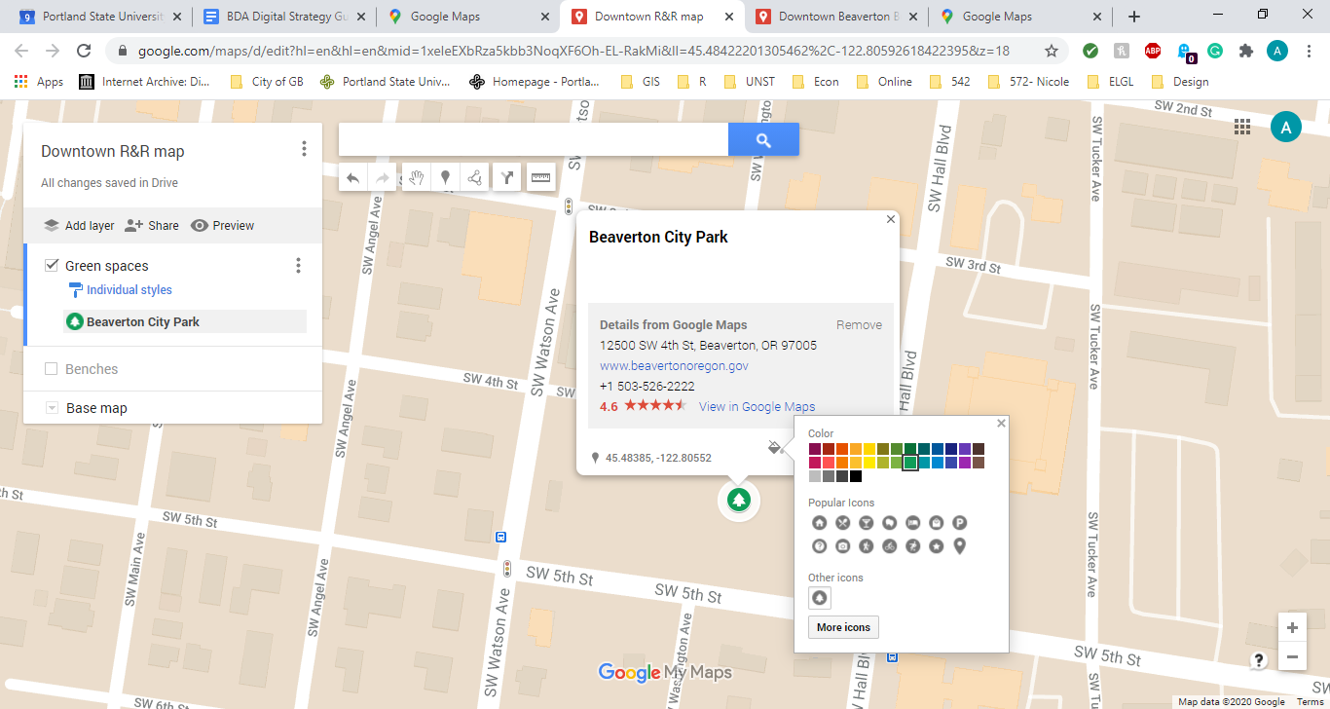
  - Add your location to the map, click on the paint bucket icon and choose your desired color and search for appropriate iconography
  - You can also add details, such as hours the park is open, whether there is lighting for sitting at night, etc by clicking the pencil icon on the location pop out, or add pictures of the location by clicking on the camera icon
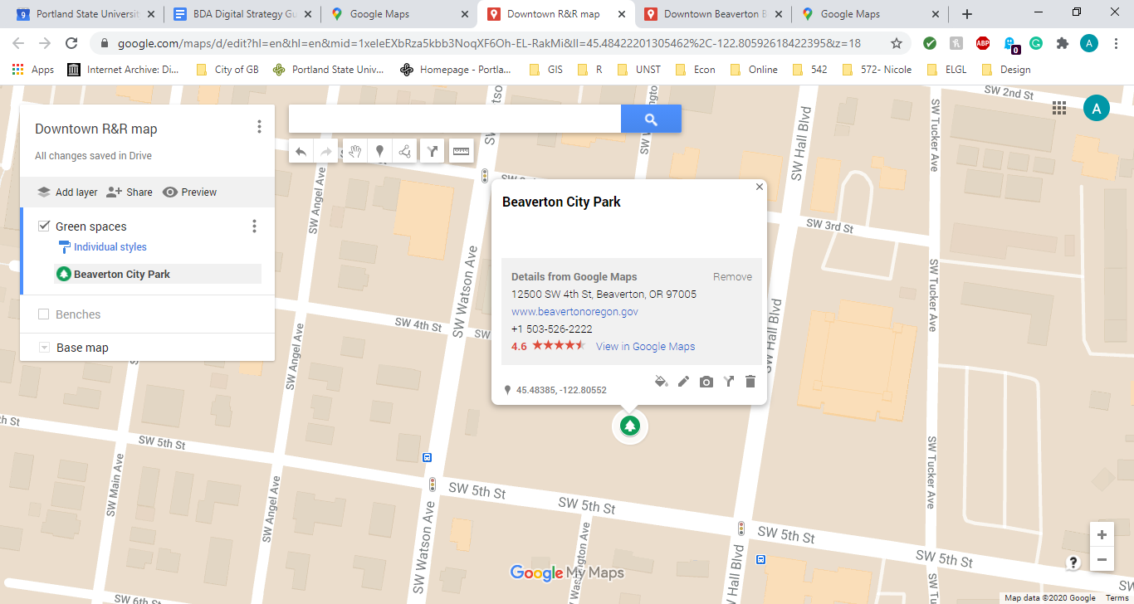
- When you want to embed your map on the website, click on the three dots at the top right of the pop out menu
  - Select from the options, whichever is appropriate
  - You can use the “Embed on my site” option for the Squarespace page

