Website and Social Media Statistics-December 2020

**Website Statistics for the month of December 2020**

Some of the most consistently visited pages include:

* Christmas in the Park
* Payments
* News

We saw a big jump in traffic on December 12th. This was our holiday event day. We had the Santa Visits, Horse Drawn Carolers, and Virtual Tree Lighting that day.

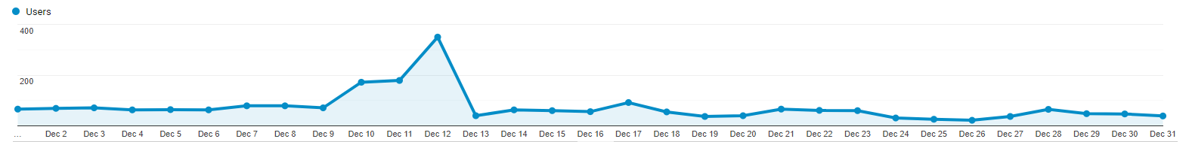

December 12th

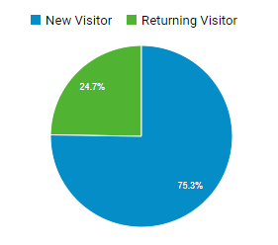

* 51.2% of visits came from a search
* 22% of visits came from social media
* 26% of visits were direct (someone typed in the url or had us bookmarked)

Some of the most common searched terms were:

* Aumsville or police department
* Aumsville Oregon city business directory
* Aumsville Oregon news
* Aumsville police department

Most search terms are not provided. This happens when people turn off cookies or use a site like duck,duck,go which hides this information.

**Social Media Statistics**

**Facebook--City of Aumsville Facebook Page for December 2020**

* 3421 likes
* +22 likes for the month
* 397 Page Views
* 4,913 Post Reach
* 1379 Post Engagement
* 68% of fans are female, 31% male
* Majority of our fans are between 25-54 years old
* Women between the ages of 35-44 are most likely to engage with the page

Our most popular post was talking about the horse drawn carolers. The short video clip has 2,700 reach and 456 engagements.

The second most popular was the announcement of the holiday light contest winner with 1,600 reach and 404 engagements.

Most posts on the page are between 200-600 reach. Reach being the number of people who see the post.

**YouTube**

Our channel had 316 views in the past month

16.6 hours of watch time

The most popular video was the Virtual Tree Lighting with 275 views

Followed by November 9 council meeting with 12 views and the November 23 council meeting with 8 views.

The average view duration is 6:02 minutes.

Our most viewed videos ever are:

5/11/20 Council Meeting—755 views

Aumsville’s Virtual Tree Lighting Ceremony – 281 views

7/13/20 Council Meeting—207 views

9/14/20 Council Meeting—110 views

Aumsville 2nd Saturday Market –78 views